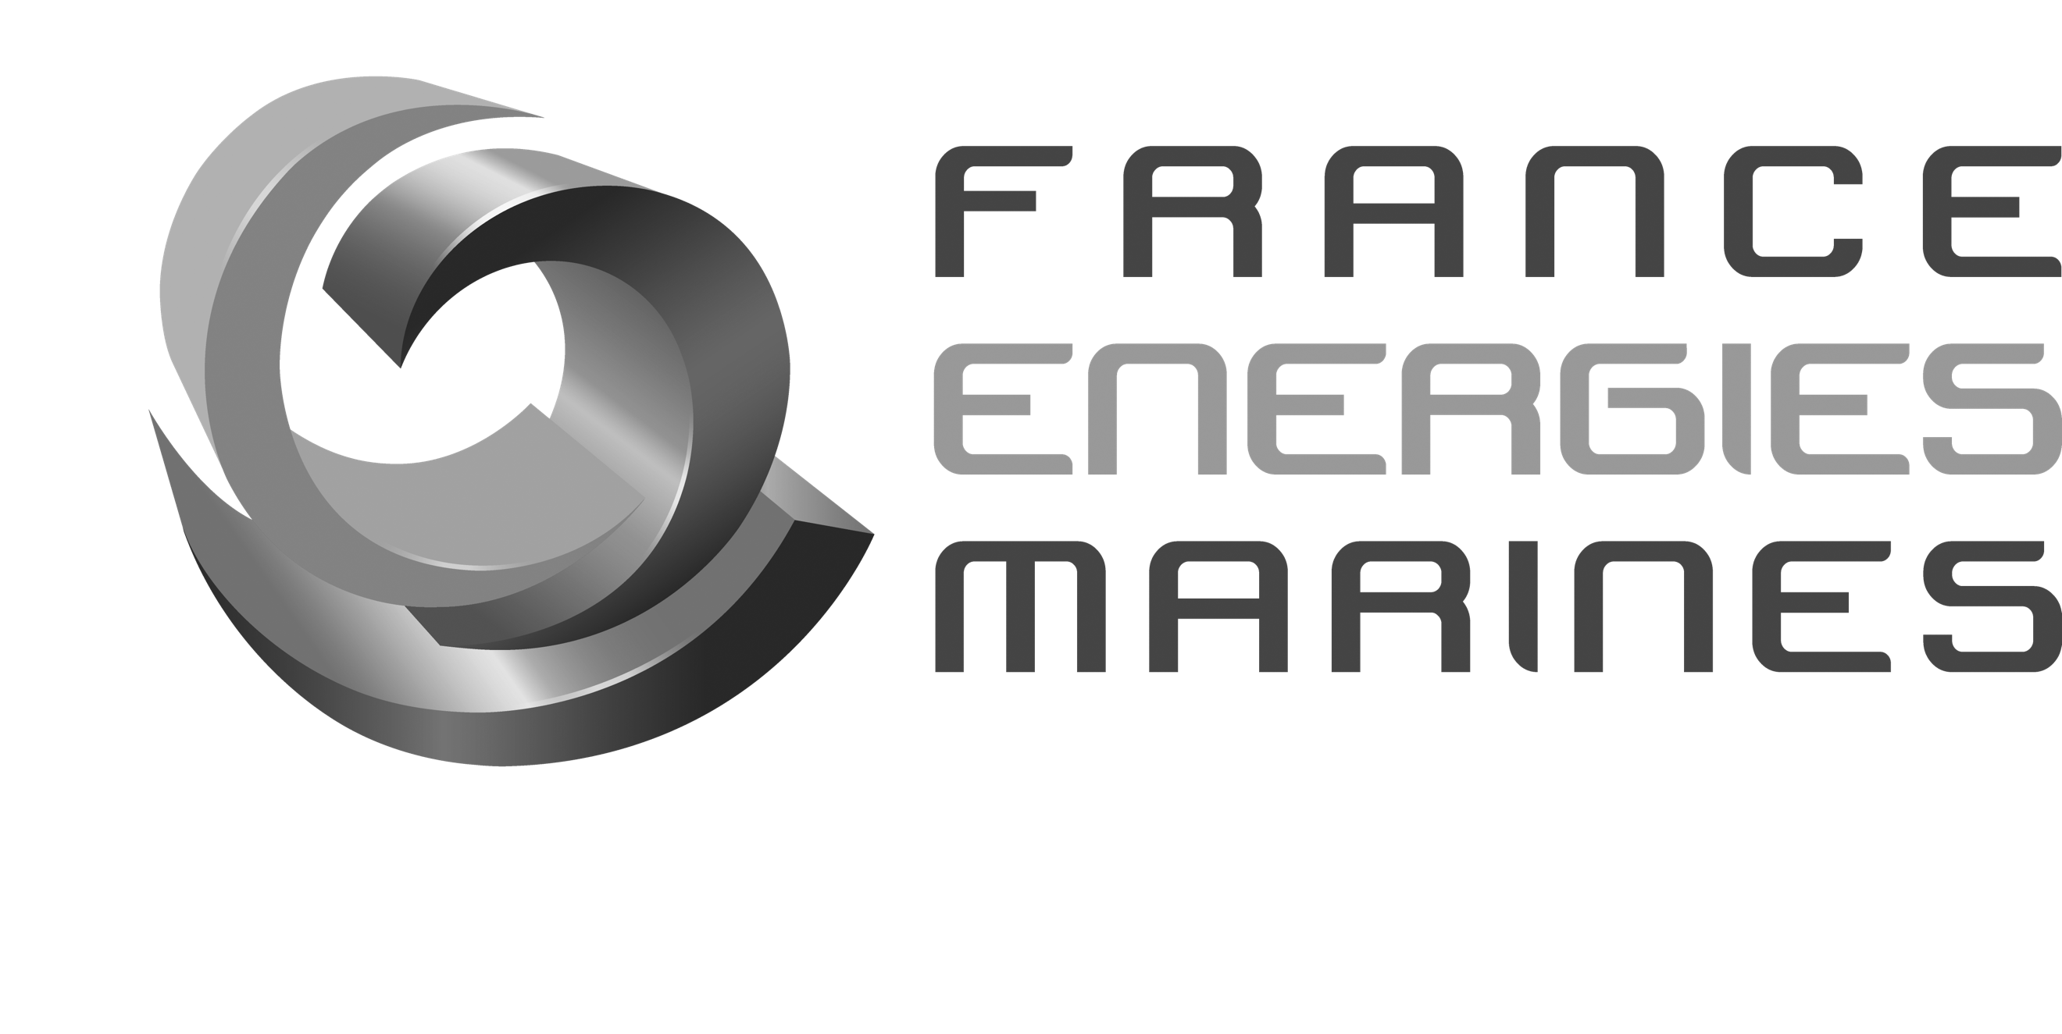

Date of Delivery: May 2023

PUBLIC – AVAILABLE FOR WIDESPREAD AND PUBLIC DISSEMINATION

This project has received funding from the European Union’s Horizon 2020 research and innovation programme under grant agreement number 815180.
ELEMENT: D10.1
site decommissioning report
Document Details

Field | Detail
project title | Effective Lifetime Extension in the Marine Environment for Tidal Energy
Project acronym | ELEMENT
grant agreement | 815180
funding scheme | Research and Innovation
project duration | 48 months, from June 2019 to May 2023
Document Number | ELEMENT-EU-0031
report Title | Site Decommissioning Report
deliverable id and type | D10.1
dissemination level | Public – Available for Widespread and Public Dissemination
author | Tara Evenno (CBS)
document version | 1.0
Status | Issued
reviewed by | Yannick Bian (CBS)
APPROVED BY | Gary Connor

Revision History

VERSION | STATUS | DATE OF ISSUE | AUTHORS | REVIEWER
0.1 | Draft | 17/05/2023 | Tara Evenno | Gavin Denham
1.0 | Draft | 31/05/2023 | Tara Evenno | Gary Connor

Contents
1. Introduction 4
2. Decommissioning Activities 5
2.1. Removal of the tidal turbine 5
2.2. Removal and transport of the ballast 5
2.3. Dismantling of the different elements of the tidal turbine 6
2.4. Removal of the turbine from the substructure 6
2.5. Removal of the rotor 7
2.6. Loading of the turbine onto the trailer 8
2.7. Loading of the cable reel onto the trailer 9
2.8. Packing the container 10
2.9. Loading of the container onto the trailer 11
2.10. Substructure 12
3. Conclusion 13

Introduction

A Funding Grant was awarded from the European Union’s Horizon 2020 research and innovation programme to develop and validate an innovative tidal turbine control system, using the tidal turbine itself as a sensor, to deliver a step change improvement in performance. This will demonstrate Effective Lifetime Extension in the Marine Environment for Tidal Energy (ELEMENT), driving the EU tidal energy sector to commercial reality. This was in response to the call LC-SC3-RES-11-2018: Developing solutions to reduce the cost and increase performance of renewable technologies.

This document pertains to work package 10 and in particular, the removal of all test equipment from the testing site during April 2023 and returning the site to its original state prior to testing. Following the successful testing of the RE50 turbine in the Ria d'Étel estuary, Chantier Bretagne Sud (CBS) oversaw the dis-assembly of the turbine assembly and load onto a trailer for transport back to Nova Innovation’s facility in Edinburgh, Scotland. This document presents the decommissioning tasks that were conducted to remove the test equipment from site.

Decommissioning Activities

Removal of the tidal turbine
A 230T crane was used to move the assembly of the turbine and substructure to the top of the slipway, so there is more access for the dismantling.

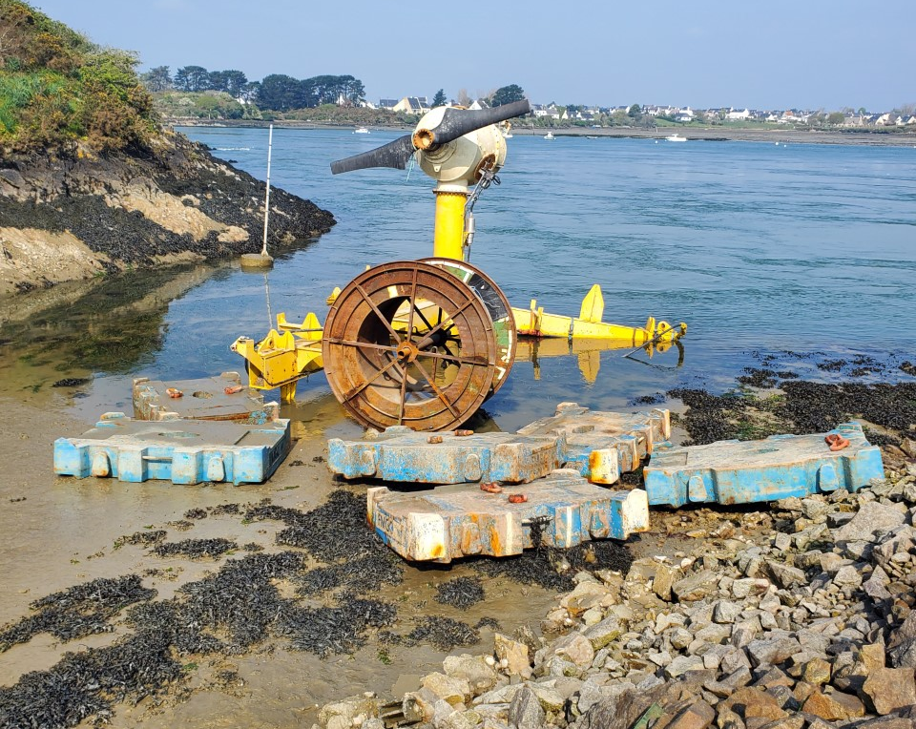
  - Figure 1: Location of the tidal turbine before decommissioning activities

Removal and transport of the ballast
Using the same crane, the six 10 tonne ballast blocks were removed from the slipway where the recovery vessel had landed them and placed on a trailer to be transported back to the suppliers that they were hired from.

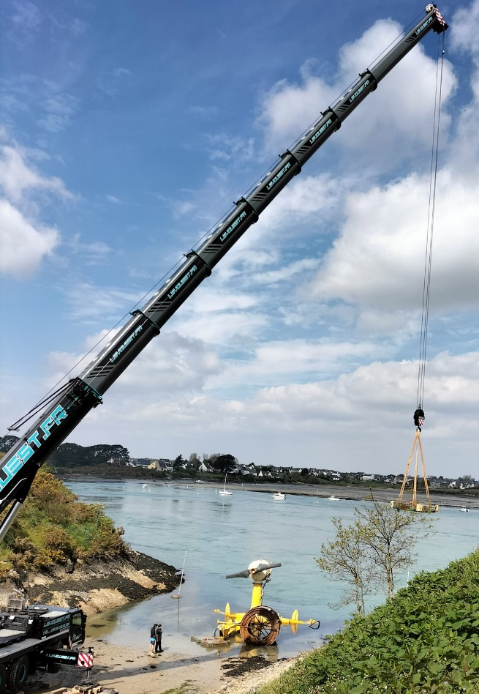
  - Figure 2: Moving the ballast with the crane from the slipway to the trailer

Dismantling of the different elements of the tidal turbine

Smaller equipment such as cameras, flow sensor, cable, supports, etc were dismantled from the main assembly and stored in the onshore station container.

The fasteners were removed and stored in bags in the container.

The cable termination piece had been removed from the subsea cable during the recovery operations. This was further removed from the substructure placed in the container.

  - Figure 3 : The cable termination piece placed in the container

The external cameras and acoustic doppler current profiler (ADCP) were dismantled and put into their carrying cases and placed in the container.

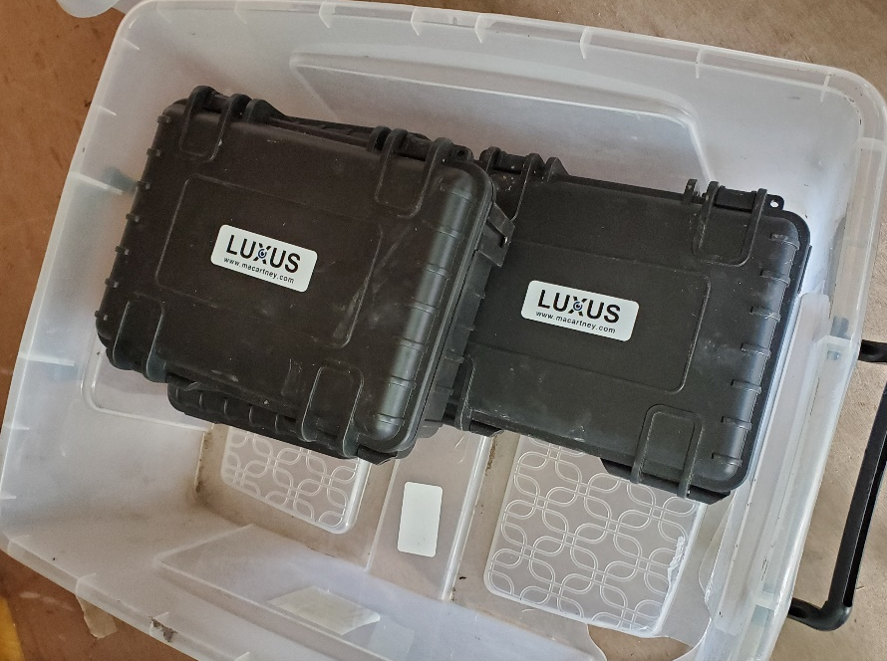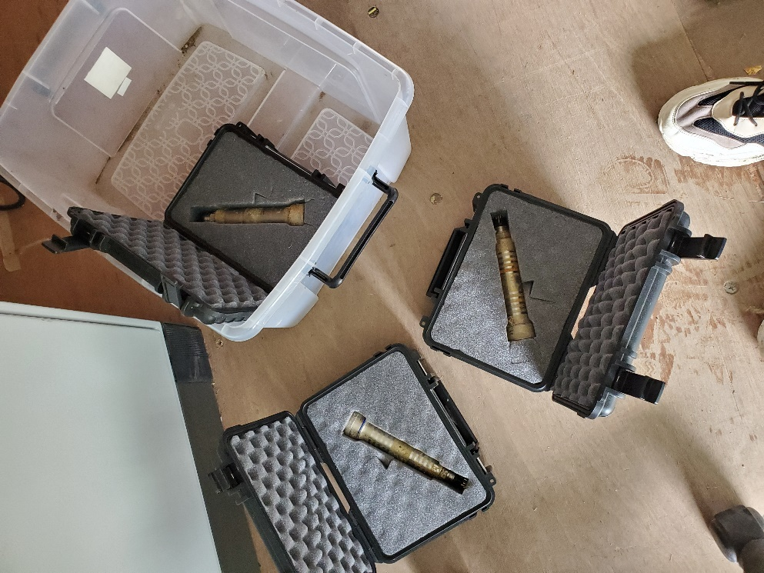
  - Figure 4: The external cameras placed in the container

Removal of the turbine from the substructure

To remove the turbine from the base, all the fasteners that held it in position were removed, then it was lifted using a crane. Some heat treatment was required to release the turbine from the structure to assist with removal.

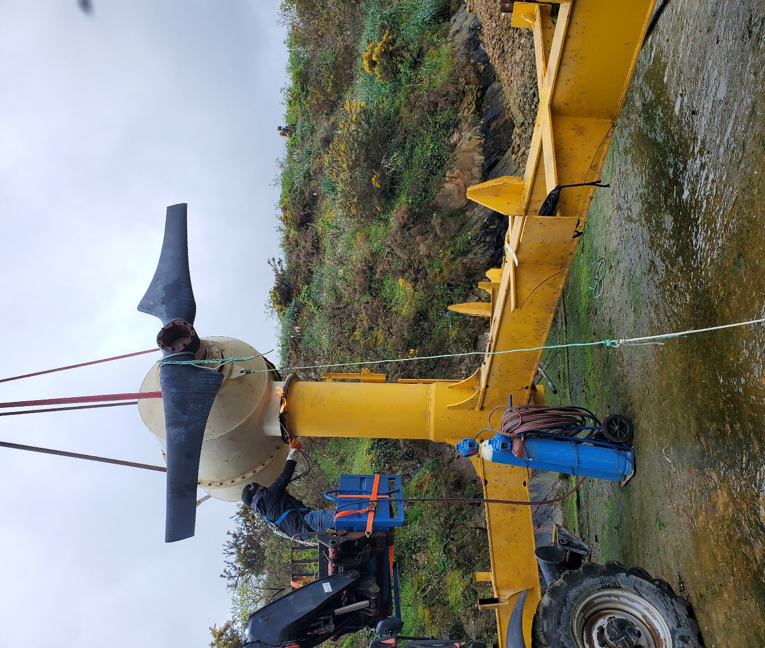
  - Figure 5: Heat treatment during removing the turbine from the substructure

Once the two parts were separated, the turbine was loaded onto the transport base and then secured to it.

Removal of the rotor
Once the turbine was placed on its support, the rotor was removed from the turbine using a telehandler and lifting slings.

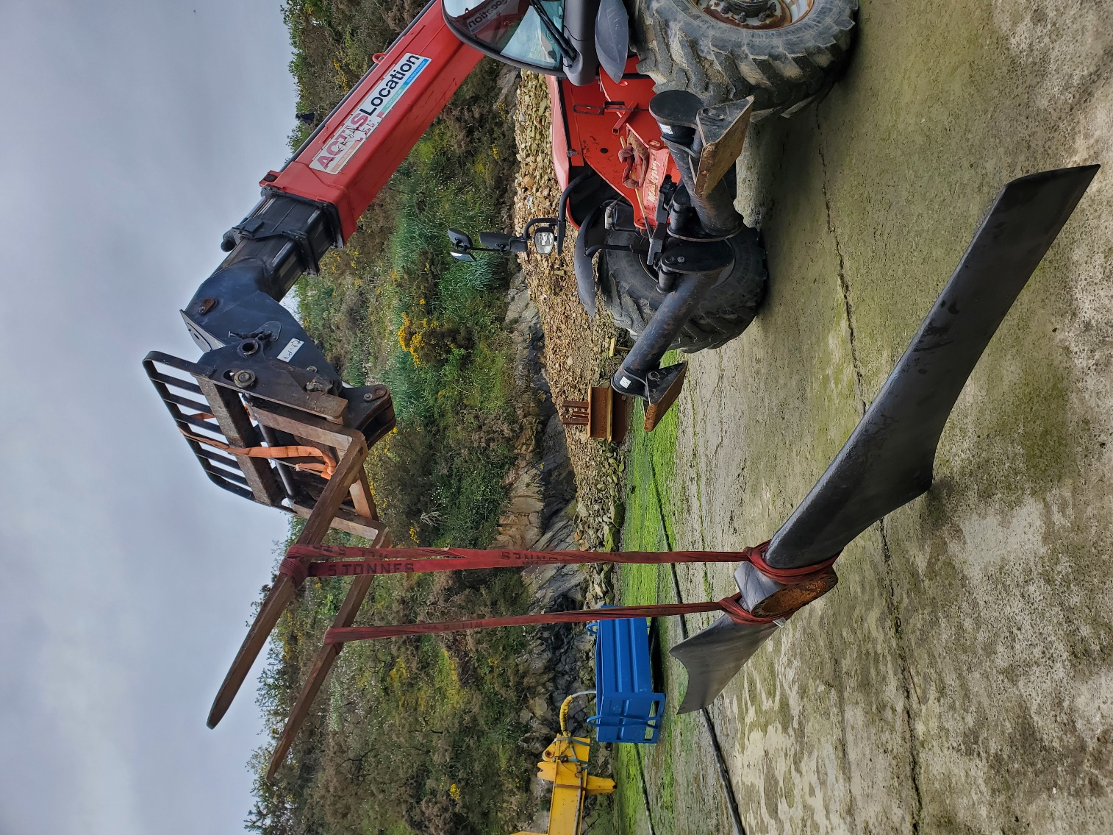
  - Figure 6: Displacement of the blade after being removed from the turbine

Loading of the turbine onto the trailer
After removing the rotor from the turbine, the turbine and the transport base assembly was lifted onto the trailer using a crane.

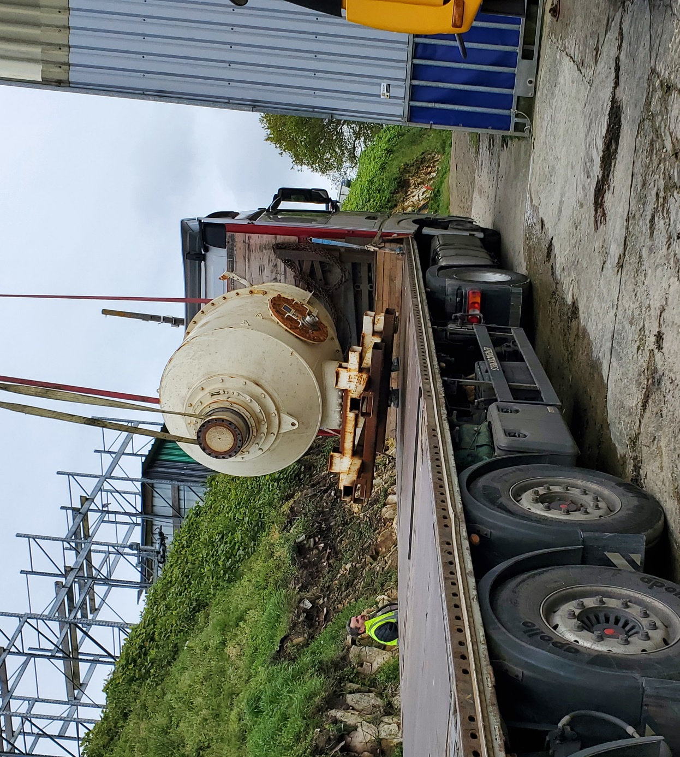
  - Figure 7: Moving the turbine with the crane to the trailer

Loading of the cable reel onto the trailer
The cable reel was lifted by a crane, using a lift beam, and placed onto the trailer.

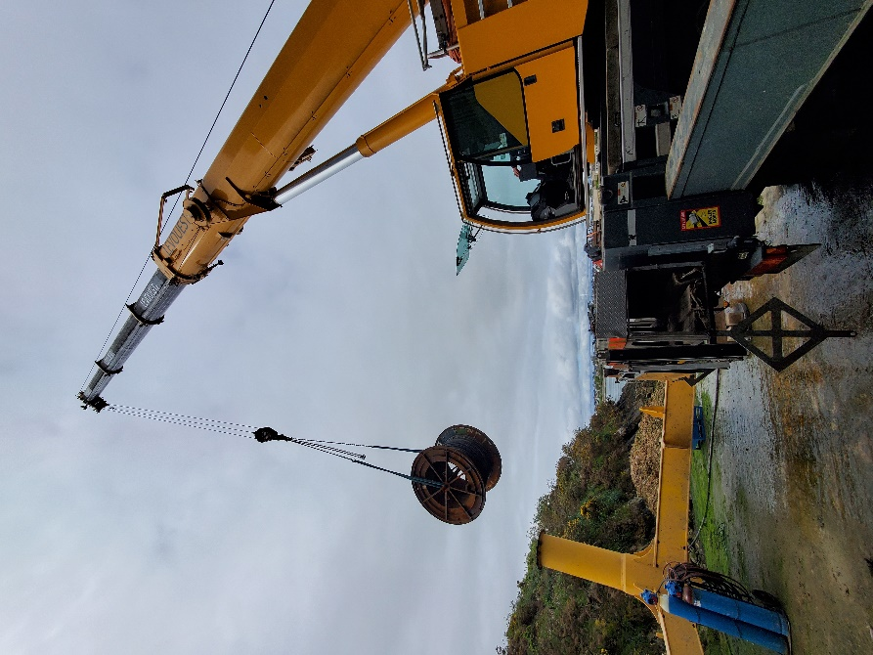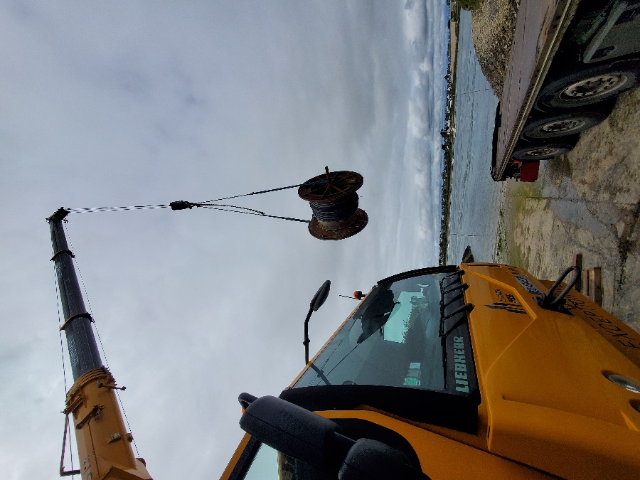
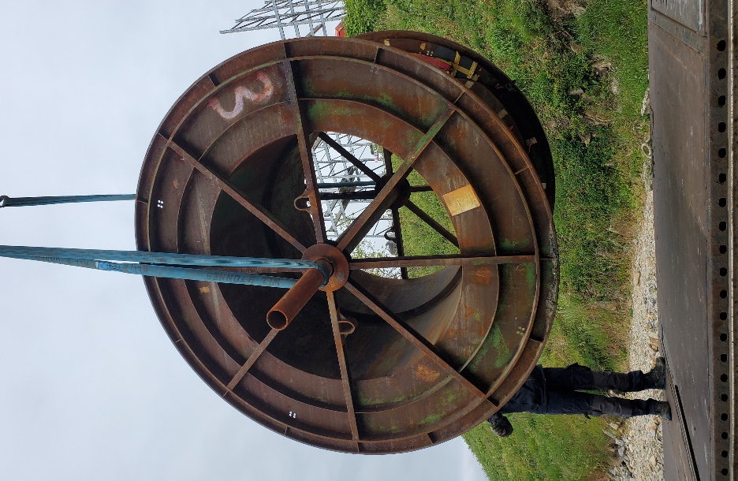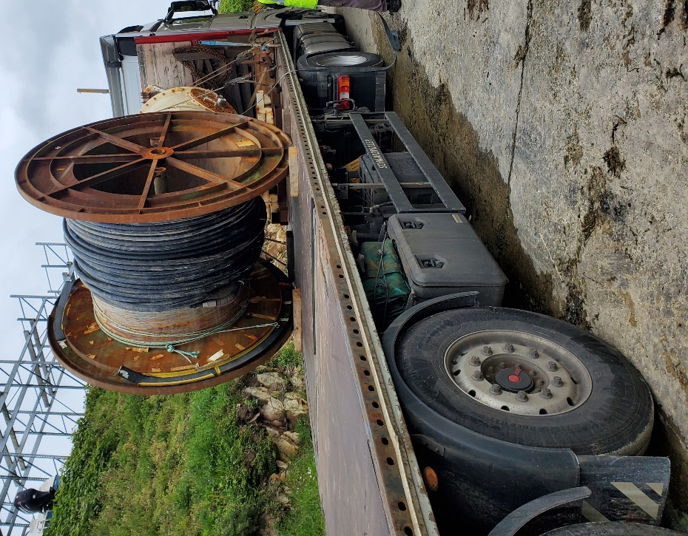
  - Figure 8: Moving the cable reel with the crane to the trailer

Packing the container

All smaller equipment was loaded into the onshore station container and secured to provide safe and weatherproof transport back to Scotland

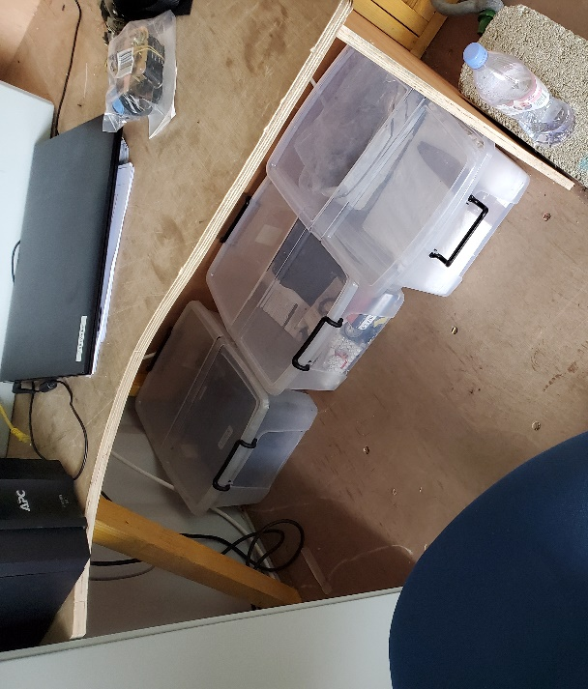
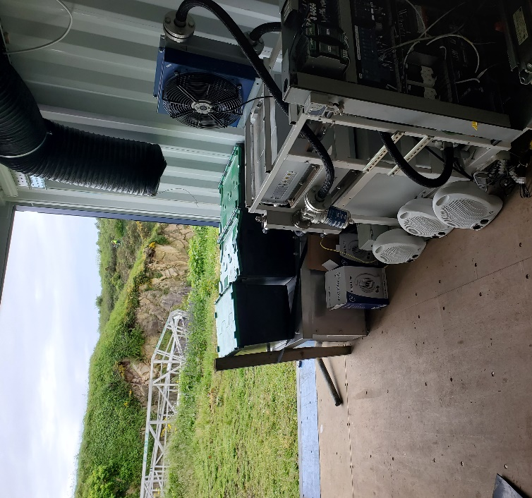

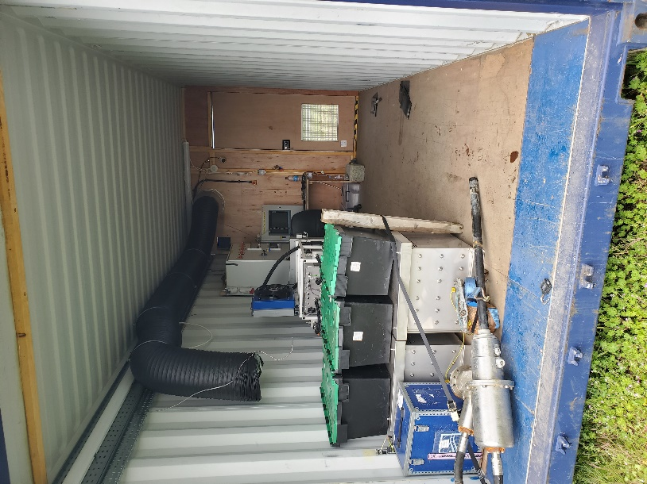
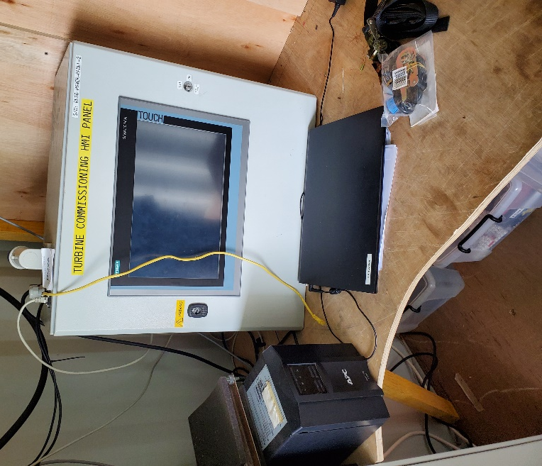
  - Figure 9: Location and storage of the different elements in the container before its departure

Once the rotor was removed from the turbine, it was loaded into the container.

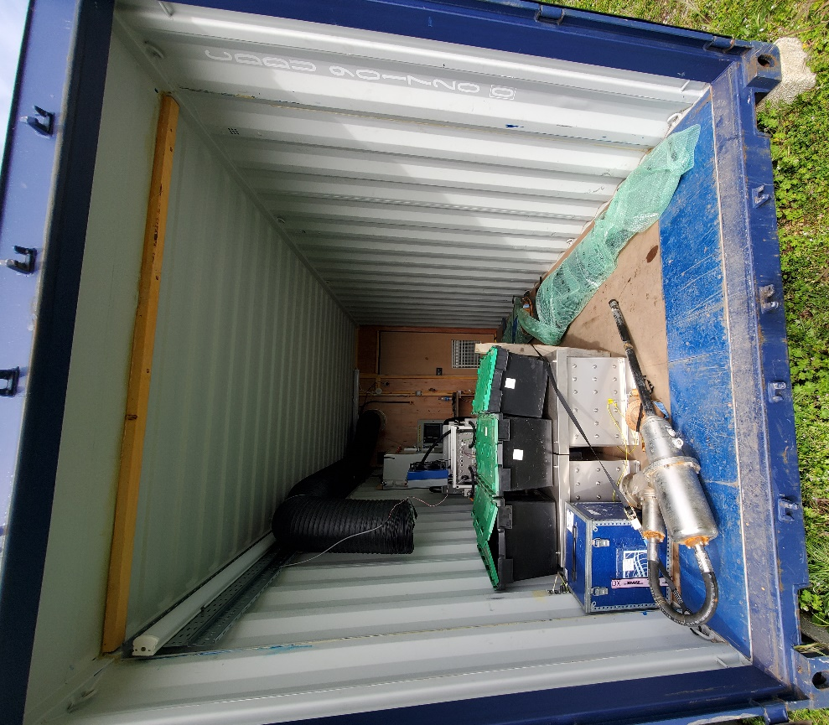
  - Figure 9: Fitting the blade into the container and securing the various components

Loading of the container onto the trailer

Once all the elements were stowed and strapped inside the container, the container was closed and lifted onto the trailer.
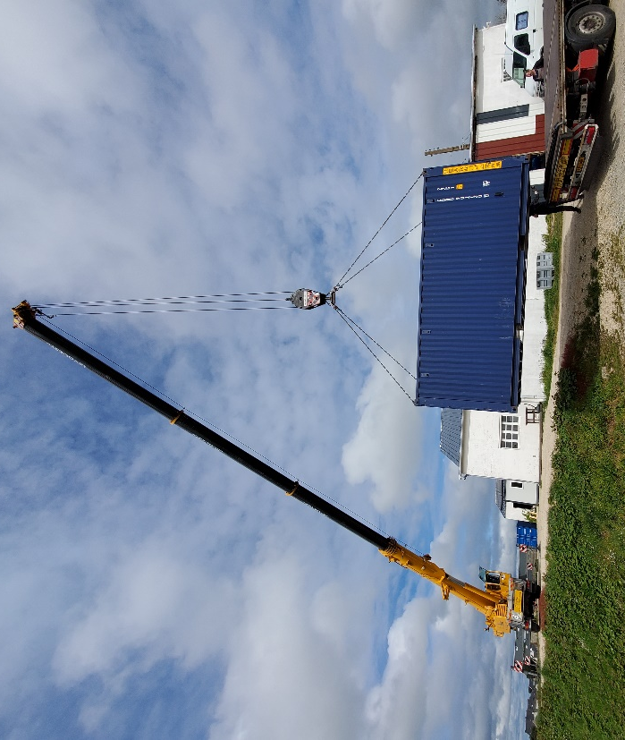
  - Figure 10: Moving the container with the crane to the trailer

Substructure

The substructure was removed from the site and is currently stored on CBS site.

  - Figure 11: Substructure before its destruction

Conclusion

The turbine and substructure, along with the ballast and subsea cable were all recovered from the water during the recovery operations as part of the test phase works. The site was successfully returned to its original state.

The turbine was then dismantled and prepared for transport back to Scotland. All the components (turbine, cable reel and container) were loaded onto the truck and left the CBS site.

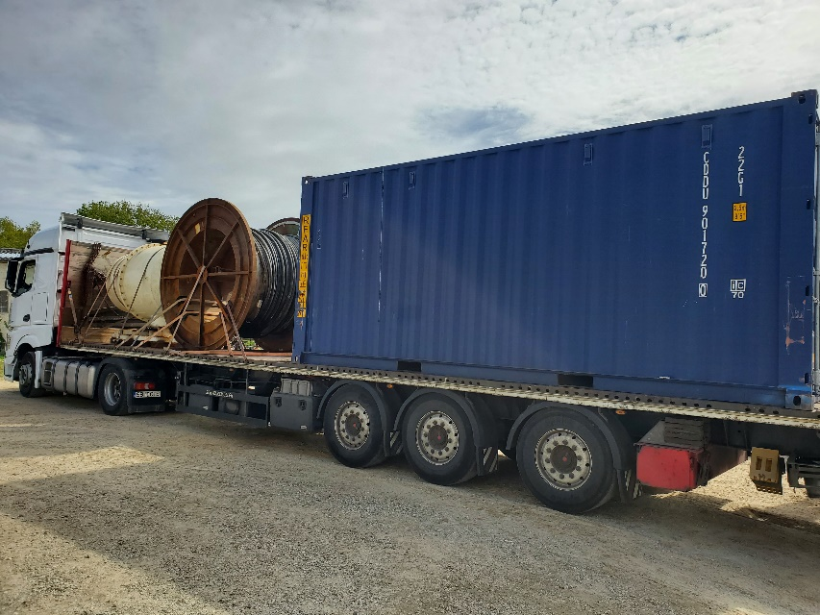
  - Figure 12: Trailer loaded for its departure to Scotland

This project has received funding from the European Union’s Horizon 2020 research and innovation programme under grant agreement number 815180.

Nova Innovation
45 Timber Bush
Edinburgh
EH6 6QH
T: +44 (0)131 241 2000
E: info@element-project.eu

