Date of Delivery: May 2023

PUBLIC – AVAILABLE FOR WIDESPREAD AND PUBLIC DISSEMINATION

ELEMENT: FINAL ENVIRONMENTAL REPORT
This project has received funding from the European Union’s Horizon 2020 research and innovation programme under grant agreement number 745862.
Document Details

Field | Detail
project title | Effective Lifetime Extension in the Marine Environment for Tidal Energy
Project acronym | ELEMENT
grant agreement | 815180
funding scheme | Research and Innovation
project duration | 48 months, from June 2019 to May 2023
Document Number | ELEMENT-EU-0038
report Title | Final Environmental Report
deliverable id and type | D4.3
dissemination level | Public – Available for widespread and public dissemination
author | Emma Araignous, Herveline Gaborieau
document version | 1.0
Status | Issued
reviewed by | Kate Smith
APPROVED BY | Gavin McPherson

Revision History

VERSION | STATUS | DATE OF ISSUE | AUTHORS | REVIEWER
0.1 | Draft | 25/05/2023 | Emma Araignous, Herveline Gaborieau | Kate Smith
1.0 | Issued | 31/05/2023 | Emma Araignous, Herveline Gaborieau | Kate Smith

TABLE OF CONTENTS
Executive summary 3
Abbreviations and acronyms 5
Context and objectives 6
Biofouling characterisation at Étel 7
What is biofouling and how to characterize it? 7
Objectives in the ELEMENT project 8
Set up of surveys 8
Difficulties encountered 9
Influence of hydrodynamics on biofouling 10
Spatio-temporal variation of biofouling general characteristics 11
Flow dynamics and turbulence in Étel River 15
Data analysis and methods 15
Results 19
Discussion 24
Conclusions 26
Collision Risk Model integration within the DTOceanPlus suite of tools 27
DTOceanPlus and the ESA module 27
Objective in the ELEMENT project 28
Collision Risk Model 28
Integration in DTOcean+ 31
Example of application 35
References 36
Supplementary material 43
Supplement 1 43
Supplement 2 68
This project has received funding from the European Union’s Horizon 2020 research and innovation programme under grant agreement number 815180. 70

Executive summary
A Funding Grant was awarded from the European Union’s Horizon 2020 (H2020) research and innovation programme to develop and validate an innovative tidal turbine control system, using the tidal turbine itself as a sensor, to deliver a step change improvement in the performance. This will demonstrate Effective Lifetime Extension in the Marine Environment for Tidal Energy (ELEMENT), driving the EU tidal energy sector to commercial reality.

This report summarises the environmental assessment performed during ELEMENT project. Particular attention was paid to the characterisation of the Étel test site with resources and flow turbulences evaluation as well as with measurement of the biofouling. The assessment of environmental impacts mostly focused on the inclusion of collision risk modelling in the environmental and social acceptance assessment module of DTOceanPlus suite of tools.

Biofouling surveys were performed at the Étel test site, to evaluate the influence of hydrodynamics/current on biofouling characteristics, foresee the potential of biocolonisation before deployment of the turbine, and understand the variability in the biocolonisation at fine spatial scale within the ria of Étel. Two surveys were set up in 2020 and 2021.

The highest species richness was observed for biofouling communities exposed to the strongest currents. Tubular hydroids (Ectopleura sp.) and their probable symbionts Endozoicomonas appeared dominant in the less dynamic site. Eukaryote assemblages were specifically shaped by shear stress, leading to metabolites profiles change. Under conditions of high hydrodynamics, the exopolymeric matrix increased and was composed of 6 times more polysaccharides than proteins, which play a crucial role in the adhesion and cohesion properties of the biofilm.

The biofouling observed over the 2.5 year study varied in terms of species composition and coverage. After 6 months of immersion, the biofouling community was dominated by algae, and notably laminarian of the genera Saccorhiza and Laminaria. After12 months, mussels dominated the community. And after 18 months, sponges, colonial ascidians, juveniles of mussels and algae co-occurred on the plates sampled. Biofouling thickness was greatest after 12 months, but was strongly dependent on the location of the measurement. After 6 months many laminarians had reached 91cm in length, but had disappeared from the plates in January 2022. This can be explained by the short life cycle of the dominant laminarian species Saccorhiza polyschides, which is annual (life-span < 10 months) and their rapid growth, that can reach 2 m a month in late spring. Mean biofouling density at the Étel test site varied between 934.8 and 1154.6 kg.m⁻³ after six to twelve months of immersion.

A 1000 kHz five-beam ADCP was deployed on the seafloor at 100 m depth in the Étel river to estimate the kinetic power density, which is commonly used for tidal-stream energy quantification, and turbulence metrics. Turbulence intensity, turbulence kinetic energy dissipation and production rates have been calculated. Investigations of the mean flow speed revealed that the flow dynamics is ebb-dominated with flow speed almost twice as high during ebb tide than during flood tide. This imbalance has a significant effect on the tidal-stream energy potential of the Étel estuary test site. On average, the kinetic power density associated with the ebbing stages of the tide is 7 times higher than that associated with the flooding stages of the tide. The hypothesis of local equilibrium between production and dissipation of turbulence kinetic energy, often observed in tidally forced systems has been evaluated. At mid-depth, a local production-dissipation balance is evidenced during the flooding stages of the tide, which is not the case during ebb tide. A major result of the study is the successful use of the Dewey and Stringer’s formulations for the calculation of the normal stresses. In particular, the efficiency of the formulation allowing the calculation of the Reynolds stress associated with the vertical flow direction was demonstrated.

Within DTOceanPlus project, a module of environmental and social acceptance assessment (ESA module) has been developed and integrated in the suite of tools. An objective of the ELEMENT project was to implement a fifth feature into DTOceanPlus allowing the assessment of collision risk between marine animals and tidal turbines. This was based on the ‘Band’ collision risk model (CRM) detailed in Scottish Natural Heritage (2016) guidance, with an example of application of the new feature using data from the EMEC tidal test site in Orkney (Band 2014). The ‘Band’ CRM estimates the number of passages through the rotor made by individuals of a given species over a period of assessment in which the rotor is operational. It is estimated based on the animal density and their diving frequency at the risk depth and takes into account the cross section of the turbine. The formula evaluates the possibility of an individual passing through the rotor without colliding and the indicator includes the probability of collision during a single transit. Four classes have been developed in the back-end of the tool to evaluate collision risk. The graphic user interface of DTOCeanPlus has been extended and a specific outputs page was added for the collision risk model outputs. The model was tested on data provided in the SNH guidance (2016) which is based on the assessment of potential collision risk for marine mammals and diving birds at the EMEC tidal test site on Orkney (Band 2014).
Acknowledgments
The ELEMENT project would like to thank GUINARD ENERGIES for their support and their help in the field. The authors of this report would like to thank Chantier Bretagne Sud for allowing the experimental manipulation to take place on their concession, as well as the colleagues who helped with biofouling survey devices and field work, and in particular Guillaume Damblans, Antoine Maison, Aurélie Portas, Maxime Thiébaut, and Rui Duarte from FEM, as well as Tangui Audern, Nicolas Ruiz and Magali Kerléo from Guinard Energies.

Abbreviations and acronyms

ACAS: Automated Collision Avoidance System
ADCP: Acoustic Doppler Current Profiler
ADV: Acoustic Doppler Velocimeter
CRM: Collision Risk Model
EMEC: European Marine Energy Centre
EnFAIT: Enabling Future Arrays in Tidal
ESA: Environmental and Social Acceptance
GUI: Graphical User Interface
MRE: Marine Renewable Energy
STA: Shetland Tidal Array

Context and objectives
The innovative control system developed through the ELEMENT project has been evaluated at two different test sites, Bluemull Sound and Étel, both located in western Europe (Figure 1). The Bluemull Sound is located in Shetland, in northern Scotland, between the islands of Unst and Yell. The Étel test site is located in southern Brittany, Western France. Figure 1 shows the location of the Bluemull and the Étel test sites. Both test sites show very different characteristics regarding physical and ecological environment. The ELEMENT project will provide data analysis and models for these sites representative of two different marketplaces and evaluate the behaviour of the new developed control system in these different environmental conditions.

The ELEMENT project has been running for four years and a test turbine was installed at Étel at the beginning of 2023. This document provides information to ELEMENT partners for challenging the test system, platform and operations for the Étel test phases and the future uses/installations of tidal turbines.

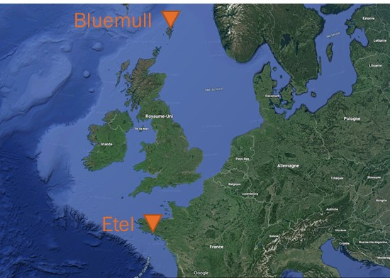
Figure 1 - Location of the two study sites where Nova Innovation tidal turbines are currently deployed (Bluemull) and were deployed in this project (Étel).
WP4 of ELEMENT project was dedicated to environmental assessment with two main parts: the characterisation of test sites and the assessment of environmental impacts. Particular attention was paid to the characterisation of Étel test site with resources and flow turbulences evaluation as well as with measurement of the biofouling. One of the main objectives was to evaluate the influence of hydrodynamics/current on biofouling characteristics in order to include it in the control model of the turbine. A key objective of the assessment of environmental impacts was to further develop the DTO+ suite of tools with the inclusion of collision risk model.

Biofouling characterisation at Étel

What is biofouling and how to characterize it?
Biofouling, and more specifically marine biofouling, is the result of a biological process (known as biocolonisation, Wahl 1989), which involves the development of living organisms on an object or any support that is introduced into the sea. The biocolonisation is a type of ecological succession, which can be defined as a gradual change in the species composition of an ecosystem from initial colonisation through sequential phases to reach dynamic equilibrium (i.e., the climax; Figure 2) (Noël et al. 2009).

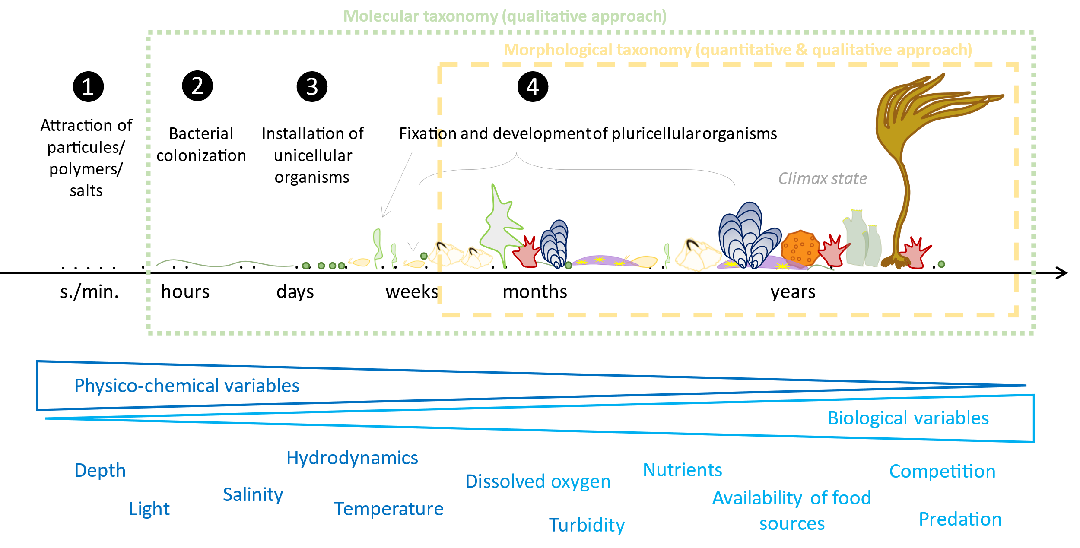
Figure 2. Representation of the biocolonisation process and the influence of environmental variables (from Quillien et al. 2018). For this report, this scheme also shows the biofouling organisms that are targeted depending on the taxonomic approach (molecular and morphological, dashed green and yellow lines) and which kind of data that can be gathered (qualitative = species composition of the biofouling community; quantitative = abundance and biomass of the species composing the biofouling community).

According to the model of Wahl (1989), the biocolonisation process can be divided into four main phases (Figure 2). Macromolecules (e.g., proteins, sugars, humic acids, mineral maters) are spontaneously attracted to the structure’s surface by adsorption almost instantly after the support is immersed in sea water (Figure 2, phase 1). Within the following minutes and hours, a bacterial film develops (Figure 2, phase 2). Several days after immersion, groups of unicellular organisms, mainly composed of diatoms, attach to the substrate by secreting mucus (Figure 2, phase 3). Finally, after several days or weeks, the first pluricellular organisms colonize the structure’s surface in the form of larvae and sporelings, which develop and grow (Figure 2, phase 4) until they reach a climax (i.e., the dynamic state of equilibrium of the succession). It is important to note that this equilibrium is relative: a climax is a state which varies over time and space according to environmental conditions (which vary on a seasonal basis and are locally modified by colonizing organisms) and various mechanisms, such as competition. According to several studies, the climax of biofouling communities is reached in more or less 10 years (Whomersley and Picken 2003; Degraer et al. 2020; Taormina et al. 2020).

Different approaches can be chosen for biofouling characterisation. In the frame of the ELEMENT project, and with the help of the ABIOP+ project, morphological and molecular analyses of biofouling have been carried out on the samples gathered at Étel test site. Morphological analyses focused on macro-fouling organisms (i.e., organisms bigger than 1mm) while molecular tools (V7 region of the 18S rDNA gene and mitochondrial cytochrome c oxidase I markers) used for the metabarcoding approach to encompass micro-fouling organisms, such as diatoms or invertebrate larvae (Figure 1, yellow and green dashed line rectangles).

Objectives in the ELEMENT project

The aims of the biofouling survey at the Étel test site, are to:
- Measure the influence of hydrodynamics/current on biofouling characteristics,
- Foresee the potential of biocolonisation where the turbine will be deployed,
- Understand the variability in the biocolonisation at fine spatial scale (<100m) within the Étel river.

Set up of surveys
Two surveys were conducted between 2020 and 2021 to overcome difficulties encountered in the field. The first survey included 3 sites (A, B and C, see Figure 3) and was conducted from October to November 2020, until A & B buoys formed a navigation danger because they were sinking during spring tides. The second survey started in January 2021 and included 3 sites (A_{bis}, B_{bis} and C, see Figure 3).

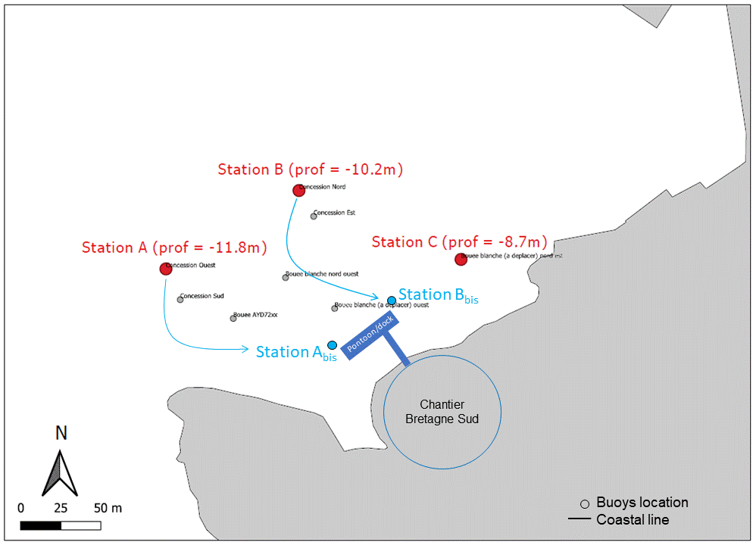 | 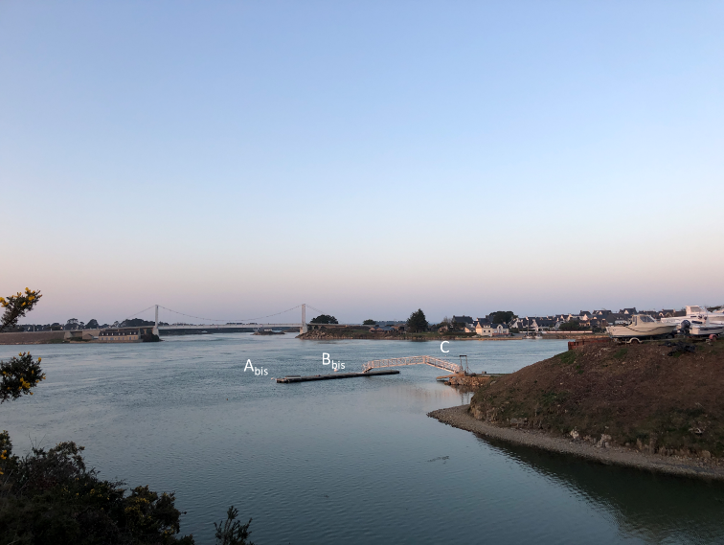

Figure 3. Left: location of the buoys (stations A, B, C, Abis, and Bbis) used during the project to survey the biocolonisation process and right: view of the three sites surveyed between January 2021 and July 2022.
At each site, panels made in a neutral material (PVC) were deployed using frames ordered by FEM from CBS (Figure 4) adapted to buoy moorings. More specifically, for the first survey, 18 A4 format panels were set at sites A, B and C and surveyed for a month. During the second survey, 18 A4 panels were set at sites A_{bis}, B_{bis} and C for 18 months.

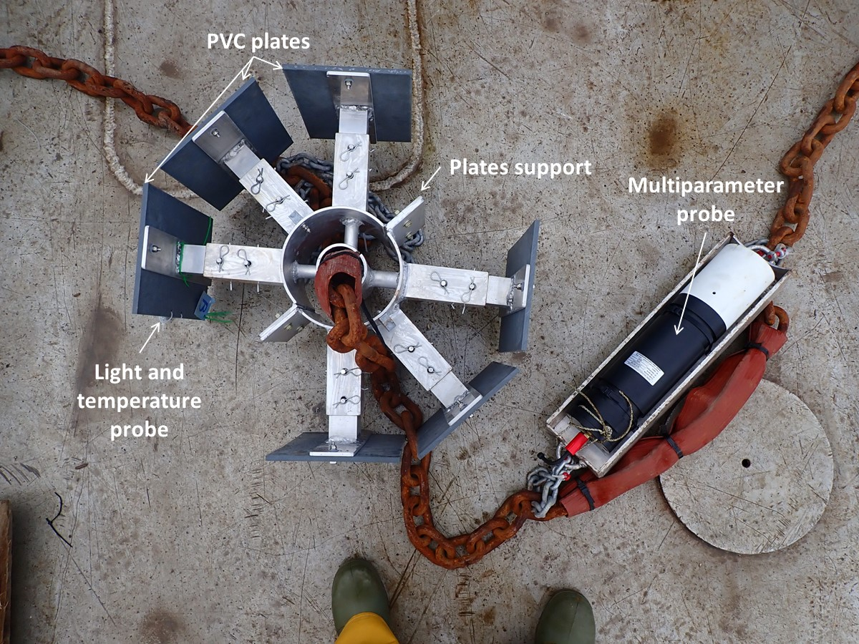
Figure 4. The deployment device for the plates and the probes.

Plate sampling enabled the measurement of several general variables (weight/biomass, thickness, and biovolume); chemical and taxonomical characterisation of the biofouling was possible for the first survey only. Interpretation of biocolonisation data was performed considering other available environmental variables, including data previously gathered at Étel test site and current data that was gathered within the project.

Difficulties encountered
During the project, and since the start of WP4 in September 2019, several difficulties were encountered that slowed and sometimes prevented data acquisition. These affected different steps of the biofouling survey: site selection, the design and conception of the deployment frames, damage or loss of material, delays in morphological taxonomic assessment. They are summarised in Table 1.

Table 1. Difficulties encountered during the biofouling characterisation at Étel test site.
Pitfall | Date | Consequences
Confidentiality of existing environmental data | Fall 2019 | Delay in finding the good geographical positions for ADCP and plates deployment
Hard to find information and solutions to deploy ADCP | Beginning of 2020 | Delay in deployment
Pre-design of plate support frames from scratch by FEM and discussion with CBS | Spring 2020
Choice of sampling sites | Spring 2020 | Delay in the beginning of the survey
Lock-down due to COVID-19 | Spring 2020
Lack of raw material for plates support construction | Summer 2020
Sinking of the A and B buoys | Fall 2020 | Premature end of the survey (1 month after deployment)
Loss of the multiparameter probe | Fall 2020 | Lack of environmental variables in data set
Finding two other sampling sites | Winter 2020 | Delay in the beginning of the new survey
Friction between the pontoon mooring and the A_{bis} plate | 2021-2022 | Data gathered at the A_{bis} site shall be taken with caution
Loss of buoy C | Summer 2022 | Lack of 6 plates at site C and consequently lack of data to discuss biofouling dynamics in Étel
Loss of plates in A_{bis} | Summer 2022 | Lack of one plate of 1.5-year-old biofouling and consequently lack of data to discuss biofouling dynamics in Étel
The lab in charge of taxonomic identification was too busy in Summer and Fall 2022 | Fall 2022 | Limited analysis in this report on species composition for the second deployment.
Despite these difficulties, we were able to investigate the influence of hydrodynamics on the first stage of biocolonisation in an exhaustive way (different methods used to characterize the components of biofouling) and measured the biofouling overall characteristics after one year and a half of immersion.

Influence of hydrodynamics on biofouling
The effects of variable sheer stress and current strength on the biofouling community structure and other biofouling components (proteins, exopolymerase substances) within the Étel river formed an article that is under review in FEMS Microbiology Ecology, presented in Supplement 1.

The main results are that the highest prokaryote and eukaryote species richness was observed for biofouling communities exposed to the strongest currents. Ectopleura sp. (Cnidaria) and their probable symbionts Endozoicomonas (Gammaproteobacteria) were dominant in the less dynamic site. Eukaryote assemblages were specifically shaped by shear stress, leading to metabolites profiles change. Under conditions of high hydrodynamic stress (currents), the exopolymeric matrix increased and was composed of 6 times more polysaccharides than proteins, which play a crucial role in the adhesion and cohesion properties of the biofilm. Results are more broadly summed up in the conceptual scheme below (Figure 5).

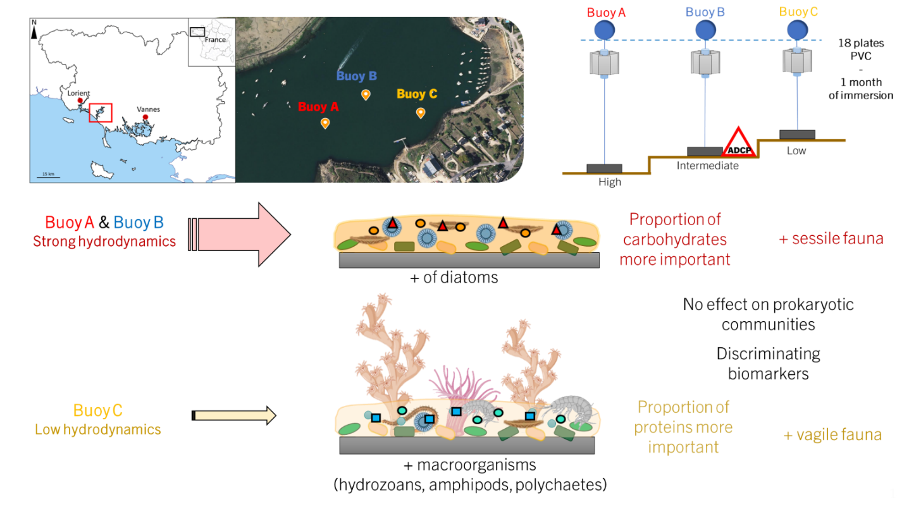
Figure 5. Conceptual scheme showing the changes occurring in eucaryote and procaryote communities, as well as EPS matrix and metabolites, under contrasted shear stresses in the Étel river.

Spatio-temporal variation of biofouling general characteristics
The biofouling observed varied with time. in terms of species composition (based on species observed in the field, with detailed taxonomic composition available later in 2023) and coverage (Figure 6). After 6 months of immersion, the biofouling communities at all sites were dominated by algae, and notably laminarian of the genera Saccorhiza and Laminaria. After 12 months, blue mussel (Mytilus edulis) dominated. After 18 months, sponges, colonial ascidians, juveniles of mussels and algae co-occurred on the plates sampled.

 | 6 months | 12 months | 18 months
Abis | 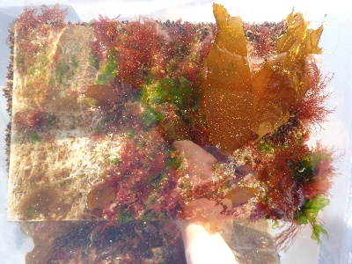 | 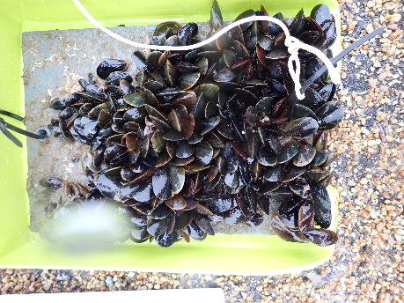 | 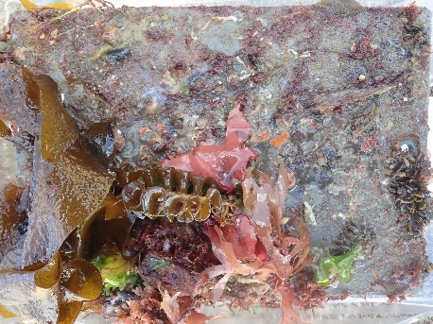
Bbis | 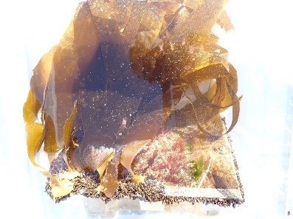 | 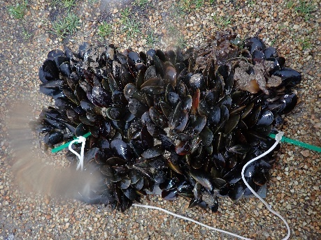 | 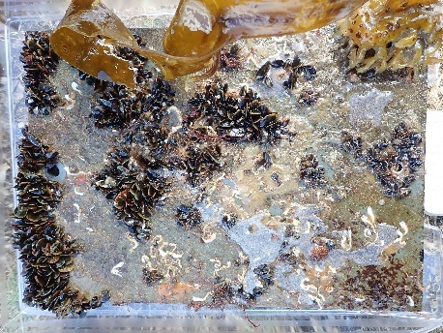
C |  | 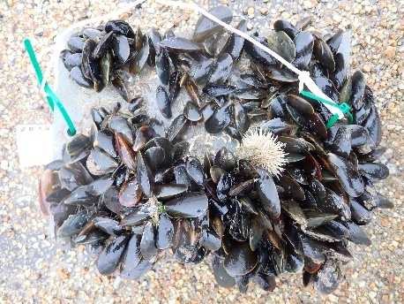 | Lost plates
Figure 6. Images showing one of two plates sampled at each sampling occasion (at three sites and three dates). Images of plates for the C site after 18 months are not shown because the buoy supporting the plates was lost.
Plates deployed at the A_{bis} site showed some damage due to friction with the pontoon mooring. Otherwise, there are no clear and visible differences between samples. The detailed analysis of the biofouling community structure of each sample enables rigorous testing for differences across samples.

In terms of thickness variations, biofouling thickness was generally highest after 12 months of immersion at the three sites with median thicknesses of 3, 6 and 4.5 for sites A, B and C respectively. (Figure 7). The lowest mean thickness was 0.71cm and was observed at B_{bis} after 18 months. At 6 and 12 months, the biofouling thickness at A_{bis} was lower compared to the other two sites, probably due to the friction with the pontoon mooring.
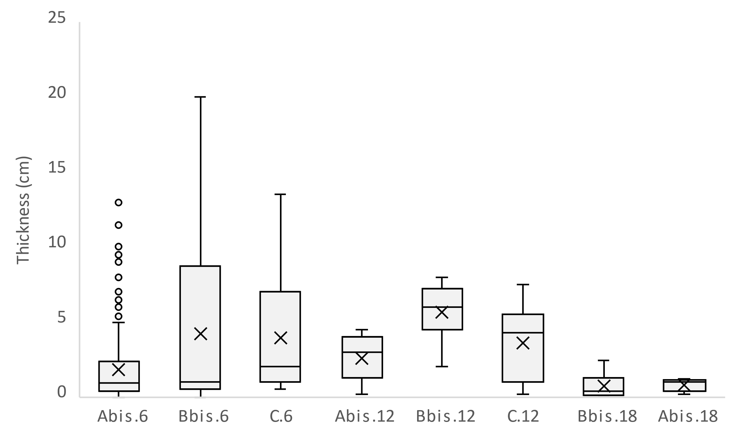
Figure 7. Thickness median (middle line in boxes), mean value (cross in boxes), 3rd and 1st quartiles (upper and lower part of boxes, respectively), minimal and maximal values (whiskers) and extreme values (dots) across the different sites studied (Abis, Bbis and C) showing biofouling of different ages (6, 12 and 18 months).

Across the three sites, thickness increased slightly from 6 to 12 months. The thickness of biofouling at B_{bis} was higher than at C and A_{bis} at 6 and 12 months. The thickness of biofouling mainly encompassed species that are not flexible, so the length of the most flexible organisms that developed on the plates was also measured, in particular algae (Table 2). In July 2021, 6 months after the immersion of the plates at A_{bis}, B_{bis} and C, many laminarians (kelp) were observed (Figure 8), with a maximum measured length of 91cm. The presence of these algae probably influenced the biomass in water of biofouling as algae are slightly buoyant.

Table 2. Length of the main species or group of species of algae that developed on the plates sampled in July 2021.
Species | Length (cm)
 | min | max | moy | SD
Saccorhiza polyschides | 5 | 91 | 25,2 | 30,2
Saccharina latissima | - | - | 52 | -
Laminaria sp. | 38 | 79 | 57,8 | 20,5
Ulva sp. | 1,5 | 10,5 | 6,6 | 3,1
Red algae | 2 | 20,5 | 8,9 | 4,5

We also observed that kelp was absent from the plates in January 2022. This can be explained by the short life cycle of the dominant species Saccorhiza polyschides, which is annual (life-span < 10 months). S. polyschides are present in the form of large algae (up to 10m long for the largest individuals – not observed in Étel though) from spring until winter. In autumn this species starts fruiting and then to decay, leaving behind the bulbous holdfasts, which remains until being washed off in late winter. The growth of S. polyschides is very fast, it may growth 2 m a month at the peak of the growth season in late spring (Norton and Burrows 1969).

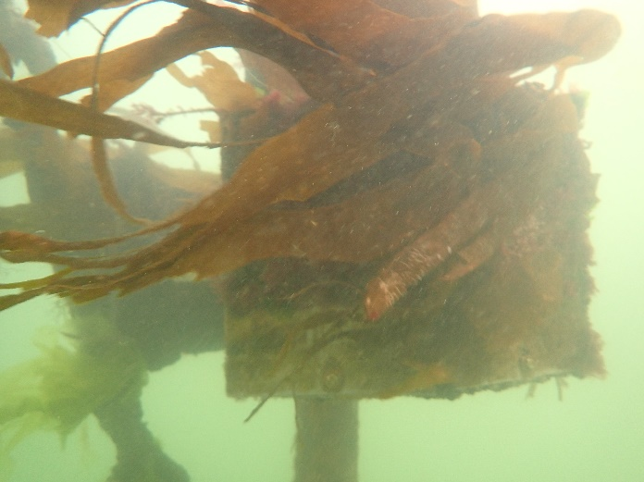 | 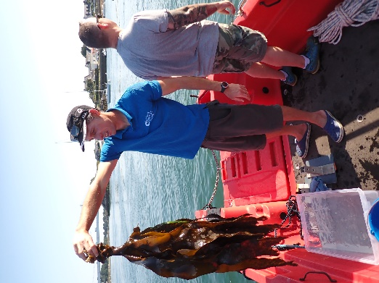
Figure 8. Saccorhiza polychides observed in July 2021 at Étel test site

Biofouling biomass varied (Figure 9) over time. The highest mean biomass was measured in January 2022 (after 12 months of immersion, B_{in air} = 19.1 ± 6.7 kg.m⁻²; B_{in water} = 2489.0 ± 947.1 g.m⁻²). The lowest mean biomass was found in July 2022 (after 18 months, B_{in air} = 3.8 ± 0.6 kg.m⁻²; B_{in water} = 301.9 ± 84.6 g.m⁻²), but we missed three measurements due to the loss of devices before the sampling. After 6 months, the values were intermediate (B_{in air} = 9.2 kg.m⁻² ± 2.8; B_{in water} = 398.2 ± 334.2 g.m⁻²). We also observed variation within each the B_{bis} station, where biomass (both in air and water) showed very different values at the first two sampling occasions A_{bis} and C stations showed less in-site variation. A_{bis} showed low biomass values in July 2021 and January 2022, probably due to the friction of the plates with the pontoon mooring.

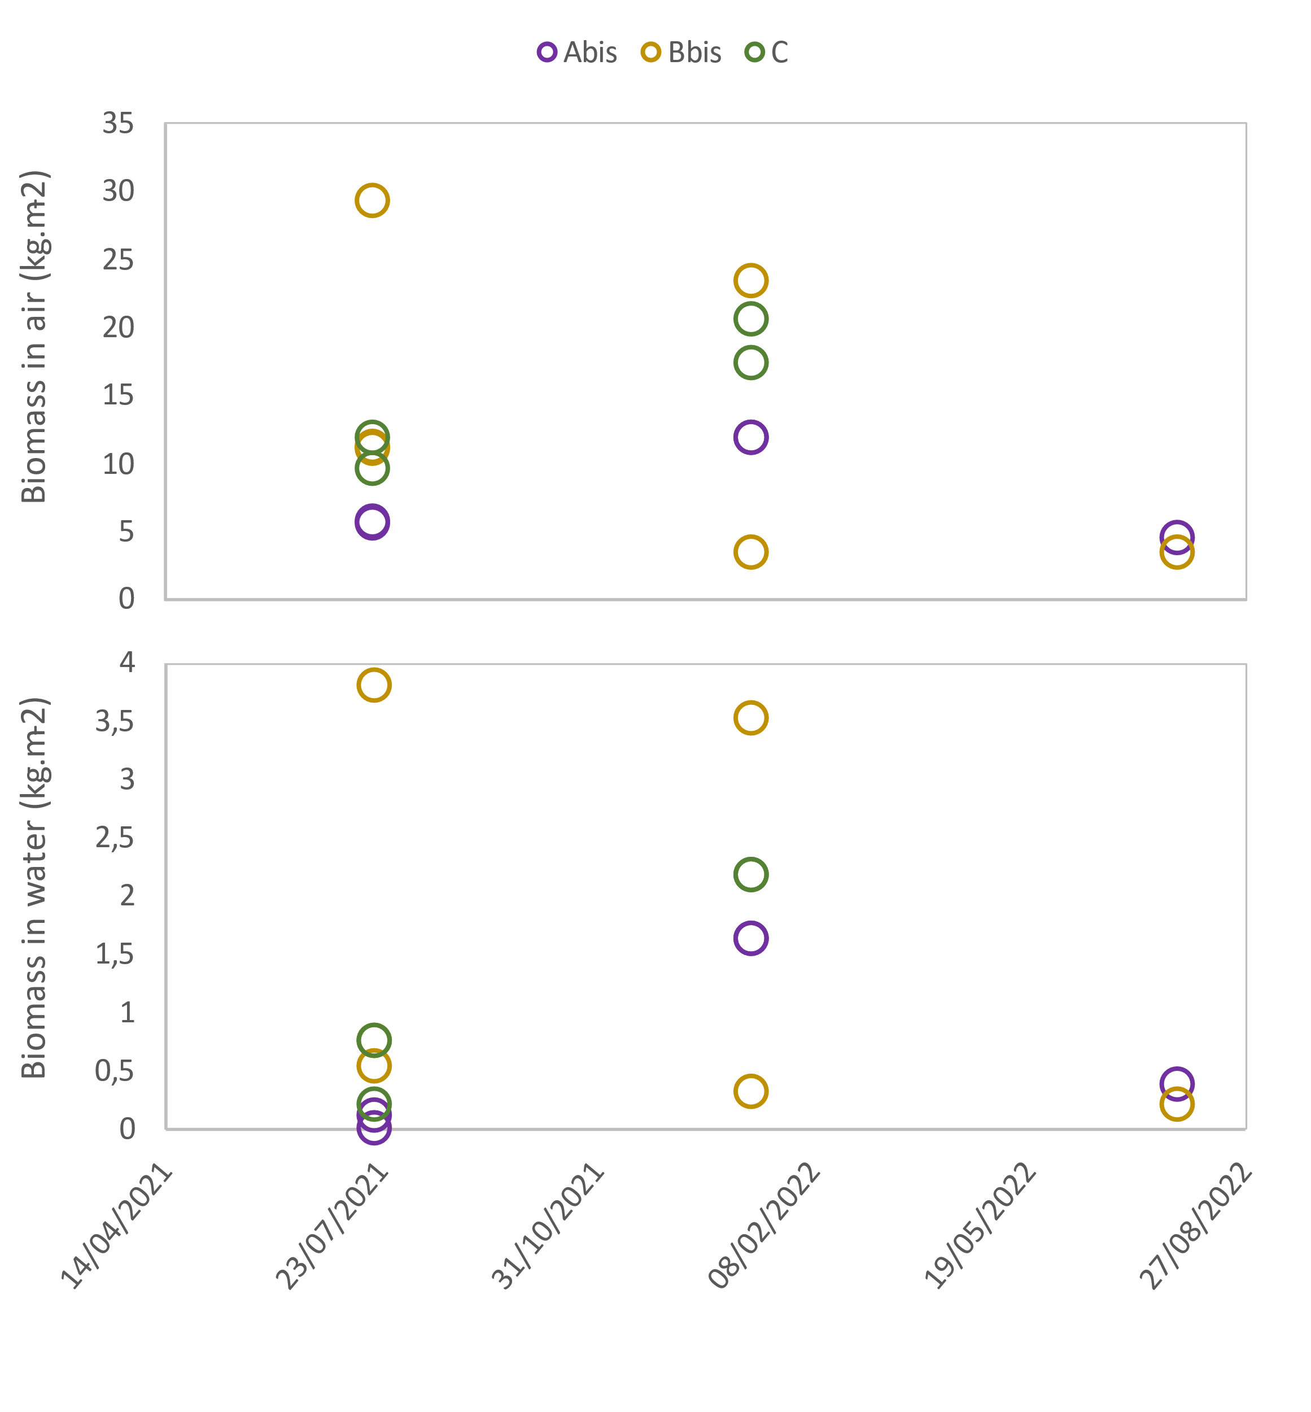
Figure 9. Biomass (kg.m⁻²), measured both in air and in water, variations across the different sites and sampling occasions.
Engineers use biofouling density in their models, so the mean biofouling density (in kg.m⁻³) was calculated based on the biomass and biovolume data gained in the field (Table 3). Density values ranged from 635.1 to 2063.3 kg.m⁻³. Samples at the last sampling occasion (+18 months) were missed, and samples at A_{bis} were not fully representative due to the friction issue. Based on the samples that were available, biofouling density at the Étel test site varied between 934.8 and 1154.6 kg.m⁻³ after 6 to 12 months of immersion.

Table 3. Biofouling density (kg.m⁻³) across the three sites and sampling occasions.
Sites | Biofouling age (months) and density (kg.m⁻³)
 | 6 | 12 | 18
A_{bis} | 2063.3 | 812.2 | 756.3
B_{bis} | 934.8 | 958.5 | 635.1
C | 999.0 | 1154.6 | -

Flow dynamics and turbulence in Étel River
This section has been published in a peer-review journal and can be cited as: Thiébaut, M., Quillien, N., Maison, A., Gaborieau, H., Ruiz, N., MacKenzie, S., ... & Filipot, J. F. (2022). Investigating the flow dynamics and turbulence at a tidal-stream energy site in a highly energetic estuary. Renewable Energy, 195, 252-262.

Data analysis and methods

Experimental settings
An upward-looking Nortek Signature 1000 kHz five-beam ADCP was deployed on the seafloor approximately 100 m off the Chantier Bretagne Sud (CBS) facilities, in the Étel estuary (Figure 10). The Nortek Signature was installed in the middle of the river where results of a two-dimensional model (not shown) have revealed the highest current magnitude. The instrument was mounted on an aluminium tripod manufactured by Nortek (Figure 11b). A 2.5 tons concrete mooring was specifically installed on the seafloor for the experiment (Figure 11c). The tripod was connected to the concrete mooring by an 8 cm width chain and deployed 10 m away. The Nortek Signature location was signalled on the water surface by a buoy (Figure 11a) installed above the concrete mooring.

The Nortek Signature was powered by two 18 V - 540 Wh alkaline batteries stored in an external canister. The Nortek Signature collected data over a 27-day period, from 13 October to 10 November 2020, near the autumn equinox. Thus, maximum velocities at site are expected to be captured. The instrument was set to record continuously the along-beam velocities at the pinging rate of 8 Hz. Velocities were recorded with 0.8 m vertical resolution (bin size), starting 1.5 m from the seafloor (centre of the first bin). The average standard deviation of the attitude parameters (heading, pitch and roll) of the Nortek Signature were found to be lower than 0.7°, indicating that the tripod remained stable throughout the deployment.

The Étel estuary test site
The mean depth and the river width at Étel estuary test site are approximately 16 m and 280 m respectively. The flow regime in the estuary is essentially governed by tides of semi-diurnal period with a slight fortnightly modulation. At the test site location, the sea surface height (SSH) varies between 13.5 m and 17.5 m providing a mean tidal range of 4 m (Figure 12). Peak flood and ebb tidal velocities occur at high and low water levels respectively with slack water at mid-tide. The tidal current dynamics is thus referred to as progressive wave system. The weather conditions were calm during the 27-day long deployment period, with low wind and insignificant maximum wave height (< 0.3 m).

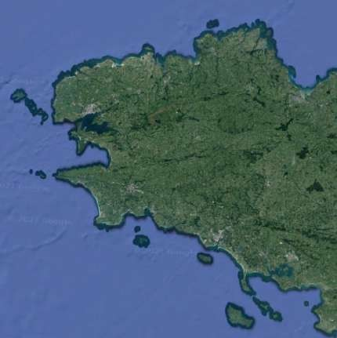
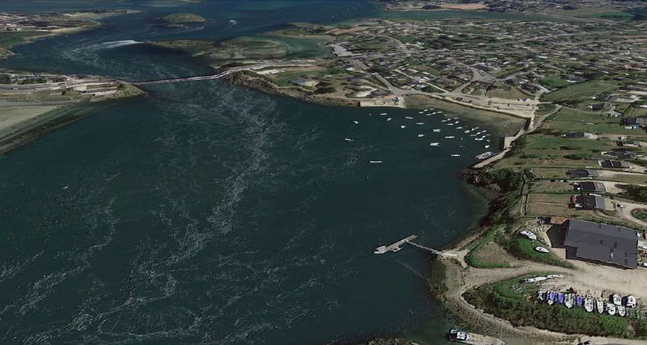
The Étel estuary test site has been used previously by Guinard Energies Nouvelles to test and validate its tidal turbines. Last campaign tests were done to validate the 20kW P154 hydrokinetic turbine from February to May 2020. In the frame of the H2020 ELEMENT project, Nova Innovation, a Scottish tidal energy technology developer, will conduct different test phases of its RE50 tidal turbine at this test site. The characterisation of the Étel estuary test site, presented in this paper, is the first step prior to the turbine installation.
Figure 10. (a) Brittany with the location of the Etel estuary (white square). (b) Etel estuary test site with the location of the Nortek Signature (white cross) deployment site, CBS facilities and the Lorois bridge.
CBS
Brittany

Etel Estuary
a

b
Lorois
bridge
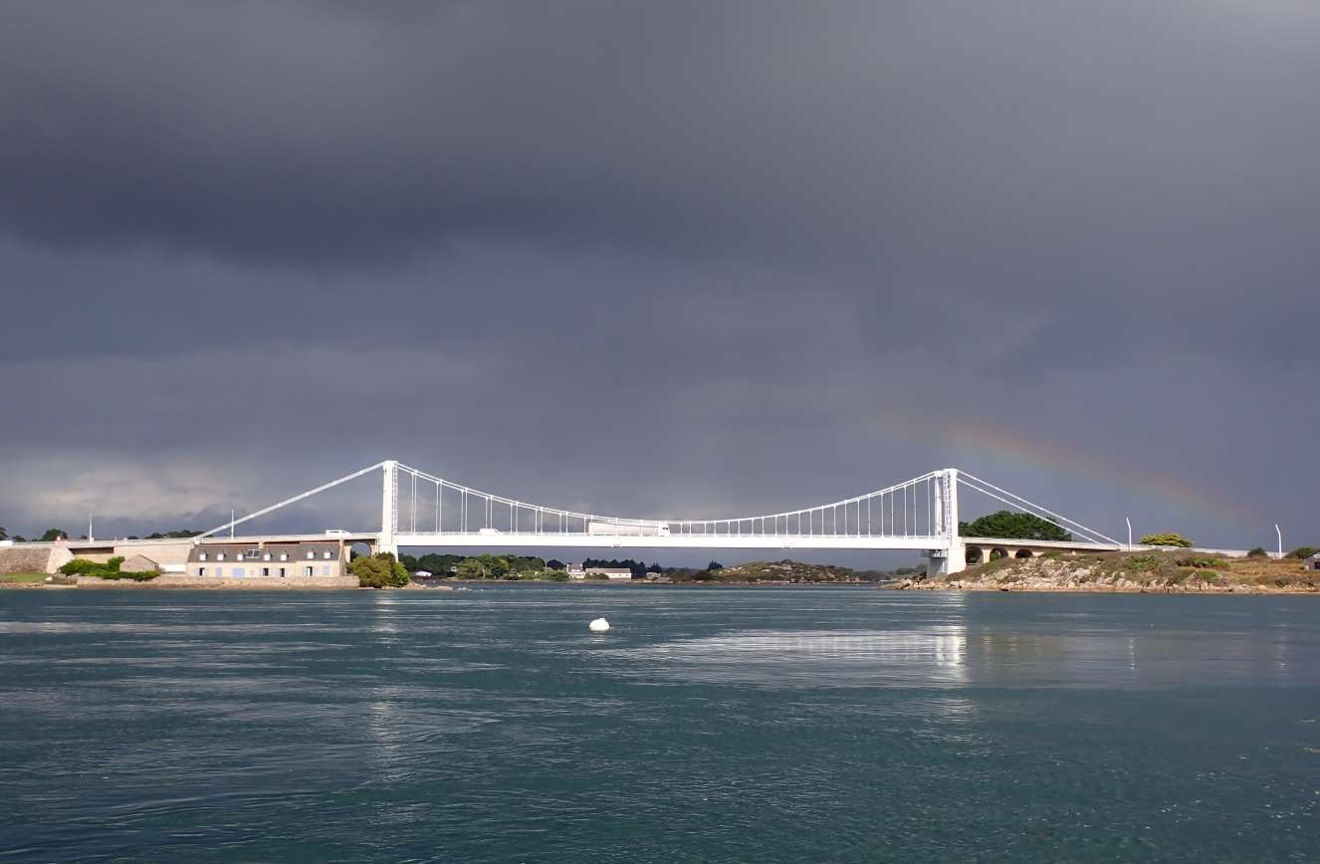
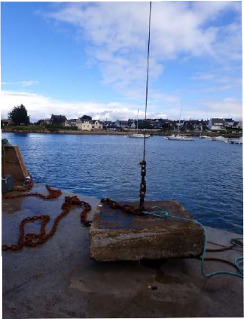
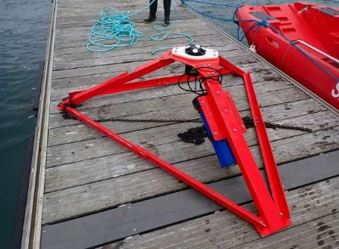
b
a

Figure 11. (a) Photograph of the Étel estuary test site with the Lorois Bridge in the background. The White surface buoy signals the location of the bottom-mounted Nortek Signature. (b) The Nortek Signature mounted on an aluminium tripod prior to its deployment in the Étel estuary. (c) 2.5 ton concrete mooring used to secure the tripod. The concrete mooring and the tripod were connected by a 10 m long, 8 cm width chain.
Note that the location of the test site is not the most energetic site of the estuary. Outside the test site, near the Lorois bridge (Figure 10b and 11a), the flow speed reaches 4 m/s. The location of the test site has been selected to offer a trade-off between flow speeds sufficiently high to validate the operation of the tidal turbines, installation constraints and reasonable cost for validation tests (risks and co-activities have also been considered).

Kinetic power density and turbulence metrics
The 27-day recording period was divided into 3981 subsets of 10 minutes each. Hereafter, an overbar is used to represent a temporal average over each subset. The 10 minutes duration is of sufficient length to provide a good sample of the largest turbulent eddies, but not so long that the turbulent processes cannot be regarded as quasi-stationary. For the purposes of this paper, the analysis focuses on the measurements at mid-depth, which is chosen to be ∼ 8.5 meter above bottom. The kinetic power density and turbulence metrics were computed at three successive bins (from bin 9 to 11) and averaged within a vertical interval of 2.4 m to give the mean value at mid-depth. Metrics associated with the flooding and ebbing stages of the tide were gathered into two distinct groups and compared. A total of 52 flooding and 53 ebbing stages were recorded throughout the 27-day period.

Kinetic power density
The theoretical kinetic power density, $P$, is commonly used for tidal-stream energy quantification. For an individual turbine, the theoretical kinetic power density available is computed as a cube of the flow speed, $U$:

Where $ρ$ is the seawater density and $U= \sqrt{u^{2}+v^{2}}$. Accounting for the size and efficiency of a particular turbine, the equation above can be modified by multiplying (1) by the turbine area A and power coefficient, C_{p}. However, the power coefficient is often made confidential by turbines designers, and it is thus not addressed in this paper.

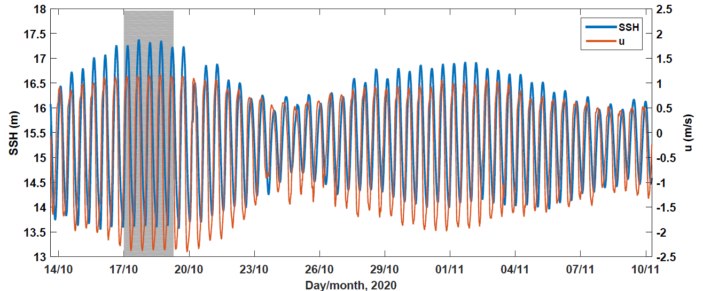
Figure 12. Time series of the sea surface height and mid-depth along-shore (streamwise) velocity u. The grey region shows the 55-hour long period chosen for a specific analysis (Figure 17).

Variance method
The variance of the along-beam velocity, $\hat{b_{i}^{'}}$, recorded by a Nortek Signature along the i-th beam is the sum of the true turbulent velocity, $b_{i}^{'}$, and an error, $n_{i}^{2}$, associated with Doppler noise such that:
$n_{i}$ is regularly approximated as Gaussian white noise (e.g., Thiébaut et al., 2020a, Guerra and Thomson 2020, Thomson et al., 2012, Richard et al., 2013, Durgesh et al., 2014, McMillan and Hay, 2017; Thiébaut et al., 2020b), with a constant spectral density, $N_{i}$, and a variance, $n^{2}$, such that:
i
Where $f_{N}$ is the Nyquist frequency.
The variance method applied on the five beams of the Nortek Signature ensures the estimation of five (out of six) components of the Reynolds stress tensor R (Eq. 4). Only the horizontal shear, $\overline{u'v'}$, remains unknown.
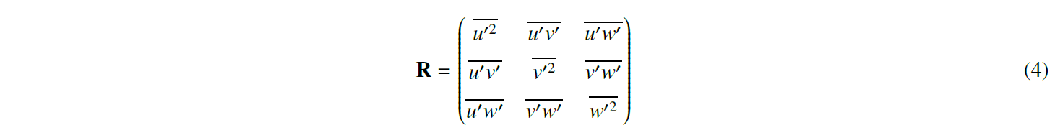

The mathematical expressions of the normal stresses, $\overline{{u'}^{2}}$, $\overline{{v'}^{2}}$, $\overline{{w'}^{2}}$, recently used in Guerra and Thomson (2017), are given by the Dewey and Stringer’s formulations (in instrument coordinates of the Nortek Signature) (Dewey and Stringer, 2007):

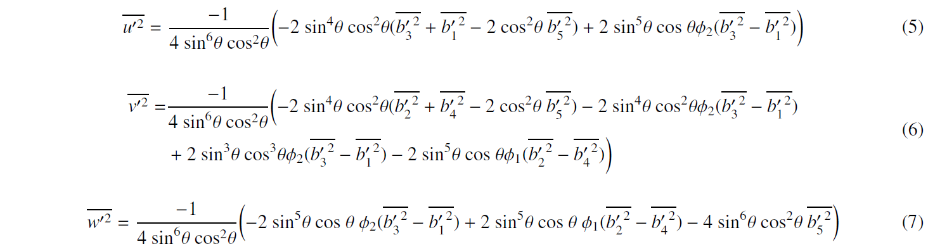

Where θ = 25° is the beam inclination angle of the Nortek Signature $\overline{{b_{i}^{'}}^{2}}= \overline{{\hat{b_{i}^{'}}}^{2}}- n_{i}^{2}$ and $ϕ_{1}$and $ϕ_{2}$ correspond to Dewey and Stringer’s pitch and roll. For the Nortek Signature coordinate system, $ϕ_{1}$ corresponds to roll and $ϕ_{2}$ corresponds to negative pitch (Guerra and Thomson, 2017).

The full formulation of the shear stresses, $\overline{u^{'}w^{'}}$ and, $\overline{v^{'}w^{'}}$ can be found in Dewey and Stringer (2007). These formulations can be simplified to give the mathematical expressions of $\overline{u^{'}w^{'}}$ and, $\overline{v^{'}w^{'}}$ employed for more than three decades (e.g., Lohrmann et al., 1990; Lu and Lueck, 1999a; Lu and Lueck, 1999b, Rippeth et al., 2002; Korotenko et al., 2013; Stacey et al., 1999; Whipple et al., 2006; Wiles et al.; 2006). According to the beam configuration of the Nortek Signature, the mathematical expressions of the shear stresses are given by:
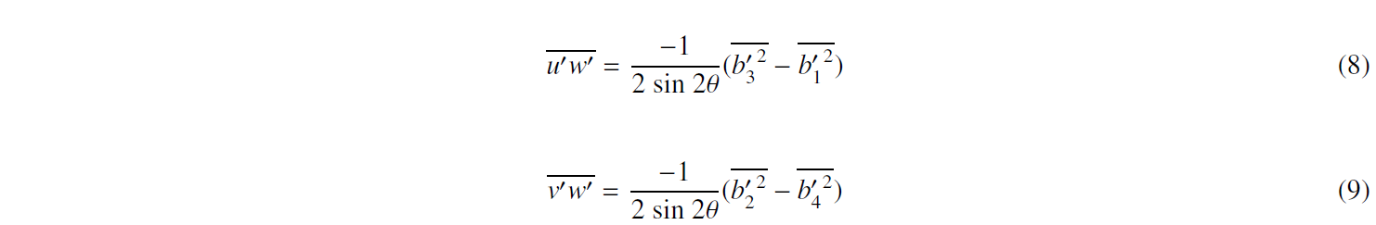
The normal and shear stresses are written in instrument coordinates; thus, the obtained stresses are rotated to along and across-shore coordinates. After the rotation, u is aligned with the along-shore flow direction, and v is aligned with the across-shore flow direction. The vertical velocity w is not affected by the rotation.

Turbulence intensity

The turbulence intensity is a common metric used throughout wind and tidal industry as well as other engineering fields to quantify turbulence. This metric is referred to as the turbulence level and represents the intensity of velocity fluctuations. In the present study, the turbulence intensity is given by the velocity fluctuations normalized by the tidal flow speed. Commercial computational fluid dynamic (CFD) codes (e.g., FLUENT) and hydro-elastic models used to simulate tidal turbine performance require specification of a turbulence intensity. Here, the focus is on horizontal turbulence intensity, TI, which involved the normal stresses $\overline{{u'}^{2}}$ and $\overline{{v'}^{2}}$ such that:

TKE dissipation and production rate

The TKE dissipation rate, ε, is the rate at which turbulence kinetic energy is converted into thermal internal energy. This turbulence metric is estimated from the spectral method (Guerra and Thomson, 2017; Thiébaut et al;, 2020a, McMillan et al., 2016). This method requires the observation of an inertial subrange in which the energy spectra of the velocity follow the classic −5/3 slope as a manifestation of the energy cascade (Frish, 1995; Pope, 2000). In the inertial subrange, the assumption of local isotropy holds over a range of length scales associated with the velocity fluctuations and a range of length scales associated with eddy size. Note that the term “local isotropy” refers only to the small-scale turbulent motions. The inertial subrange does not consider the very large scale (the integral length scale), where the energy is injected into the system by the external forces, nor does it include the very small scale (the Kolmogorov microscale), where the energy is dissipated into heat by viscosity.

Under negligible wave motions, the energy spectrum $S_{5}$ associated with the vertical velocity measured directly by beam 5 can be related to the TKE dissipation rate ε and the radian wavenumber k such that:
where $C_{w}$ ≈ 0.65 is the universal Kolmogorov constant (Pope, 2000) and $N_{5}$ is the Doppler noise level associated with the energy spectra $S_{5}$. Eq. 11 applies to scales much smaller than the production scale even in flows like boundary layers, which are inhomogeneous and anisotropic, because the turbulence at small scales is approximately independent of the details of its origin and thus is locally homogeneous and isotropic. From Eq. 11, the TKE dissipation rate ε can then be expressed as:

where the brackets ( ) denote an average over the inertial subrange.
The TKE production rate 𝒫 indicates the amount of energy that is transferred from the mean flow to the TKE. 𝒫 is estimated from the product of the Reynolds stresses and the vertical gradient of the along-shore, across-shore and vertical velocity as:
At highly energetic and well-mixed sites, such that of the present study, an assumption of local equilibrium is commonly made such that ε ≈ 𝒫 (e.g., Guerra and Thomson, 2017; Thomson et al., 2012; Rippeth et al., 2003; Osalusi et al., 2009). This assumption will be tested in this study.

Results

Tidal-stream energy potential
The estimation of the flow speed is the first step toward the assessment of the tidal-stream energy potential at a site. The mean and maximum flow speed are 1 m/s and 2.65 m/s respectively. A significant imbalance of the flow speed during the ebbing and flooding stages of the tide is identified. This imbalance is clearly exhibited in Figure 12 with the temporal evolution of the mid-depth along-shore velocity. The mean current asymmetry, i.e., the ratio of the mean flow speed during flood tide to the mean flow speed during ebb tide is 0.5. The flow at the Étel estuary test site is thus ebb-dominated. The cut-in-speed of a typical tidal turbine ranges between the velocity value of 0.5 m/s and 1 m/s. The cumulative occurrence of the flow speed at mid-depth shows that velocity values of 0.5 m/s and 1 m/s are exceeded respectively 82% and 66% of time during ebb tide and respectively 74% and 15% of time during flood tide (Figure 13a). Since the kinetic power density and the output power generated by a tidal turbine is related to the velocity cube, a high current asymmetry can generate significant difference in power production between the flooding and ebbing stages of the tide. Considerable difference in kinetic power density between both flood and ebb tide is shown in Figure 14. During flood and ebb tide, the maximum mid-depth kinetic power density reaches 1.2 kW/m² and 10.1 kW/m² respectively. The mean kinetic power density during flood tide is 0.3 kW/m² whereas that estimated during ebb tide is 7 times higher, i.e., 2.1 kW/m² which is almost twice as high as the maximum value of P reaches during flood tide (Table 4).

Table 4. Mean values and standard deviations σ of the mid-depth flow speed $U$, kinetic power density P, horizontal turbulence intensity TI, and the dissipation and production rates ε and 𝒫. The means and standard deviations are obtained by computing statistics on the flooding and ebbing stages of the tide recorded during the 27 days of deployment.
Metrics | U± σ_{U} (m/s) | P± σ_{P} (kW/m²) | TI ± σ_{TI} (%) | ε ± σ_{ε} (× 10⁻³ m²s⁻³) | 𝒫 ± σ_{P} (× 10⁻³ m²s⁻³)
Flood tide | 0.7 ± 0.3 | 0.3 ± 0.25 | 18.7 ± 3.3 | 0.3 ± 0.25 | 0.3 ± 0.15
Ebb tide | 1.3 ± 0.7 | 2.1 ± 2.0 | 13.2 ± 2.9 | 1.2 ± 0.7 | 0.5 ± 0.3

80
Ebb tide
Flood tide
a

60

40
Cumulative occurrence (%)

20

0
0.5 0.75 1 1.25 1.5 1.75 2 2.25 2.5
U (m/s)
80
b
Ebb tide Flood tide

60

40

20

0
1 2 3 4 5 6 7 8 9 10
P (kW/m²)
Figure 13. (a) Cumulative occurrence of the mid-depth flow speed. (b) Cumulative occurrence of the mid-depth kinetic power density. In each panel, black and grey colors are used to identify the flooding and ebbing stages of the tide respectively. Dashed lines show the mean values.

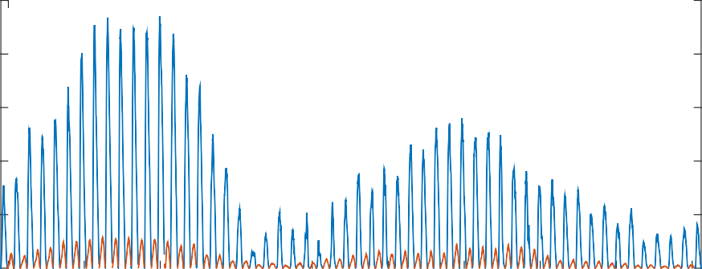
10
Ebb tide Flood tide

8

6
P (kW/m²)

4

2

0
14/10 17/10 20/10 23/10 26/10 29/10 01/11 04/11 07/11 10/11
Day/month, 2020
Figure 14. Time series of the mid-depth kinetic power density P. Orange and blue colours are used to identify the flooding and ebbing stages of the tide, respectively. Dashed lines show the mean values associated with both tidal stages.

Energy spectra
Mid-depth energy spectra, $S_{5}$, of the vertical velocity measured directly by beam 5 during the flooding and ebbing stages of the tide are shown in Figure 15. Three distinct regions are considered: the low frequency subrange ($f$ ≤ 0.15 Hz), the inertial subrange (0.15 Hz < $f$ < 1 Hz) and the high frequency subrange ($f$ ≥ 1 Hz). At low frequencies (i.e., the turbulence-production subrange), the large energy-containing eddies are responsible for the energy exchange between the mean flow and turbulence. In this frequency subdomain, the slope of the spectra is less steep than the classic $f^{-5/3}$ slope associated with the inertial subrange and the energy cascade. The different slope is a manifestation of the large-scale anisotropy of the large eddies which may be advecting through the measurement site without participating directly in the energy cascade. At mid-frequencies, spectra follow the classic $f^{-5/3}$ energy cascade. There, the energy is cascading down from large (i.e., lower frequencies) to small (i.e., higher frequencies) eddies. Considering a mean flow speed of O(1) m/s, the inertial subrange should extend to a frequency of 10³-10⁴ Hz (Durgesh et al., 2014), which is well beyond the Nyquist frequency ($f_{N}$ = 4 Hz) of the present study. As a result, the true spectra are expected to follow a $f^{-5/3}$ slope throughout the higher frequencies. However, there, the spectra become flat which is the signature of the instrument inherent Doppler noise. This noise is generated by random scatterer motions within the bin volumes of the Nortek Signature. The characterisation of the Doppler noise-induced error is addressed in the next section.

Doppler noise
The Doppler noise-induced error, $n_{i}$, generates overestimation of the along-beam velocity fluctuations associated with the i-th beam thus generating turbulence metrics systematically biased high. Failing to account for Doppler noise would result in unnecessarily high factors of safety and thus be conservative in the specifications of turbines design. A proper removal of $n_{i}$ in along-beam velocity fluctuations requires the identification of the constant spectral density, $N_{i}$. The determination of $N_{i}$ requires the identification of the characteristic frequency $f_{c}$. In this paper, the characteristic frequency is set to $f_{c}$= 0.8 $f_{N}$ which gives $f_{c}$ ~3 Hz. The characteristic frequency is chosen to ensure that the spectra are completely flat at frequency $f$ ≥ $f_{c}$ and thus only noise is considered when characterizing the Doppler noise. $N_{i}$ is then estimated by averaging the spectral densities associated with the frequency range $f_{c}$ ≤ $f$ ≤ $f_{N}$. Setting $f_{c}$ at 80% of the Nyquist frequency, instead of 90%, for example, guarantee a wider frequency range to do the averaging of the spectral densities and eventually get more accurate values of $N_{i}$.
The Doppler noise prescribes by Nortek is constant and can be found in the header of the .ad2cp files in the line beginning with "GETPRECISION". For the Nortek Signature deployment presented in this paper, the .ad2cp files indicate a constant error $n$ induced by Doppler noise (referred as measurement uncertainty by Nortek) of $n$ = 2.98 × 10⁻² m/s. However, previous studies suggested that the Doppler noise increases with increasing flow speed (e.g., Thiébaut et al. 2020a; Thomson et al., 2012; Lemmin and Lhermitte, 1999). To the best of our knowledge, such finding has not yet been demonstrated for measurements collected by a Nortek Signature. To address this gap, the variation of Doppler noise with flow speed is investigated in this paper. The results of this analysis are illustrated in Figure 16. The focus is on the Doppler noise-induced error $n_{1}$ associated with along-beam velocities recorded by beam 1. $n_{1}$ is the square root of the Doppler noise-induced variance (Eq. 3). Figure 16 shows that $n_{1}$ increases with increasing flow speed $U$. The mean value of $n_{1}$ is 2.95 × 10⁻² m/s which is 1% lower than the constant error $n$ estimated by the internal software of the Nortek Signature. However, $n_{1}$ is lower than $n$ for flow speed lower than the velocity threshold 1.25-1.5 m/s which means that the use of $n$ in the evaluation of the along-beam velocity fluctuations and associated turbulence metrics will lead to estimates systematically biased low. In contrary, for flow speed higher than the velocity threshold 1.25-1.5 m/s, the use of $n$ will lead to turbulence estimates systematically
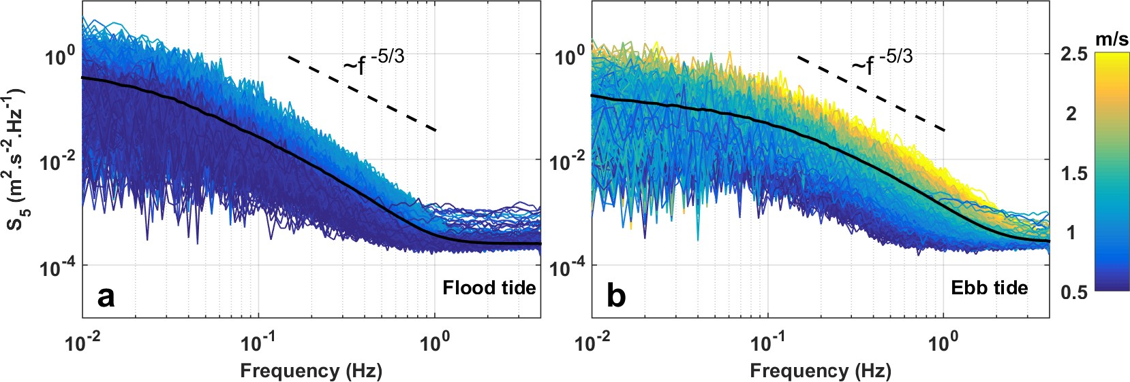
Figure 15. Individual 10-min energy spectra, S₅, of the mid-depth vertical velocity measured directly from beam 5 over the 27-day period of Nortek Signature deployment. Energy spectra associated with the flooding and ebbing stages of the tide are shown in (a) and (b) respectively. Color scale accounts for the mean flow speed at mid-depth. Solid and black curves represent the average of the individual 10-min energy spectra. Black dashed lines show the classic spectral slope $f^{-5/3}$.

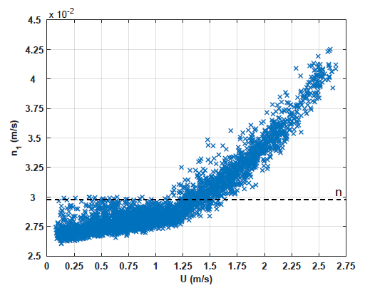
Figure 16. Doppler noise-induced error $n_{1}$ versus mean flow speed $U$. The dashed horizontal black line indicates the constant Doppler noise-induced error $n$ given by the internal software of the Nortek Signature.
biased high. $n_{1}$ estimates associated with flow speed higher than this velocity threshold are, on average, 15% higher than $n$. Similar results were found for the other beams (results not shown).

The along-beam velocity fluctuations, $b_{i}^{'}$, are calculated according to three scenarios: (1) without correction of the Doppler noise-induced error, (2) with correction of the constant Doppler noise-induced error $n$ and, (3) with correction of the Doppler noise-induced error $n_{1}$ varying with flow speed. On average, $b_{i}^{'}$ ,estimates corrected from $n$ is less than 1% lower than $b_{i}^{'}$ estimates corrected from $n_{1}$ but with significant variations according to the flow speed. A maximum of 40% is reached during periods of the highest flow speed. Not considering for Doppler noise removal generates, on average, $b_{i}^{'}$ estimates 7% higher than $b_{i}^{'}$ estimates corrected for $n_{i}$.

Turbulent velocity fluctuations
The ratios of the variance (square root of the turbulent velocity fluctuations), $\overline{{v'}^{2}}$, associated with the across-shore flow direction and, $\overline{{w'}^{2}}$, associated with the vertical flow direction to $\overline{{u'}^{2}}$, associated with the along-shore direction are approximately $\overline{{v'}^{2}}/ \overline{{u'}^{2}}$ = 0.89 and $\overline{{w'}^{2}}/ \overline{{u'}^{2}}$ = 0.61. These results agree with the ratios found in Sea Scheldt estuary, Belgium, from acoustic Doppler velocimeter (ADV) measurements (Sentchev et al., 2019).

Time series of the mid-depth horizontal turbulence intensity, TI, are shown in Figure 17b. The focus is on a 55-hour period, from October 17th - 00:00, to October 19th - 07:00 UTC (gray region in Figure 12). This period exhibited the highest flow speed with the widest velocity range. The highest TI estimates are found during the flooding stages of the tide where they reach more than 25%. The mean TI associated with this tidal stage is 18.7% (Table 4). Mean and maximum TI associated with the ebbing stages of tide are 13.2% and 19.6% respectively. The horizontal turbulence intensity involves the normal stresses $\overline{{u'}^{2}}$ and $\overline{{v'}^{2}}$ which are calculated by the Dewey and Stringer’s formulations. Reynolds stresses estimates derived from these formulations need to be validated to improve the level of confidence of the turbulence metrics calculated from these Reynolds stresses. The Nortek Signature allows for a direct measurement of the normal stress associated with the vertical flow direction through the calculation of the variance of the along-beam velocities measured by beam 5, i.e., $\overline{{b_{5}^{'}}^{2}}$. The normal stress associated with the vertical flow direction can also be calculated from the mathematical expression of $\overline{{w'}^{2}}$, given by the Dewey and Stringer’s formulations (Eq. 7). Estimates of $\overline{{b_{5}^{'}}^{2}}$ and $\overline{{w'}^{2}}$ are compared considering $\overline{{b_{5}^{'}}^{2}}$ as the reference. Results of this analysis are shown in Figure 18. In comparison to the 1:1 line of perfect agreement (slope = 1, y-intercept = 0), the best fit of the distribution is done with a linear function of slope = 0.99 and y-intercept = 1.7 × 10⁻⁴. The coefficient of determination R² of the best fit is 0.99. The mean gap between $\overline{{w'}^{2}}$ and $\overline{{b_{5}^{'}}^{2}}$ is 4.9%.

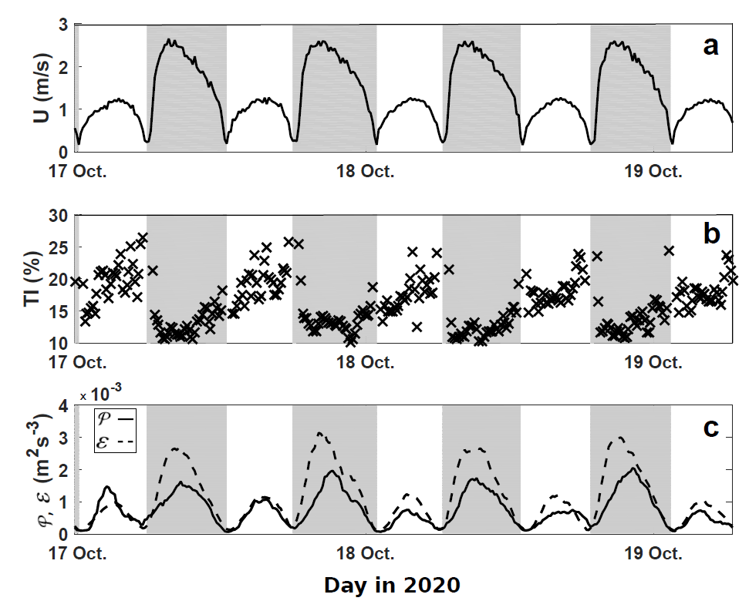
Figure 17. Time series of the mid-depth flow speed (a), TI (b), and TKE dissipation and production rates (c). Each panel presents turbulence metrics computed during a 55-hour period exhibiting the highest flow speed and velocity ranges (Figure 12). Gray regions show the ebbing stages of the tide.
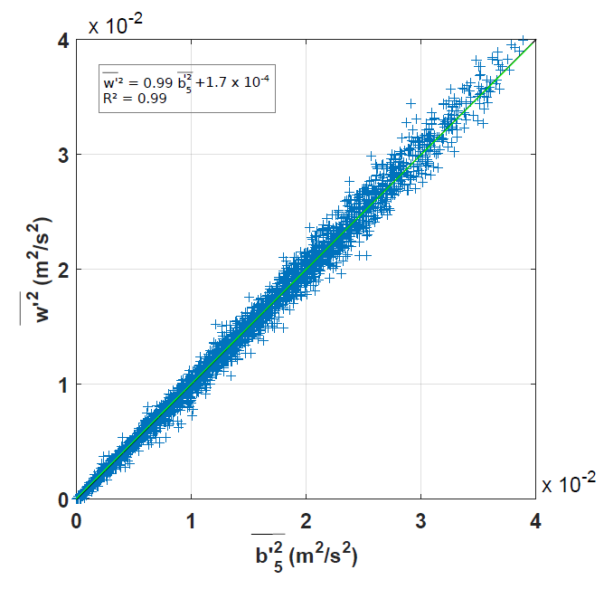
Figure 18. Mid-depth variance associated with the vertical flow direction calculated with the Dewey and Stringer’s formulation, $\overline{{w'}^{2}}$, versus the variance measured directly by beam 5, $\overline{{b_{5}^{'}}^{2}}.$ The green line is the best fit of the distribution. The black line indicates perfect agreement.

TKE dissipation and production rates
Time series of the mid-depth TKE dissipation and production rates are presented in Figure 17c. Both turbulence metrics track each other and exhibit a clear quarter-diurnal tidal variation. Maximum values of the TKE dissipation rate, ε, and production rate, 𝒫, are observed during peak ebb tide velocity, falling off around slack water and increasing to a second maximum during peak flood tide velocity. The maximum values of ε and 𝒫 are reached during the ebbing stages of the tide, i.e., 3.1 × 10⁻³ m²s⁻³ and 2.0 × 10⁻³ m²s⁻³ respectively.
The mean TKE dissipation rate, averaged over the 27-day of the Nortek Signature deployment is 1.2 × 10⁻³ m²s⁻³ during ebb tide (Table 4). During flood tide, the mean value of ε is 4 times lower than the mean ebb value. On the flooding stage of the tide, the mean TKE production rate exhibits similar mean value in comparison to ε whereas during the ebbing stage of the tide, the mean value of 𝒫 is almost twice lower than that of ε.
Quantile-quantile plots (Q-Q plots) of the quantiles of 𝒫 computed at mid-depth against that of ε are shown in Figure 19. Results show that the distribution associated with the ebbing stages of the tide lies on a straight line (black dashed lines in Figure 19) for ε and 𝒫 values lower than 2.0 × 10⁻³ m²s⁻³ and 1.0 × 10⁻³ m²s⁻³ respectively. During flood tide, the distribution is normally distributed for ε and 𝒫 values lower than 0.75 × 10⁻³ m²s⁻³. Moreover, during this tidal stage, estimates higher than 1.2 x 10⁻³ m²s⁻³ show that extreme production rates are systematically higher than extreme dissipation rates. This represents 4% of the estimates associated with the flooding stages of the tide. Such situation can be seen during the first flooding stage of the tide in Figure 17c. Similar situations were identified during the 27-day long dataset. However, no satisfying physical explanation of these situations could be given in this paper.
The slope of both distributions is gentler in comparison to the slope of 1:1 line representing perfect agreement between ε and 𝒫 (solid black line in Figure 19), particularly for the distribution associated with the ebbing stages of the tide. On average, the ratio ε/ 𝒫 at mid-depth was found to be 1.9 and 0.95 during ebb tide and flood tide respectively.
Mid-depth TKE dissipation rate as a function of mid-depth flow speed is shown in Figure 20. On the flooding stages of the tide, ε is proportional to $U^{3}$ that is suggestive of bottom boundary layer physics where production and dissipation are expected to be approximately in balance. On the ebbing stages of the tide, the linear relationship between ε and $U^{3}$ is exhibited only for flow speed higher than 2 m/s. At lower flow speeds, ε deviates from this relationship, which suggests that the boundary layer is no longer the dominant physical process at mid-depth.

Discussion
Successful tidal-stream energy projects at a prospective site require a comprehensive assessment of the flow dynamics and turbulence. This is a key step in providing detailed tidal-stream resource evaluation and ascertain the level of complexity that is required for simulating the loads and predicting fatigue life. These aspects have motivated the deployment of an upward-looking Nortek Signature 1000 kHz five-beam ADCP, in the center of the Étel river for a 27-day period covering two full spring tide periods. Investigation of the mean flow speed reveals

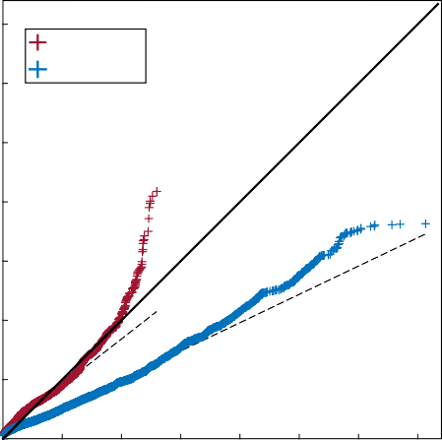
x 10⁻³
Flood tide
Ebb tide
3.5

3

2.5

2
(m²s⁻³)

1.5

1

0.5

0
Figure 19. Q-Q plots of the quantiles of the TKE production rate estimates, 𝒫, against the TKE dissipation rate estimates, ε, computed at mid-depth. The entire 27-day long dataset of the TKE production and dissipation is presented. Red and blue colours are used to identify the flooding and ebbing stages of the tide respectively. The black dashed lines are the best fit of the distributions. The solid black line indicates perfect agreement.
0.5 1 1.5 2 2.5 3 3.5
(m²s⁻³) x 10⁻³

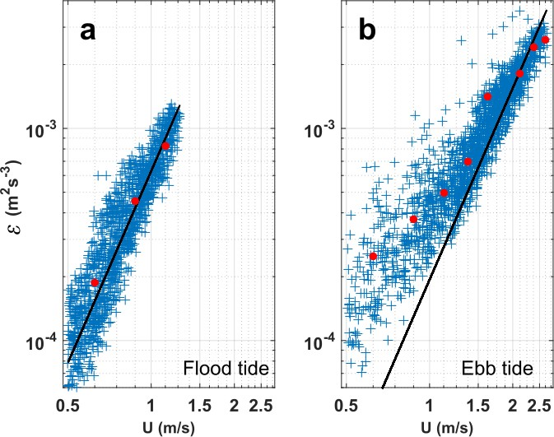
Figure 20. Log-log representation of the mid-depth TKE dissipation rate, ε, as a function of mid-depth flow speed, U. The entire 27-day long dataset of the TKE dissipation rate is presented. ε estimates associated with the flooding and ebbing stages of the tide are shown in panel (a) and (b) respectively. Red dots are mean values averaged within flow speed-bins of 0.25 m/s. The black line shows a $U^{3}$ slope.

that the flow dynamics is ebb-dominated with flow speed almost twice higher during ebb tide than during flood tide. Similar imbalance between both tidal stages was reported from four-beam ADCP measurements collected in the Sea Scheldt Estuary, Belgium (Sentchev et al., 2019). This imbalance has a significant effect on the tidal-stream energy potential of the Étel estuary test site. On average, the kinetic power density associated with the ebbing stages of the tide is 7 times higher than that associated with the flooding stages of the tide. Note that, the Nortek Signature deployment took place near the autumn equinox. Thus, mean flow speed and kinetic power density presented in this report are likely slightly higher than annual mean values.
An approximate TKE budget has been established in order to test the hypothesis of local equilibrium between pro- duction and dissipation that is often observed in tidally forced systems (e.g., Guerra and Thomson, 2017; McMillan et al., 2016; Trowbridge et al., 1999; Kilcher et al., 2017; Stacey et al., 1999). At mid-depth, a local production-dissipation balance is evidenced during the flooding stages of the tide. This result is further supported by the evidence of a linear relationship between ε and $U^{3}$ suggestive of bottom boundary layer physics and equilibrium between production and dissipation of turbulence. However, during ebb tide, ε against $U^{3}$ deviates from the linear relationship which suggests that the boundary layer is no longer the dominant physical process at this height. This result is supported by the mid-depth TKE dissipation rate almost twice higher, on average, than the mid-depth TKE production rate. Thus, during ebb tide, other terms of the TKE budget are likely to be important, such as turbulence advection and turbulent transport.

The estuary shape also affects the TKE dissipation rate. On the north-eastward-flowing flood tide, the flow passes over several bathymetric features, including a prominent ridge, before reaching the deployment location. The complex bathymetry generates macroturbulence near the bed, which then propagates upward in the water column and results in high turbulence levels at the deployment location. On the south-westward-flowing ebb tide, the flow converges due to the estuary shape. The associated acceleration generates high velocities and a rapid suppression of turbulence with a high rate of dissipation.
A major result of this paper is the successful use of the Dewey and Stringer’s formulations for the calculation of the normal stresses. In particular, the efficiency of the formulation allowing the calculation of the Reynolds stress associated with the vertical flow direction is demonstrated. This is done through a comparison between of $\overline{{w'}^{2}}$ estimates derived from the Dewey and Stringer’s formulations and estimates of the variance, $\overline{{b_{5}^{'}}^{2}}$, measured directly by the fifth (vertical) beam of the Nortek Signature. The mean gap between $\overline{{w'}^{2}}$ and $\overline{{b_{5}^{'}}^{2}}$estimates is less than 5%. This result allows for a certain level of confidence in TI estimates presented in this paper since TI calculation involves the normal stresses of the Reynolds tensor. The Dewey and Stringer’s formulations are based on the small angle approximation of the pitch and roll of the Nortek Signature. Thus, a proper characterisation of turbulence from metrics derived from these formulations requires a proper installation of the Nortek Signature during the deployment, with ideally a constant zero-magnitude pitch and roll. A sensitivity study of the pitch and roll values to the calculation of the Reynolds stresses and turbulence metrics such as TI derived from the Dewey and Stringer’s formulations would be a relevant topic for future works. The Dewey and Stringer’s formulations also involve the variance of the along-beam velocities. Variance estimates have been corrected from the Doppler noise-induced variance, $n_{i}^{2}$ which is found to increase with increasing flow speed. The mean of $n_{i}^{2}$ is very similar to the constant Doppler noise-induced variance, $n^{2}$, estimated by the internal software of Nortek Signature. However, it is demonstrated that the use of $n^{2}$, instead of $n_{i}^{2}$ generates variance estimates of the along-beam velocities systematically biased low for flow speeds lower than the threshold - 1.25-1.5 m/s - and systematically biased high for flow speed higher than this threshold. The use of $n_{i}^{2}$ instead of $n^{2}$ is thus recommended. This will allow for more accurate turbulence characterisation and thus optimized tidal turbines design.

Conclusions
This study demonstrates the efficiency of the Dewey and Stringer’s formulations for the evaluation of the normal stresses. This result offers interesting prospects for future turbulence characterisation at tidal energy sites. The Dewey and Stringer’s will enable the characterisation of metrics such as the turbulence intensity or turbulent kinetic energy along three orthogonal flow directions. The three-dimensional structure of turbulence is essential to optimizing the design of turbines. In the wind energy industry, measurements of the three-dimensional turbulence are used to initialize turbulent simulator such as the TurbSim model employed in the unsteady aerostructural code OpenFAST. These, and other, design codes have helped the wind industry reach its present state of maturity and reliability. Similar design codes such as the tidal version of TurbSim have been developed in the last decade but a critical gap in developing comparable design codes for tidal turbines is a lack of information about the three-dimensional turbulence. Results provide in this paper will contribute to fill this gap and represent a valuable step in the development of robust design tools that will improve the survivability, reliability, and performance of tidal turbines.

Collision Risk Model integration within the DTOceanPlus suite of tools

DTOceanPlus and the ESA module
DTOceanPlus is a suite of second-generation, open source and integrated design tools, applicable to different levels of technology (from subsystems to devices and networks), from concept to development and deployment (Figure 21). Notably, a module of environmental and social acceptance assessment (ESA module) is integrated within the assessment tools.
Figure 21. Representation of the DTOceanPlus suite of tools.
In line with the regulatory context of environmental risk and socio-economic opportunity assessment, the Environmental and Social Acceptance (ESA) module is structured around four features (Figure 22) representing complementary assessments:
- Identification of the potential presence of endangered species in the area of MRE installation (i.e. species included in the IUCN red list);
- Environmental impact assessment estimated for the main environmental stressors pre-identified as potential stressors from MRE such as the underwater noise or the collision risk between vessels/devices and the marine wildlife;
- Estimation of the carbon footprint and the green-house effect of the project in terms of Global Warming Potential and Cumulative Energy Demand; and
- Information to improve the social acceptance of the project considering socio-economic opportunities.
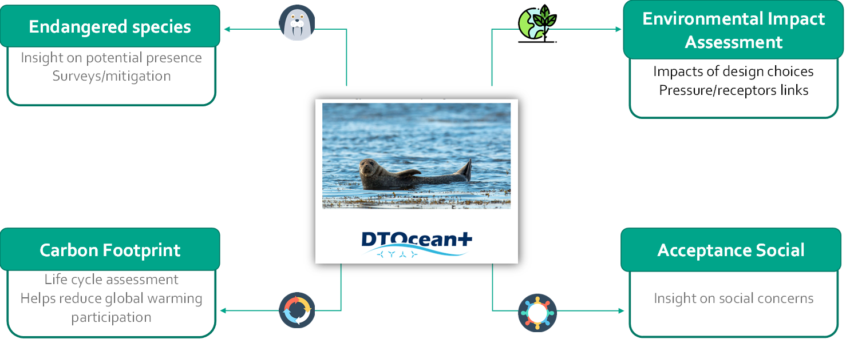
Figure 22. The four features of the Environmental and Social Acceptance module.

Objective in the ELEMENT project
In this modelling section, the objectives are to:
- Implement a fifth feature into the DTOceanPlus ESA module allowing the assessment of collision risk between marine animals and tidal turbines, based on the Scottish Natural Heritage (2016) guidance note.
- Provide an example of application of the new feature with the data from the EMEC tidal test site on Orkney (Band 2014)

Collision Risk Model
Although the evidence base is improving, knowledge about the risk of collision between marine animals and tidal turbines is still scarce (Copping et al, 2020). The frequency of nearfield encounters and the little-known consequences for marine animals of any such interactions limit understanding of the real impact of tidal turbines. This gap in knowledge creates a major constraint in MRE permitting processes and in the acceptability of MRE projects (Copping et al. 2018). It is assumed for commercial tidal farms that collision risk will increase with the number and size of turbines by increasing the overall rotor-swept area. Given this risk and the gaps in terms of understanding any impacts on bird and marine mammal individuals or populations, developers are generally required to conduct a collision risk assessment as part of the process of applying for project permits and licences.

The Collision Risk Model, or ‘Band CRM’ (Band 2012a, Band et al. 2016) was developed to estimate the risk to birds flying through wind farms. It was later modified and tailored to provide a tool for modelling potential underwater collisions with tidal turbines (detailed in Scottish National Heritage, 2016). The modified Band CRM is intended to be suitable for marine mammals and diving birds.

The Band CRM estimates the number of passages through the rotor made by individuals of a given species over a period of assessment in which the rotor is operational. It is measured in terms of the density and speed of the species at the depth of the risk, the cross-sectional area of the rotor, and to account for the possibility of an individual to pass through a rotor without colliding, the indicator includes the probability of collision during a single transit. Inputs of the CRM includes information regarding the species evaluated, the rotor characteristics and mean current speed (Table 5).
Table 5. Inputs of the Collision Risk Model
Inputs | Symbol | Type | Unit
Animal
Observed density |  | double | Animal/m²
Proportion of time foraging |  | double | -
Dive frequency foraging |  | double | dives/s
Foraging trips per day | G | double | trips/day
Dives per foraging trip | U | double | dives/trip
Mean underwater duration of dive |  | double | s
Mean surface time |  | double | s
Watch period |  | double | s
Depth distribution type |  | string | -
Length | L | double | m
Wingspan / body width | W | double | m
Vertical swim speed | u | double | m/s
Plunge speed | u' | double | m/s
Device
Number of rotors | B | double | m
Rotor diameter (c/f) | 2R | double | m
Rotor minimum depth |  | double | m
Number of blades | b | double | -
Maximum blade width | C | double | m
Blade pitch at blade tip | γ | double | degrees
Blade profile | c/C |  | -
Rotation speed | Ω | double | rpm
% Time not operational | nop | double | -
Current
mean current speed (m s-1) |  | double | m/s

Animal density at risk depth (D)
The density at risk equation considers the observed density of individuals in the area of assessment and the time spent by the species at risk depth.
First, observed density is corrected by the proportion of individuals visible at surface:
$$D_{A}= \frac{D_{s}}{P}$$ | (14)
P is a function of the species foraging strategy in terms of dive frequency, duration of a dive and the watch period of the observer:
$$P=1-F*MAX(0,t_{u}-t_{w})$$ | (15)

Dive frequency (F) for birds
For birds, F can be calculated with two different methods depending on the available data, with the proportion of time foraging and the dive frequency foraging for method 1:
$$F_{birds1}=P_{2} ×F_{2}$$ | (16)
With regard to the number of foraging trips per day and the number of dives for each trip for method 2:
$$F_{birds2}=\frac{(G ×U )}{24 ×3600}$$ | (17)

Dive frequency (F) for marine animals
In the case marine mammals, F is calculated as follow:
$$F_{marine animals}=\frac{1}{(t_{u}-t_{s})}$$ | (18)
Once the adjusted density is calculated, time per dive at risk depth is calculated differently for each dive distribution type (shallow, deep or plunge), considering the vertical swim speed, plunge speed.

- For shallow diving mammals, all dive time at risk are considered except for the time taken to swim down and back up from maximum rotor height:
$$H_{shallow}=t_{u}-2 ×\frac{D_{m}}{u}$$ | (19)

- For deep-diving mammals, dive time is considered only the time while swimming down and back up through the depths occupied by the rotor of radius is at risk:
$$H_{deep}=2 ×\left(\frac{ 2R}{u}\right)$$ | (20)
- For plunge distribution type:
$$H_{plunge}=t_{u}-\frac{D_{m}}{u}- \frac{D_{m}}{u'}$$ | (21)

Density at risk depth (D)
The adjusted density ($D_{A}$, Equation 14) is then multiply by the time per dive at risk depth to obtain the density at risk depth:

$$D=D_{A}\frac{Q_{2R}}{2R}$$ | (22)

Total frontal Area (rarea)
Total frontal area (rarea) is the cross-sectional area of a rotor multiply by the number of rotors with 0.5W allows for clearance of the blade tip considering the width of the species.
$rarea=Bπ(R+0.5W)$² | (23)

Encounter probability for a single transit (pcoll)
To account for the possibility of an individual to pass through a rotor without colliding, the probability of collision at any point of transit away from the rotor centre can be evaluated as follow:

$$p\left(r\right)=\frac{bΩ}{2πv}*\left[\left|±c*sin{γ+α*c*cos{γ}}\right|+max⁡(L,W_{α})\right]$$ | (24)
With :
$α$ = $v/{rΩ}$

Probability of encounter in a single transit (pcoll) is then the integration of the probability p(r) over the area (A) of the rotor disc:
$$pcoll=\frac{\iint{p\left(r\right)dA}}{\iint{dA}}$$ | (25)

Collision risk
The general equation to assess the collision risk for the time of period examined (tope) is:
$$CRM=D*rarea*v*pcoll*tope$$

Integration in DTOcean+

Architecture of the tool
Each module of the DTOceanPlus suite of tools is implemented using a similar structure which comprises three layers:
- The Business Logic, including a set of modules, classes, libraries implementing all the functionalities of the modules
- The Application Programming Interface that will constitute the gate of the module to the other modules, that either consume the services provided by ESA or whose services are consumed by ESA.
- The Graphic User Interface (GUI), allowing interaction with the user in order to show results and receive inputs, besides exporting/importing data to/from files.

The modified Band CRM has been integrated within the ESA module at the same level in the architecture as for the four main features (Figure 23).

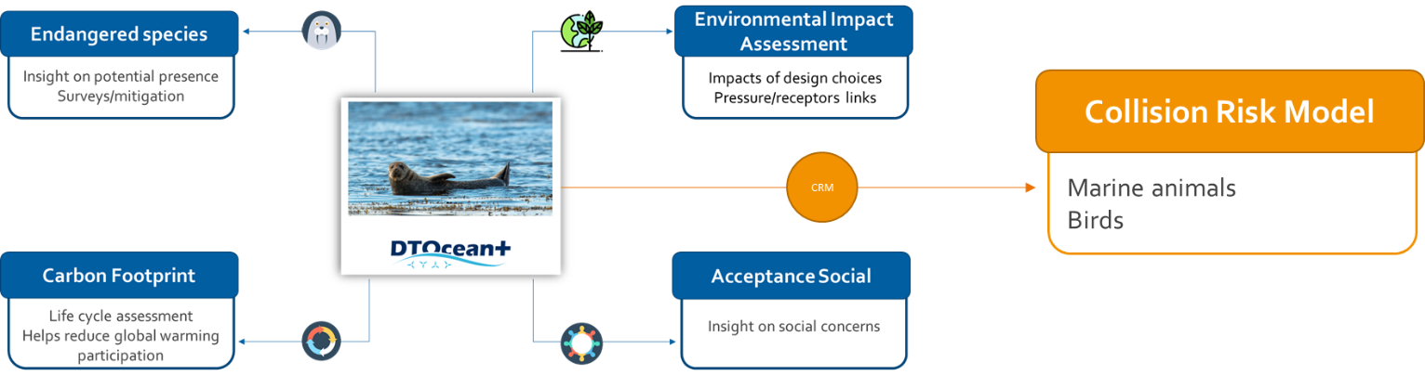
Figure 23. Level of integration of the CRM in the architecture of the ESA module.
The CRM evaluation will calculate the different parameters described in the previous sections; the flow processes are summarized in Figure 24. Inputs and Outputs of the ESA module are displayed in the GUI and saved in json format in the “storage” file of the source code. Details on the business logic and the graphical user interface developed for the integration of the CRM are detailed in the following sections.
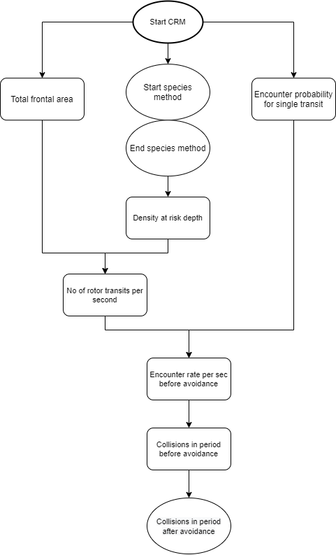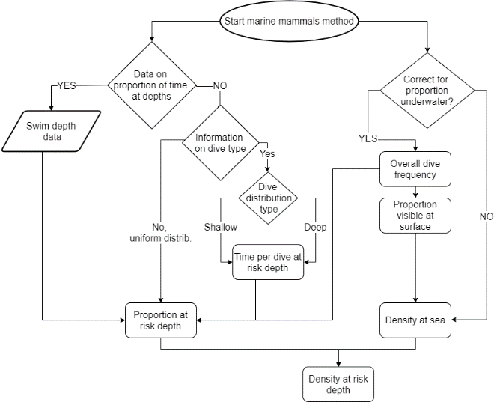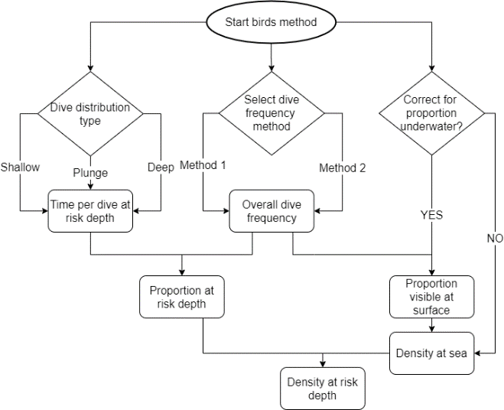
Species methods
Figure 24. Flow diagram of the CRM feature.

Business logic
Four classes have been developed in the back-end of the tool to evaluate the CRM (Figure 25).

The main CRMList class corresponds to the Collision Risk Model overall results. This class will process all the inputs for CRM provided by the other modules and/or the user process the required inputs (init_from_files()) and computes and aggregates the results of CRM_results (compute_all_CRM()).

CRM_results class evaluates the collision risk for one specific species (CRM()). This class calculates the probability of collision at each point of transit (p(r)) and averaged the encounter probability for a single transit. The main method returns the final collision risk with and without avoidance rate (CRM()), this method is dependent of the last classes animal_density_at_risk_depth or bird_density_at_risk_depth that contain characteristics of species and allows for the calculation of the density at risk depth (density_at_risk_depth()). Proportion_visible_surface() returns the proportion of the time that an animal is visible at the surface, taking account of the time spent underwater and watch period which extends the time visible. A specific method in the animal_density_at_risk_depth class (Q2R2()) returns the proportion of time at risk depth for three specific species: harbour seal, harbour porpoise and grey seal.

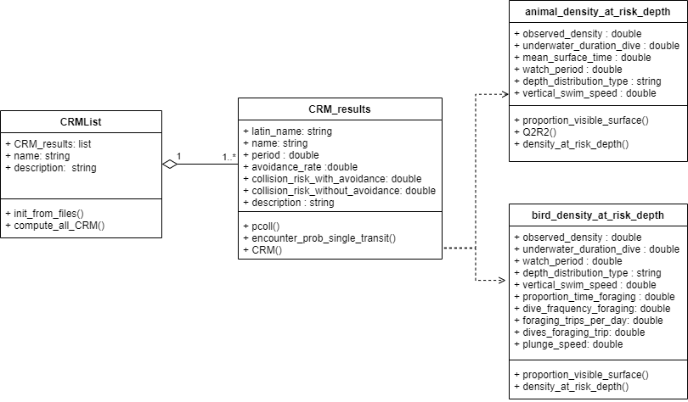
Figure 25. Class diagram of the CRM business logic

Graphical User Interface
The inputs pages of the ESA module were not built according to the 5 features but rather in coherence with the DTOceanPlus suite of tools and in a perspective of non-redundancy for the user. In this sense, four sections of inputs have been built:
- The “farm info” section which regroups parameters defining the farm general information, the area description, initial state of environmental parameters, and the species or habitats that are identified in the area.
- The “device info” section includes device general information, dimensions, materials.
- The “electrical info” section groups parameters related to energy and cables.
- The “logistic info” which gathers marine operation planning for three phases of the life cycle of a project: installation, exploitation and decommissioning.

Inputs required to run a CRM evaluation (Table 4) were already considered in the last version of DTOceanPlus and included in the “device info” section. The main addition in the inputs pages corresponds to the inputs required for the animal parameters. In the “farm info” section, the user can add bird or marine animal species to be evaluated for collision risk by inputting the required information (Figure 15).
Figure 26. Wireframe of the inputs section of the species parameters required for the CRM evaluation.
The outputs of the ESA module are divided and specific to each feature. Thus, a specific outputs page was added for the CRM’s outputs (Figure 27).

Figure 27. Wireframe of the outputs page of the CRM evaluation and example of outputs for the Harbour porpoise.

Example of application
To test the CRM tool within the ESA module, the example provided in SNH (2016) was used. This is based on data from the EMEC tidal test site on Orkney (Band 2014) for four species of diving bird and four marine mammal species (Table 6).
Table 6. Species characteristics used for the EMEC example.
Parameter | Eider | Red-throated diver | Cormorant | Black guillemot | Harbour porpoise | Harbour seal | Grey seal | Minke whale
Observed density | 3.07E-07 | 1.08E-08 | 6.62E-08 | 5.71E-07 | 3.39E-09 | 3.57E-09 | 1.05E-08 | 2.15E-10
Proportion of time foraging | 0.6 | 0.4 | 1 | 0.37 | - | - | - | -
Dive frequency foraging | 0.02 | 0.03 | 0.01 | 0.01 | - | - | - | -
Foraging trips per day | - | - | - | - | - | - | - | -
Dives per foraging trip | - | - | - | - | - | - | - | -
Mean underwater duration of dive | 25.9 | 26.1 | 40 | 77.1 | 26.2 | 180 | 297 | 87
Mean surface time | - | - | - | - | 3.9 | 39.51 | 165 | 3.5
Watch period | 10 | 10 | 10 | 10 | 10 | 10 | 10 | 10
Depth distribution type | shallow | shallow | deep | deep | harbour porpoise | harbour seal | grey seal | uniform
Length | 0.6 | 0.61 | 0.9 | 0.31 | 1.48 | 1.41 | 1.86 | 8.8
Wingspan / bodywidth | 0.94 | 1.11 | 1.45 | 0.55 | 0.32 | 0.34 | 0.42 | 2.2
Vertical swim speed | 1.65 | 1.65 | 1.65 | 1.48 | - | - | 1.4 | -
Plunge speed | - | - | - | - | - | - | - | -
The turbine used in the example is a reference 3-blade turbine of 25m diameter, the average depth of the channel is assumed to be 30m so that the rotor would not breach the surface and encounter animals at the surface (Table 7).
Table 7. Turbine characteristics used for the EMEC example
Device | Orkney example
Number of rotors | 1
Rotor diameter | 25
Rotor minimum depth | 2.5
Number of blades | 3
Maximum blade width | 1.5
Blade pitch at blade tip | 5
Rotation speed | 6.95
% Time not operational | 12.4
Mean current speed | 1.82
Blade profile | 0.690  0.730  0.790  0.880  0.960  1.000  0.980  0.920  0.850  0.800  0.750  0.700  0.640  0.580  0.520  0.470  0.410  0.370  0.300  0.240  0.000

The collision risk associated with each species is given with or without considering the avoidance rate (Table 8).
Table 8. Collision risk outputs of the EMEC example
Parameter | Eider | Red-throated diver | Cormorant | Black guillemot | Harbour porpoise | Harbour seal | Grey seal | Minke whale
Collision risk without avoidance | 22.473 | 1.003 | 5.834 | 12.562 | 1.717 | 2.593 | 4.596 | 1.409
Avoidance rate | 0.98 | 0.98 | 0.98 | 0.98 | 0.98 | 0.98 | 0.98 | 0.98
Collision risk with avoidance | 0.45 | 0.02 | 0.12 | 0.25 | 0.03 | 0.05 | 0.09 | 0.03

References
Abelson, A., and M. Denny. 1997. Settlement of Marine Organisms in Flow. Annual Review of Ecology and Systematics 28: 317–339. doi:10.1146/annurev.ecolsys.28.1.317.
Angermann, L. 2010. Numerical Simulations: Examples and Applications in Computational Fluid Dynamics. BoD – Books on Demand.
Antoniadou, C., E. Voultsiadou, and C. Chintiroglou. 2011. Seasonal patterns of colonization and early succession on sublittoral rocky cliffs. Journal of Experimental Marine Biology and Ecology 403: 21–30. doi:10.1016/j.jembe.2011.04.001.
Antunes, J., P. Leão, and V. Vasconcelos. 2019. Marine biofilms: diversity of communities and of chemical cues. Environmental Microbiology Reports 11: 287–305. doi:10.1111/1758-2229.12694.
Aquatera Ltd, MarineSpace Ltd (2017). The Forward Look; an Ocean Energy Environmental Research Strategy for the UK. Report by Aquatera Ltd. Report for Marine Scotland Science. Degraer, S., D. Carey, J. Coolen, Z. Hutchison, F. Kerckhof, B. Rumes, and J. Vanaverbeke. 2020. Offshore Wind Farm Artificial Reefs Affect Ecosystem Structure and Functioning: A Synthesis. Oceanography 33: 48–57. doi:10.5670/oceanog.2020.405
Araújo, P. A., J. Malheiro, I. Machado, F. Mergulhão, L. Melo, and M. Simões. 2016. Influence of Flow Velocity on the Characteristics of Pseudomonas fluorescens Biofilms. Journal of Environmental Engineering 142. American Society of Civil Engineers: 04016031. doi:10.1061/(ASCE)EE.1943-7870.0001068.
Band, W. 2012a. Using a collision risk model to assess bird collision risks for offshore windfarms. The Crown Estate Strategic Ornithological Support Services (SOSS) report SOSS-02. SOSS Website. Original published Sept 2011, extended to deal with flight height distribution data March 2012. www.bto.org/science/wetland-and-marine/soss/projects
Band, W. 2014. Detailed Collision Risk Assessment: Marine mammals, Basking shark, and Diving Birds. In Fall of Warness test site Environmental Appraisal: Annex 7. EMEC.
Band, B., Sparling, C., Thompson, D., Onoufriou, J., San Martin, E., West, N. 2016. Refining Estimates of Collision Risk for Harbour Seals and Tidal Turbines. Scott. Mar. Freshw. Sci., 7, 17.
Battin, T. J. 2000. Hydrodynamics is a major determinant of streambed biofilm activity: From the sediment to the reach scale. Limnology and Oceanography 45: 1308–1319. doi:10.4319/lo.2000.45.6.1308.
Battin, T. J., L. A. Kaplan, J. D. Newbold, X. Cheng, and C. Hansen. 2003. Effects of Current Velocity on the Nascent Architecture of Stream Microbial Biofilms. Applied and Environmental Microbiology 69. American Society for Microbiology: 5443–5452. doi:10.1128/AEM.69.9.5443-5452.2003.
Besemer, K., G. Singer, R. Limberger, A.-K. Chlup, G. Hochedlinger, I. Hödl, C. Baranyi, and T. J. Battin. 2007. Biophysical Controls on Community Succession in Stream Biofilms. Applied and Environmental Microbiology 73. American Society for Microbiology: 4966–4974. doi:10.1128/AEM.00588-07.
Besemer, K., G. Singer, I. Hödl, and T. J. Battin. 2009. Bacterial Community Composition of Stream Biofilms in Spatially Variable-Flow Environments. Applied and Environmental Microbiology. American Society for Microbiology. World. doi:10.1128/AEM.01284-09.
Blöcher, N. 2013. Biofouling in the Norwegian Salmon Farming Industry. Norges teknisk-naturvitenskapelige universitet, Fakultet for naturvitenskap og teknologi, Institutt for biologi.
Blumenkrantz, N., and G. Asboe-Hansen. 1973. New method for quantitative determination of uronic acids. Analytical Biochemistry 54: 484–489. doi:10.1016/0003-2697(73)90377-1.
Bokulich, N. A., S. Subramanian, J. J. Faith, D. Gevers, J. I. Gordon, R. Knight, D. A. Mills, and J. G. Caporaso. 2013. Quality-filtering vastly improves diversity estimates from Illumina amplicon sequencing. Nature Methods 10: 57–59. doi:10.1038/nmeth.2276.
Bradford, M. M. 1976. A rapid and sensitive method for the quantitation of microgram quantities of protein utilizing the principle of protein-dye binding. Analytical Biochemistry 72: 248–254. doi:10.1016/0003-2697(76)90527-3.
Briand, J.-F., A. Barani, C. Garnier, K. Réhel, F. Urvois, C. LePoupon, A. Bouchez, D. Debroas, et al. 2017. Spatio-temporal variations of marine biofilm communities colonizing artificial substrata including antifouling coatings in contrasted french coastal environments. Microbial Ecology 74: 585–598. doi:10.1007/s00248-017-0966-2.
Briand, J.-F., X. Pochon, S. A. Wood, C. Bressy, C. Garnier, K. Réhel, F. Urvois, G. Culioli, et al. 2018. Metabarcoding and metabolomics offer complementarity in deciphering marine eukaryotic biofouling community shifts. Biofouling 34: 657–672. doi:f.
Brunet, C., D. Davoult, and R. Casotti. 1996. Physiological reactions to a change in light regime in cultured Skeletonema costatum (Bacillariophyta): implications for estimation of phytoplankton biomass. Hydrobiologia 333: 87–94. doi:10.1007/BF00017571.
Callahan, B. J., P. J. McMurdie, M. J. Rosen, A. W. Han, A. J. A. Johnson, and S. P. Holmes. 2016. DADA2: High-resolution sample inference from Illumina amplicon data. Nature Methods 13. Nature Publishing Group: 581–583. doi:10.1038/nmeth.3869.
Carriot, N., B. Paix, S. Greff, B. Viguier, J.-F. Briand, and G. Culioli. 2021. Integration of LC/MS-based molecular networking and classical phytochemical approach allows in-depth annotation of the metabolome of non-model organisms - The case study of the brown seaweed Taonia atomaria. Talanta 225: 121925. doi:10.1016/j.talanta.2020.121925.
Carriot, N., R. Barry-Martinet, J.-F. Briand, A. Ortalo-Magné, and G. Culioli. 2022. Impact of phosphate concentration on the metabolome of biofilms of the marine bacterium Pseudoalteromonas lipolytica. Metabolomics 18: 18. doi:10.1007/s11306-022-01875-x.
Catão, E. C. P., T. Pollet, B. Misson, C. Garnier, J.-F. Ghiglione, R. Barry-Martinet, M. Maintenay, C. Bressy, et al. 2019a. Shear Stress as a Major Driver of Marine Biofilm Communities in the NW Mediterranean Sea. Frontiers in Microbiology 0. Frontiers. doi:10.3389/fmicb.2019.01768.
Catão, E. C. P., T. Pollet, B. Misson, C. Garnier, J.-F. Ghiglione, R. Barry-Martinet, M. Maintenay, C. Bressy, et al. 2019b. Shear Stress as a Major Driver of Marine Biofilm Communities in the NW Mediterranean Sea. Frontiers in Microbiology 10. Frontiers. doi:10.3389/fmicb.2019.01768.
Catao, E. C. P., N. Gallois, F. Fay, B. Misson, and J.-F. Briand. 2021. Metal resistance genes enrichment in marine biofilm communities selected by biocide-containing surfaces in temperate and tropical coastal environments. Environmental Pollution 268: 115835. doi:10.1016/j.envpol.2020.115835.
Chang, J., X. He, X. Bai, and C. Yuan. 2020. The impact of hydrodynamic shear force on adhesion morphology and biofilm conformation of Bacillus sp. Ocean Engineering 197: 106860. doi:10.1016/j.oceaneng.2019.106860.
Chong, J., O. Soufan, C. Li, I. Caraus, S. Li, G. Bourque, D. S. Wishart, and J. Xia. 2018. MetaboAnalyst 4.0: towards more transparent and integrative metabolomics analysis. Nucleic Acids Research 46: W486–W494. doi:10.1093/nar/gky310.
Christensen, T. 1991. The Diatoms. Biology and Morphology of the Genera. Phycologia 30. Taylor & Francis: 233–235. doi:10.2216/i0031-8884-30-2-233.1.
Connell, J. H. 1978. Diversity in Tropical Rain Forests and Coral Reefs. Science 199. American Association for the Advancement of Science: 1302–1310. doi:10.1126/science.199.4335.1302.
Copping, A.E., Grear, M.E. 2018. Applying a simple model for estimating the likelihood of collision of marine mammals with tidal turbines. International Marine Energy Journal 1, 27–33. https://doi.org/10.36688/imej.1.27-33.
Copping, A.E. and Hemery, L.G., editors. 2020. OES-Environmental 2020 State of the Science Report: Environmental Effects of Marine Renewable Energy Development Around the World. Report for Ocean Energy Systems (OES). DOI: 10.2172/1632878.
Dang, H., and C. R. Lovell. 2016. Microbial Surface Colonization and Biofilm Development in Marine Environments. Microbiology and Molecular Biology Reviews 80: 91–138. doi:10.1128/MMBR.00037-15.
Degraer, S., D. Carey, J. Coolen, Z. Hutchison, F. Kerckhof, B. Rumes, and J. Vanaverbeke. 2020. Offshore Wind Farm Artificial Reefs Affect Ecosystem Structure and Functioning: A Synthesis. Oceanography 33: 48–57. doi:10.5670/oceanog.2020.405.
Djaoudi, K., J. Angel. T. Onrubia, A. Boukra, L. Guesnay, A. Portas, R. Barry-Martinet, B. Angeletti, S. Mounier, et al. 2022. Seawater copper content controls biofilm bioaccumulation and microbial community on microplastics. Science of The Total Environment 814: 152278. doi:10.1016/j.scitotenv.2021.152278.
Dobretsov, S., R. M. M. Abed, T. Muthukrishnan, P. Sathe, L. Al-Naamani, B. Y. Queste, and S. Piontkovski. 2018. Living on the edge: biofilms developing in oscillating environmental conditions. Biofouling 34: 1064–1077. doi:10.1080/08927014.2018.1539707.
Douterelo, I., R. L. Sharpe, and J. B. Boxall. 2013. Influence of hydraulic regimes on bacterial community structure and composition in an experimental drinking water distribution system. Water Research 47: 503–516. doi:10.1016/j.watres.2012.09.053.
Dubois, Michel., K. A. Gilles, J. K. Hamilton, P. A. Rebers, and Fred. Smith. 1956. Colorimetric method for determination of sugars and related substances. Analytical Chemistry 28: 350–356. doi:10.1021/ac60111a017.
Durham, W. M., O. Tranzer, A. Leombruni, and R. Stocker. 2012. Division by fluid incision: Biofilm patch development in porous media. Physics of Fluids 24. American Institute of Physics: 091107. doi:10.1063/1.4747154.
Escudié, F., L. Auer, M. Bernard, M. Mariadassou, L. Cauquil, K. Vidal, S. Maman, G. Hernandez-Raquet, et al. 2018. FROGS: Find, Rapidly, OTUs with Galaxy Solution. Bioinformatics 34: 1287–1294. doi:10.1093/bioinformatics/btx791.
Flemming, and J. Wingender. 2010. The biofilm matrix. Nature Reviews Microbiology 8. Nature Publishing Group: 623–633. doi:10.1038/nrmicro2415.
Galasso, C., C. Corinaldesi, and C. Sansone. 2017. Carotenoids from Marine Organisms: Biological Functions and Industrial Applications. Antioxidants 6. Multidisciplinary Digital Publishing Institute: 96. doi:10.3390/antiox6040096.
Gast, R. J., M. R. Dennett, and D. A. Caron. 2004. Characterisation of Protistan Assemblages in the Ross Sea, Antarctica, by Denaturing Gradient Gel Electrophoresis. Applied and Environmental Microbiology 70. American Society for Microbiology: 2028–2037. doi:10.1128/AEM.70.4.2028-2037.2004.
Genzano, G. N. 2005. Trophic ecology of a benthic intertidal hydroid, Tubularia crocea, at Mar del Plata, Argentina. Journal of the Marine Biological Association of the United Kingdom 85. Cambridge University Press: 307–312. doi:10.1017/S0025315405011197h.
Gerard, V. A. 1987. Hydrodynamic streamlining of Laminaria saccharina Lamour. in response to mechanical stress. Journal of Experimental Marine Biology and Ecology 107: 237–244. doi:10.1016/0022-0981(87)90040-2.
Gomes, L. C., and F. J. M. Mergulhão. 2021. A Selection of Platforms to Evaluate Surface Adhesion and Biofilm Formation in Controlled Hydrodynamic Conditions. Microorganisms 9. Multidisciplinary Digital Publishing Institute: 1993. doi:10.3390/microorganisms9091993.
Hödl, I., L. Mari, E. Bertuzzo, S. Suweis, K. Besemer, A. Rinaldo, and T. J. Battin. 2014. Biophysical controls on cluster dynamics and architectural differentiation of microbial biofilms in contrasting flow environments. Environmental Microbiology 16: 802–812. doi:10.1111/1462-2920.12205.
Hunsucker, J. T., K. Z. Hunsucker, H. Gardner, and G. Swain. 2016. Influence of hydrodynamic stress on the frictional drag of biofouling communities. Biofouling 32. Taylor & Francis: 1209–1221. doi:10.1080/08927014.2016.1242724.
Hunsucker, K. Z., A. Koka, G. Lund, and G. Swain. 2014. Diatom community structure on in-service cruise ship hulls. Biofouling 30. Taylor & Francis: 1133–1140. doi:10.1080/08927014.2014.974576.
Hunsucker, K. Z., H. Gardner, K. Lieberman, and G. Swain. 2019. Using hydrodynamic testing to assess the performance of fouling control coatings. Ocean Engineering 194: 106677. doi:10.1016/j.oceaneng.2019.106677.
Hutchinson, N., S. Nagarkar, J. C. Aitchison, and G. A. Williams. 2006. Microspatial variation in marine biofilm abundance on intertidal rock surfaces. Aquatic Microbial Ecology 42: 187–197. doi:10.3354/ame042187.
Isberg, R. R., and P. Barnes. 2002. Dancing with the Host: Flow-Dependent Bacterial Adhesion. Cell 110: 1–4. doi:10.1016/S0092-8674(02)00821-8.
Johnson, A., and M. Koehl. 1994. Maintenance of dynamic strain similarity and environmental stress factor in different flow habitats: thallus allometry and material properties of a giant kelp. Journal of Experimental Biology 195: 381–410. doi:10.1242/jeb.195.1.381.
Kitchen, S. A., A. Z. Poole, and V. M. Weis. 2017. Sphingolipid Metabolism of a Sea Anemone Is Altered by the Presence of Dinoflagellate Symbionts. The Biological Bulletin 233. The University of Chicago Press: 242–254. doi:10.1086/695846.
Koehl, M. R. A. 2007. Mini review: Hydrodynamics of larval settlement into fouling communities. Biofouling 23. Taylor & Francis: 357–368. doi:10.1080/08927010701492250.
Krsmanovic, M., D. Biswas, H. Ali, A. Kumar, R. Ghosh, and A. K. Dickerson. 2021. Hydrodynamics and surface properties influence biofilm proliferation. Advances in Colloid and Interface Science 288: 102336. doi:10.1016/j.cis.2020.102336.
Lawes, J. C., B. A. Neilan, M. V. Brown, G. F. Clark, and E. L. Johnston. 2016. Elevated nutrients change bacterial community composition and connectivity: high throughput sequencing of young marine biofilms. Biofouling 32. Taylor & Francis: 57–69. doi:10.1080/08927014.2015.1126581.
Lebeau, J., T. Petit, M. Fouillaud, L. Dufossé, and Y. Caro. 2020. Alternative Extraction and Characterisation of Nitrogen-Containing Azaphilone Red Pigments and Ergosterol Derivatives from the Marine-Derived Fungal Talaromyces sp. 30570 Strain with Industrial Relevance. Microorganisms 8: E1920. doi:10.3390/microorganisms8121920.
Lehtola, M. J., I. T. Miettinen, T. Lampola, A. Hirvonen, T. Vartiainen, and P. J. Martikainen. 2005. Pipeline materials modify the effectiveness of disinfectants in drinking water distribution systems. Water Research 39: 1962–1971. doi:10.1016/j.watres.2005.03.009.
Lemos, M., F. Mergulhão, L. Melo, and M. Simões. 2015. The effect of shear stress on the formation and removal of Bacillus cereus biofilms. Food and Bioproducts Processing 93: 242–248. doi:10.1016/j.fbp.2014.09.005.
Leray, M., J. Y. Yang, C. P. Meyer, S. C. Mills, N. Agudelo, V. Ranwez, J. T. Boehm, and R. J. Machida. 2013. A new versatile primer set targeting a short fragment of the mitochondrial COI region for metabarcoding metazoan diversity: application for characterizing coral reef fish gut contents. Frontiers in Zoology 10: 34. doi:10.1186/1742-9994-10-34.
Li, Y., C. Wang, W. Zhang, P. Wang, L. Niu, J. Hou, J. Wang, and L. Wang. 2015. Modeling the Effects of Hydrodynamic Regimes on Microbial Communities within Fluvial Biofilms: Combining Deterministic and Stochastic Processes. Research-article. ACS Publications. American Chemical Society. World. doi:10.1021/acs.est.5b03277. October 13.
Li, Y., Y. Lou, T. Mu, A. Ke, Z. Ran, J. Xu, J. Chen, C. Zhou, et al. 2017. Sphingolipids in marine microalgae: Development and application of a mass spectrometric method for global structural characterisation of ceramides and glycosphingolipids in three major phyla. Analytica Chimica Acta 986: 82–94. doi:10.1016/j.aca.2017.07.039.
Liu, Y., and J.-H. Tay. 2002. The essential role of hydrodynamic shear force in the formation of biofilm and granular sludge. Water Research 36: 1653–1665. doi:10.1016/S0043-1354(01)00379-7.
Lourenço-Lopes, C., M. Fraga-Corral, C. Jimenez-Lopez, M. Carpena, A. G. Pereira, P. Garcia-Oliveira, M. A. Prieto, and J. Simal-Gandara. 2021. Biological action mechanisms of fucoxanthin extracted from algae for application in food and cosmetic industries. Trends in Food Science & Technology 117. Plant-Based Bioactive Compounds: Healthy Promoters And Protective Agents: 163–181. doi:10.1016/j.tifs.2021.03.012.
Love, M. I., W. Huber, and S. Anders. 2014. Moderated estimation of fold change and dispersion for RNA-seq data with DESeq2. Genome Biology 15: 550. doi:10.1186/s13059-014-0550-8.
Martin, M. 2011. Cutadapt removes adapter sequences from high-throughput sequencing reads. EMBnet.journal 17: 10–12. doi:10.14806/ej.17.1.200.
Marty, A., F. Schoefs, G. Damblans, J.-V. Facq, B. Gaurier, and G. Germain. 2022. Experimental study of two kinds of hard marine growth effects on the hydrodynamic behavior of a cylinder submitted to wave and current loading. Ocean Engineering 263: 112194. doi:10.1016/j.oceaneng.2022.112194.
McMurdie, P. J., and S. Holmes. 2013. phyloseq: An R Package for Reproducible Interactive Analysis and Graphics of Microbiome Census Data. PLOS ONE 8. Public Library of Science: e61217. doi:10.1371/journal.pone.0061217.
Molino, P. J., E. Campbell, and R. Wetherbee. 2009. Development of the initial diatom microfouling layer on antifouling and fouling-release surfaces in temperate and tropical Australia. Biofouling 25. Taylor & Francis: 685–694. doi:10.1080/08927010903089912.
Moreira, J. M. R., M. Simões, L. F. Melo, and F. J. Mergulhão. 2015. The combined effects of shear stress and mass transfer on the balance between biofilm and suspended cell dynamics. Desalination and Water Treatment 53: 3348–3354. doi:10.1080/19443994.2014.933625.
Nadell, C. D., D. Ricaurte, J. Yan, K. Drescher, and B. L. Bassler. 2017. Flow environment and matrix structure interact to determine spatial competition in Pseudomonas aeruginosa biofilms. Edited by Sara Mitri. eLife 6. eLife Sciences Publications, Ltd: e21855. doi:10.7554/eLife.21855.
Neal, A. L., F. N. Simões, and A. B. Yule. 1996. Interactions between shear rates and biofilms affecting exploratory behaviour by cyprids ofElminius modestus (Cirripedia). Marine Biology 127: 241–246. doi:10.1007/BF00942109.
Neave, M. J., C. T. Michell, A. Apprill, and C. R. Voolstra. 2017. Endozoicomonas genomes reveal functional adaptation and plasticity in bacterial strains symbiotically associated with diverse marine hosts. Scientific Reports 7. Nature Publishing Group: 40579. doi:10.1038/srep40579.
Noël, L. M.-L. J., J. N. Griffin, P. S. Moschella, S. R. Jenkins, R. C. Thompson, and S. J. Hawkins. 2009. Changes in Diversity and Ecosystem Functioning During Succession. In Marine Hard Bottom Communities, ed. M. Wahl, 206:213–223. Ecological Studies. Berlin, Heidelberg: Springer Berlin Heidelberg. doi:10.1007/b76710_15.
Norton, T. A., and E. M. Burrows. 1969. Studies on marine algae of the British Isles. 7. Saccorhiza polyschides (Lightf.) Batt. British Phycological Journal 4: 19–53. doi:10.1080/00071616900650031.
Nothias, L.-F., M. Esposito, J. Costa, J. Paolini, D. Touboul, and M. Litaudon. 2015. Molecular networks, a bioinformatic tool for tandem mass spectrometry data interpretation. Spectra Analyse: 65–70.
Oberbeckmann, S., B. Kreikemeyer, and M. Labrenz. 2018. Environmental Factors Support the Formation of Specific Bacterial Assemblages on Microplastics. Frontiers in Microbiology 8: 2709. doi:10.3389/fmicb.2017.02709.
Oberbeckmann, S., D. Bartosik, S. Huang, J. Werner, C. Hirschfeld, D. Wibberg, S. E. Heiden, B. Bunk, et al. 2021. Genomic and proteomic profiles of biofilms on microplastics are decoupled from artificial surface properties. Environmental Microbiology 23: 3099–3115. doi:10.1111/1462-2920.15531.
Oksanen, J., R. Kindt, P. Legendre, B. Hara, G. Simpson, P. Solymos, M. Henry, H. Stevens, et al. 2009. The vegan Package.
Oursel, B., C. Garnier, G. Durrieu, S. Mounier, D. Omanović, and Y. Lucas. 2013. Dynamics and fates of trace metals chronically input in a Mediterranean coastal zone impacted by a large urban area. Marine Pollution Bulletin 69: 137–149. doi:10.1016/j.marpolbul.2013.01.023.
Panevska, A., M. Skočaj, I. Križaj, P. Maček, and K. Sepčić. 2019. Ceramide phosphoethanolamine, an enigmatic cellular membrane sphingolipid. Biochimica Et Biophysica Acta. Biomembranes 1861: 1284–1292. doi:10.1016/j.bbamem.2019.05.001.
Parada, A. E., D. M. Needham, and J. A. Fuhrman. 2016. Every base matters: assessing small subunit rRNA primers for marine microbiomes with mock communities, time series and global field samples. Environmental Microbiology 18: 1403–1414. doi:10.1111/1462-2920.13023.
Paul, E., J. C. Ochoa, Y. Pechaud, Y. Liu, and A. Liné. 2012. Effect of shear stress and growth conditions on detachment and physical properties of biofilms. Water Research 46: 5499–5508. doi:10.1016/j.watres.2012.07.029.
Peng, J., J.-P. Yuan, C.-F. Wu, and J.-H. Wang. 2011a. Fucoxanthin, a Marine Carotenoid Present in Brown Seaweeds and Diatoms: Metabolism and Bioactivities Relevant to Human Health. Marine Drugs 9. Molecular Diversity Preservation International: 1806–1828. doi:10.3390/md9101806.
Peng, J., J.-P. Yuan, C.-F. Wu, and J.-H. Wang. 2011b. Fucoxanthin, a marine carotenoid present in brown seaweeds and diatoms: metabolism and bioactivities relevant to human health. Marine Drugs 9: 1806–1828. doi:10.3390/md9101806.
Pierre, G., J.-M. Zhao, F. Orvain, C. Dupuy, G. L. Klein, M. Graber, and T. Maugard. 2014. Seasonal dynamics of extracellular polymeric substances (EPS) in surface sediments of a diatom-dominated intertidal mudflat (Marennes–Oléron, France). Journal of Sea Research 92. Trophic Significance of Microbial Biofilm in Tidal Flats: 26–35. doi:10.1016/j.seares.2013.07.018.
Pluskal, T., S. Castillo, A. Villar-Briones, and M. Orešič. 2010. MZmine 2: Modular framework for processing, visualizing, and analyzing mass spectrometry-based molecular profile data. BMC Bioinformatics 11: 395. doi:10.1186/1471-2105-11-395.
Portas, A., N. Quillien, G. Culioli, and J.-F. Briand. 2022. Eukaryotic diversity of marine biofouling from coastal to offshore areas. Frontiers in Marine Science 9.
Quillien, N., M. Lejart, and Damblans, Guillaume. 2018. Bibliographical atlas of biofouling along the French coasts in the context of offshore renewable energy. France Energies Marines Editions. Plouzané.
Railkin, A. I. 2003. Marine Biofouling: Colonization Processes and Defenses. Boca Raton: CRC Press. doi:10.1201/9780203503232.
REPHY – French Observation And Monitoring Program For Phytoplankton And Hydrology In Coastal Waters. 2021. REPHY dataset - French Observation and Monitoring program for Phytoplankton and Hydrology in coastal waters. Metropolitan data. SEANOE. doi:10.17882/47248.
Rickard, A. H., A. J. McBain, A. T. Stead, and P. Gilbert. 2004. Shear Rate Moderates Community Diversity in Freshwater Biofilms. Applied and Environmental Microbiology 70. American Society for Microbiology: 7426–7435. doi:10.1128/AEM.70.12.7426-7435.2004.
Rusconi, R., J. S. Guasto, and R. Stocker. 2014. Bacterial transport suppressed by fluid shear. Nature Physics 10. Nature Publishing Group: 212–217. doi:10.1038/nphys2883.
Sahu, G., K. K. Satpathy, A. K. Mohanty, S. Biswas, M. S. Achary, and S. K. Sarkar. 2013. Larval abundance and its relation to macrofouling settlement pattern in the coastal waters of Kalpakkam, southeastern part of India. Environmental Monitoring and Assessment 185: 1951–1967. doi:10.1007/s10661-012-2679-9.
Salazar Alekseyeva, K., B. Mähnert, F. Berthiller, E. Breyer, G. J. Herndl, and F. Baltar. 2021. Adapting an Ergosterol Extraction Method with Marine Yeasts for the Quantification of Oceanic Fungal Biomass. Journal of Fungi 7. Multidisciplinary Digital Publishing Institute: 690. doi:10.3390/jof7090690.
Salta, M., J. A. Wharton, Y. Blache, K. R. Stokes, and J.-F. Briand. 2013. Marine biofilms on artificial surfaces: structure and dynamics. Environmental Microbiology 15: 2879–2893. doi:10.1111/1462-2920.12186.
Schultz, M. P., J. A. Bendick, E. R. Holm, and W. M. Hertel. 2011. Economic impact of biofouling on a naval surface ship. Biofouling 27: 87–98. doi:10.1080/08927014.2010.542809.
Scottish Natural Heritage 2016. Assessing collision risk between underwater turbines and marine wildlife. Report by Scottish Natural Heritage.
Sentchev, A., M. Thiébaut, and F. G. Schmitt. 2020. Impact of turbulence on power production by a free-stream tidal turbine in real sea conditions. Renewable Energy 147: 1932–1940. doi:10.1016/j.renene.2019.09.136.
Simões, M., M. O. Pereira, S. Sillankorva, J. Azeredo, and M. J. Vieira. 2007. The effect of hydrodynamic conditions on the phenotype of Pseudomonas fluorescens biofilms. Biofouling 23. Taylor & Francis: 249–258. doi:10.1080/08927010701368476.
Singer, G., K. Besemer, P. Schmitt-Kopplin, I. Hödl, and T. J. Battin. 2010. Physical Heterogeneity Increases Biofilm Resource Use and Its Molecular Diversity in Stream Mesocosms. PLOS ONE 5. Public Library of Science: e9988. doi:10.1371/journal.pone.0009988.
Song, J., L. Beule, E. Jongmans-Hochschulz, A. Wichels, and G. Gerdts. 2022. The travelling particles: community dynamics of biofilms on microplastics transferred along a salinity gradient. ISME Communications 2. Nature Publishing Group: 1–12. doi:10.1038/s43705-022-00117-4.
Stewart, P. S. 2012. Mini-review: Convection around biofilms. Biofouling 28. Taylor & Francis: 187–198. doi:10.1080/08927014.2012.662641.
Taormina, B., A. Percheron, M. P. Marzloff, X. Caisey, N. Quillien, M. Lejart, N. Desroy, O. Dugornay, et al. 2020. Succession in epibenthic communities on artificial reefs associated with marine renewable energy facilities within a tide-swept environment. Edited by Steven Degraer. ICES Journal of Marine Science 77: 2656–2668. doi:10.1093/icesjms/fsaa129.
Thiébaut, M., N. Quillien, A. Maison, H. Gaborieau, N. Ruiz, S. MacKenzie, G. Connor, and J.-F. Filipot. 2022. Investigating the flow dynamics and turbulence at a tidal-stream energy site in a highly energetic estuary. Renewable Energy 195: 252–262. doi:10.1016/j.renene.2022.06.020.
Van de Peer, Y., P. De Rijk, J. Wuyts, T. Winkelmans, and R. De Wachter. 2000. The European Small Subunit Ribosomal RNA database. Nucleic Acids Research 28: 175–176. doi:10.1093/nar/28.1.175.
Van Loosdrecht, M. C. M., D. Eikelboom, A. Gjaltema, A. Mulder, L. Tijhuis, and J. J. Heijnen. 1995. Biofilm structures. Water Science and Technology 32. Biofilm Structure, Growth and Dynamics: 35–43. doi:10.1016/0273-1223(96)00005-4.
Vieira, M. J., L. F. Melo, and M. M. Pinheiro. 1993. Biofilm formation: Hydrodynamic effects on internal diffusion and structure. Biofouling 7: 67–80. doi:10.1080/08927019309386244.
Vu, B., M. Chen, R. J. Crawford, and E. P. Ivanova. 2009. Bacterial Extracellular Polysaccharides Involved in Biofilm Formation. Molecules 14: 2535–2554. doi:10.3390/molecules14072535.
Wahl, M. 1989. Marine epibiosis. I. Fouling and antifouling: some basic aspects. Marine Ecology Progress Series 58: 175–189.
Wang, M., J. J. Carver, V. V. Phelan, L. M. Sanchez, N. Garg, Y. Peng, D. D. Nguyen, J. Watrous, et al. 2016. Sharing and community curation of mass spectrometry data with Global Natural Products Social Molecular Networking. Nature Biotechnology 34. Nature Publishing Group: 828–837. doi:10.1038/nbt.3597.
Wang, Q., G. M. Garrity, J. M. Tiedje, and J. R. Cole. 2007. Naïve bayesian classifier for rapid assignment of rRNA sequences into the new bacterial taxonomy. Applied and Environmental Microbiology 73. American Society for Microbiology: 5261–5267. doi:10.1128/AEM.00062-07.
Want, A., M. C. Bell, R. E. Harris, M. Q. Hull, C. R. Long, and J. S. Porter. 2021. Sea-trial verification of a novel system for monitoring biofouling and testing anti-fouling coatings in highly energetic environments targeted by the marine renewable energy industry. Biofouling 37. Taylor & Francis: 433–451. doi:10.1080/08927014.2021.1928091.
Weaver, R. J., P. A. Cobine, and G. E. Hill. 2018. On the bioconversion of dietary carotenoids to astaxanthin in the marine copepod, Tigriopus californicus. Journal of Plankton Research 40: 142–150. doi:10.1093/plankt/fbx072.
Wheeler, J. D., E. Secchi, R. Rusconi, and R. Stocker. 2019. Not Just Going with the Flow: The Effects of Fluid Flow on Bacteria and Plankton. Annual Review of Cell and Developmental Biology 35: 213–237. doi:10.1146/annurev-cellbio-100818-125119.
Whomersley, P., and G. B. Picken. 2003. Long-term dynamics of fouling communities found on offshore installations in the North Sea. Journal of the Marine Biological Association of the United Kingdom 83: 897–901. doi:10.1017/S0025315403008014h.
Wilson, J. B. 1994. The “Intermediate Disturbance Hypothesis” of Species Coexistence Is Based on Patch Dynamics. New Zealand Journal of Ecology 18. New Zealand Ecological Society: 176–181.
Wu, H.-Y., F.-L. Yang, L.-H. Li, Y. K. Rao, T.-C. Ju, W.-T. Wong, C.-Y. Hsieh, M. V. Pivkin, et al. 2018. Ergosterol peroxide from marine fungus Phoma sp. induces ROS-dependent apoptosis and autophagy in human lung adenocarcinoma cells. Scientific Reports 8. Nature Publishing Group: 17956. doi:10.1038/s41598-018-36411-2.
Xia, S., K. Wang, L. Wan, A. Li, Q. Hu, and C. Zhang. 2013. Production, Characterisation, and Antioxidant Activity of Fucoxanthin from the Marine Diatom Odontella aurita. Marine Drugs 11. Multidisciplinary Digital Publishing Institute: 2667–2681. doi:10.3390/md11072667.
Xu, C., S. Zhang, M. Beaver, P. Lin, L. Sun, S. M. Doyle, J. B. Sylvan, A. Wozniak, et al. 2018. The role of microbially-mediated exopolymeric substances (EPS) in regulating Macondo oil transport in a mesocosm experiment. Marine Chemistry 206: 52–61. doi:10.1016/j.marchem.2018.09.005.
Yang, H., J. Tong, C. W. Lee, S. Ha, S. H. Eom, and Y. J. Im. 2015. Structural mechanism of ergosterol regulation by fungal sterol transcription factor Upc2. Nature Communications 6. Nature Publishing Group: 6129. doi:10.1038/ncomms7129.
Zargiel, K. A., and G. W. Swain. 2014. Static vs dynamic settlement and adhesion of diatoms to ship hull coatings. Biofouling 30. Taylor & Francis: 115–129. doi:10.1080/08927014.2013.847927.
Zargiel, K. A., J. S. Coogan, and G. W. Swain. 2011. Diatom community structure on commercially available ship hull coatings. Biofouling 27. Taylor & Francis: 955–965. doi:10.1080/08927014.2011.618268.

Supplementary material

Supplement 1
Impact of hydrodynamic on community structure and metabolic production of marine biofilms formed in a highly energetic estuary

Aurélie Portas^{1,2}, Nathan Carriot¹, Annick Ortalo-Magné¹, Guillaume Damblans², Maxime Thiébaut², Gérald Culioli^{1,3}, Nolwenn Quillien², and Jean-François Briand^{1*}
¹ MAPIEM, EA 4323, Université de Toulon, France
² France Energies Marines, Brest, France
³ Institut Méditerranéen de Biodiversité et d'Ecologie marine et continentale (IMBE), UMR CNRS-IRD-Avignon Université-Aix-Marseille Université, Avignon, France

*corresponding author: briand@univ-tln.fr

Abstract
Marine biofilms are a specific lifestyle for microbial communities. Various surface and environmental parameters can affect their formation, among which hydrodynamic is one poorly studied, mainly due to the difficulty of its characterisation in aquatic environments. Here, we intend to determine how water dynamic in the Étel Estuary (NW Atlantic Ocean, France) influence the colonisation of artificial substrates. Hydrodynamic conditions, mainly identified as shear stress, were fully characterized through the measure of current speed, turbulence intensity and energy with ADCP (Acoustic Doppler Current Profiler). One-month biofilms were analyzed by coupling metabarcoding (16S, 18S rDNA and COI), untargeted metabolomics (liquid chromatography coupled with high-resolution mass spectrometry, LC-HRMS) and characterisation of the main biochemical components of the exopolymeric matrix. A higher richness was observed for biofouling communities (prokaryotes and eukaryotes) exposed to the strongest currents. Ectopleura (Cnidaria) and their putative symbionts Endozoicomonas (Gammaproteobacteria) appeared dominant in the less dynamic site. Eukaryotes assemblages were specifically shape by shear stress, leading to metabolites profiles change. Under conditions of high hydrodynamic, the exopolymeric matrix increased and was composed of 6 times more polysaccharides than proteins, which play a crucial role in the adhesion and cohesion properties of the biofilm. This original multidisciplinary approach showed the importance of shear stress both on the structure of marine biofilms and on the metabolic response of these complex communities.

Keywords: shear stress, biofouling, microbial community, metabolomics, extracellular polymeric substances (EPS)

INTRODUCTION

In marine environments, biofouling refers to the complex colonisation of submerged substrates by micro- and macroorganisms (Railkin 2003). This biological process consists on adhesion and diversification of microbial communities, dominated by bacteria, diatoms, and other unicellular eukaryotes, embedded in a self-produced matrix of extracellular polymeric substances (EPS), and then by the settlement of larger multicellular organisms (Flemming and Wingender 2010; Dobretsov et al. 2018). The unwanted development of biofouling is an issue for marine industry, as it leads to increased costs and more regular maintenance operations (Schultz et al. 2011; Salta et al. 2013). In the offshore renewable energy sector, biofouling impacts different components (e.g., dynamic cables, mooring lines, floats) by affecting hydrodynamic behavior or increasing structural loading, which finally can negatively affect structure resistance and energy production (Want et al. 2021). However, research in this domain is scarce because access to structures deployed in highly dynamic offshore environments is constraining.
Regardless of their sessile way of life, biofouling community composition and structure are controlled by a wide range of environmental variables, physico-chemical properties of substrates and biological interactions (Dang and Lovell 2016; Briand et al. 2017; Antunes et al. 2019). In recent decades, most of studies have investigated the relationships between marine biofilm communities and environmental variables, such as salinity (Oberbeckmann et al. 2018; Song et al. 2022), nutrients (Lawes et al. 2016; Oberbeckmann et al. 2018), temperature (Briand et al. 2017), trace metal elements concentrations (Djaoudi et al. 2022). Conversely, hydrodynamic loading sustained by biofilm was scarcely investigated. It is induced by the flow surrounding the substrate and is the sum of incoming flow and local wake, i.e., flow modification due to the presence of the substrate and the biofilm itself. Hence, the biofouling is sensitive to flow dynamics, but it also modifies the surrounding flow (Marty et al. 2022). The hydrodynamic loading is of three-dimensional nature in turbulent regime and therefore presents two loading categories: normal and tangential forces. Normal forces are expressed as pressure fields, and they are typical of oscillating flow like waves acting on offshore systems. Tangential forces are the shear stress, typical of tidal hydrodynamic or vessel in route. No studies have been conducted on the effect of the former forces on biofilm formation to our knowledge, and only few have been conducted on shear stress. In the present study, we further investigated the latter, i.e., hydrodynamic of shear stress nature. Previous studies have mainly focused on the effects of hydrodynamic on biofilms in freshwater ecosystems, on the influence on antifouling coatings on marine biofouling (Hunsucker et al., 2019; Zargiel & Swain, 2014) or in controlled conditions. They all show that flow forces can have a very strong influence on biofilm characteristics. Shear stress influences the attachment of organisms (Isberg and Barnes 2002), community composition (Besemer et al., 2009; Catão et al., 2019), structure (Battin et al. 2003) and metabolism of biofilms (Singer et al. 2010). Hydrodynamic regulates the transport of bacterial cells (Rusconi et al. 2014), the supply of nutrients (Vieira et al. 1993) and the attachment of larvae and propagules adapt to huge physical constraints to settle (Koehl 2007). Logically, local hydrodynamic associated with properties of the natural environment can also affect the organisation of the biofilm matrix. These observations have been particularly well demonstrated for Pseudomonas aeruginosa biofilms which form large and stiff 3D structure when submitted to high hydrodynamic forces (Nadell et al. 2017). In general, biofilms grown under high shear conditions present a flat and dense monolayer structure, which can withstand mechanical stress due to its compactness. Conversely, under low shear, biofilms have a multilayer structure which improves nutrient exchange compared to the flat structure but cannot resist the same mechanical stimuli (Liu and Tay 2002; Paul et al. 2012; Araújo et al. 2016). Besides, in natural aquatic ecosystems, the flow force exerted on the stream biofilm has been reported to alter biofilm community assembly where flow-induced changes affect community richness (Besemer et al. 2007). To date, the extent of knowledge on the relationships between shear stress and marine biofilm communities is therefore really scarce and, in addition, limited to prokaryotes or diatom communities (Catão et al., 2019; Zargiel et al., 2011). Especially, no studies have described the whole biofouling assemblages, including microbes and multicellular eukaryotes, formed in-situ under hydrodynamic stress.
Thus, the aim of this study was to assess whether a complex local estuarine hydrodynamic regime characterized by strong marine currents could shape biofouling assemblages. The in-situ experiment was conducted on the estuary of the Étel River (French Atlantic coast, Brittany) because this location is known for its strong tidally driven currents (up to 2.5 m/s) (Thiébaut et al. 2022). A combined multidisciplinary approach incorporating metabarcoding, gross biochemical composition of the matrix and metabolomics, aimed to provide complementary information on the effect of shear stress on biofouling process.

MATERIALS & METHODS

Study site and experimental design
The Étel estuary is located on the Atlantic coast of France in Brittany (47°67’N; 3°20’W). Hydrodynamic regime of the river is essentially governed by tide. Three sampling sites have been selected to capture different hydrodynamic conditions within the Étel estuary. Two high energetic sites in the center of the river (buoys BA and BB) with high tidal flow speeds. The third site (buoy BC) was located nearby shorelines where the tidal flow speed is low (Figure 1A). BA, BB and BC buoys were immersed at 11.8, 10.2 and 8.7m depth, respectively. BA was the westernmost buoy 78m from the shore, BB was the northernmost buoy (137m), and BC was in the east 47m from the coast.
The experiment was conducted for one month from 13 October to 10 November 2020. Each buoy had a metal frame supporting 6 polyvinyl chloride (PVC) panels (20 cm × 27 cm) previously sandblasted to increase the roughness and promote the adhesion. After 27 days of immersion, plates were taken out seawater and biofouling was collected from panels using sterile stainless-steel blades. Three replicates were scraped for each analysis: one panel for EPS, one third for metabolomics, and one sixth for metabarcoding (Figure S1).

Figure 1: Map of the sampled sites and photographs of panels (A) Map of the sampling area in the Étel estuary. Colors show sampled sites (red: buoy A (BA). blue: buoy B (BB) and orange/yellow buoy C (BC). (B) Photographs of the panels sampled at each site after 27 days of immersion.
Environmental data collection
Water temperature, turbidity, salinity, and dissolved oxygen (DO) concentration measured in-situ were provided by the REPHY program (REPHY – French observation and monitoring program for phytoplankton and hydrology in coastal waters, 2021). The measurements were carried out 3 times during the immersion period upstream of the Lorois bridge (300m from the studied sites). Seawater was also collected and transported to the laboratory. Nutrients (NO₂⁻, NO₃⁻, PO₄³⁻, Si(OH)₄) were measured using standard colorimetric methods for seawater while dissolved organic carbon (DOC) and total nitrogen (TN) were analyzed on a TOC-V_{CSH} analyzer (Shimadzu) (Oursel et al. 2013).

Hydrodynamic conditions
Velocity measurements by three 5-beam Acoustic Doppler Current Profiler (ADCP, Nortek Signature 1000 kHz) were used to assess the flow dynamics and turbulence within the Étel estuary. More details on the ADCP configuration deployments and assessment of the flow dynamics and turbulence at the Étel estuary sites are described in Thiébaut et al., 2022.
In this paper, the metrics of interest for the flow characterisation were the flow speed, the turbulence intensity (TI) and the turbulence kinetic energy (TKE) throughout the water column. TI is referred to as the turbulence level and represents the intensity of velocity fluctuations. TKE is the mean kinetic energy associated with eddies in turbulent flow.
The ADCPs were deployed during two different periods to cover the three sites. Firstly, for 24 days, from September 12th to October 6^{th,} 2020, where the ADCPs were deployed on the seafloor, below the buoys BA and BC. Secondly, for 27 days, from October 13th to November 10^{th,} 2020, where a single ADCP was installed on the seafloor, below the buoy BB (corresponding to immersion panel period).

DNA metabarcoding, bioinformatics and statistical analysis
DNA extraction was performed using the DNeasy PowerBiofilm Kit (Qiagen) following manufacturer’s instructions. A Negative control was performed during extraction protocol. DNA quantity and quality were measured using NanoDrop 1000 Spectrophotometer (ThermoScientific).
Three sets of primers were chosen for metabarcoding: the V4-V5 region of the 16S rDNA gene for prokaryotes (Parada et al. 2016) while eukaryote diversity was analysed with two genetic markers being the most adapted for marine biofouling communities (Portas et al. 2022) : the mitochondrial cytochrome c oxidase I (COI) (Leray et al. 2013) and the V7 region of the 18S rDNA gene (Van de Peer et al. 2000; Gast et al. 2004). Primers were modified to include Illumina™ overhangs adaptors. Primers sequences and PCR programs are detailed in the Supporting Information. Negative controls were run for the three markers. Samples (n = 27, 9 per each primer pair) were sequenced using Illumina MiSeq platform with the 2 × 300 bp chemistry (Eurofins Genomics, Ebersberg, Germany).
Adapters were first removed using Cutadapt v.3.1 (Martin 2011). Then, the resulting sequences were processed with the DADA2 v.1.20.0 (Callahan et al. 2016) into R software and FROGS v.4.0.1 (Escudié et al. 2018). Reads were filtered, dereplicated, merged and chimera were removed with dada2 and ASVs were assigned using FROGS affiliation tool (Supporting Information for more details). For bacteria, ASVs were assigned with SILVA 138 database. The Protist Ribosomal Reference (PR2, v.4.14.0) was used to assign the 18S rDNA sequences and MIDORI (v.2018) for the COI sequences, the latter only included marine organism sequences. ASV sequences were affiliated using blast+ (v.2.10) retaining ASVs with greater than 95% identification and 75% sequence coverage. Below these thresholds, if an ASVs showed a bootstrap confidence score under 75% at each level with the naïve Bayesian classifier method (Wang et al., 2007), it was classified as unknown. Then, ASVs with abundance lower than 0.005% (Bokulich et al. 2013) and sequences not assigned to marine species (i.e., contamination from human DNA and terrestrial species) were removed from dataset. ASVs classified as chloroplasts or mitochondria were removed from the 16S rDNA gene data set.
Statistical analysis was performed in R implementing the phyloseq (McMurdie and Holmes 2013) and vegan (Oksanen et al. 2009) packages. Samples were rarified to the minimum sample read depth for each primer (16S rDNA: 26,651; 18S rDNA: 141,902; COI: 63,631). As estimates of relative eukaryotic abundance could be biased by variation in the length and number of copies of this gene across eukaryotic taxa, the analyses were based by presence/absence indices. For this reason, the alpha diversity was calculated by the Chao1 richness and the number of ASV observed. The effects of tidal current on biofilm species richness were tested using an analysis of variance (ANOVA) followed by Tukey honestly significant difference test. Beta diversity was examined using a principal coordinate analysis (PCoA) ordinations based on the weighted UniFrac dissimilarity matrix for prokaryotic data and on unweighted UniFrac distances matrix for eukaryotic data. Permutational analyses of variance (PERMANOVA) with “sampling site” as the factor and pairwise comparisons were performed. Additionally, to identify the taxa preferentially associated with hydrodynamic conditions, differential abundance (Log Fold Changes; LFC) of genera between high (BA and BB) and low (BC) hydrodynamic conditions was performed using DESeq2 (Love et al. 2014). Count data were normalized by regularized-logarithm transformation which accounts for lower counts or the DESeq2 analysis.

Metabolomics analysis
The biological material was transferred to a glass tube containing 25 mL of pure ethyl acetate (Carlo Erba; Val-de-Reuil, France) and kept at -4°C until further laboratory analysis. For medium blanks (in triplicate), a PVC panel without colonisation was treated using the same protocol. Thereafter, the 12 samples were sonicated in an ultrasonic bath (Bransonic 2150E-DTH; Danbury, CT, USA) for 30 min at room temperature. Upper organic phases were collected in separated glass tubes and dried under N₂. Tubes were then filled with argon and kept at -20°C. At the end of seasonal monitoring, all the dried extracts were weighed and then dissolved in LC-MS grade methanol (Fisher; Loughborough, UK) to obtain a final concentration of 10 mg/mL for each sample and transferred in 2-mL HPLC vials.
A pool sample solution was prepared taking the same volume of each sample (biofouling extracts and medium blanks). The resulting solution was divided into several HPLC vials that were used as quality-control samples (QCs) to ensure reproducibility. Before injection, all samples, blanks, and QCs were filtered (0.22 µm). At the beginning of the injection sequence, two analytical blanks (methanol only) and a QC sample (×10) were injected prior to the samples. Biofouling extracts and medium blanks were then randomly injected to avoid any possible time-dependent changes in LC-MS chromatographic fingerprints while a QC sample was injected every three samples.
Biofouling metabolome analyses were carried out on an ultra-performance liquid chromatography system coupled with an electrospray ionization quadrupole time-of-flight mass spectrometer (UHPLC-ESI-QTOF-MS) in positive mode. All characteristics are detailed in Supporting Information.
LC-MS raw data were converted into “.netCDF” files using DataAnalysis (version 4.3; Bruker Daltonics) and processed with MZmine-2.58 (Pluskal et al. 2010). The first step corresponded to the final data matrix construction, with parameters listed in Table S1. In a second step, two successive filtering were applied to remove experimental and analytical biases based on signal-to-noise ratio (using blanks; minimal S/N ratio: 6) and coefficient of variation (using QCs; minimal CV: 20%) with an in-house script on R and final manual filtering. The resulting data matrix was analysed using the MetaboAnalyst 5.0 online webtool (Chong et al. 2018). Data were log₁₀-transformed and mean-centered to make individual features more comparable. Principal component analysis (PCA) was carried out to visualize the inherent clusters between conditions, and partial least squares discriminant analysis (PLS-DA) to assess the discrimination between groups and to characterize chemomarkers of each group. From PLS-DA, variable importance in projection (VIP) values were selected to assess the importance of each metabolite in driving separation among groups.

Metabolites annotation using molecular networking
Data analysis software was used to convert UPLC-MS/MS raw files into ".mzXML" files. These MS/MS data were used to build a molecular network (MN) through the Global Natural Products Social Molecular Networking online workflow (GNPS web platform; http://gnps.ucsd.edu). This platform allows to create a network allowing the visualisation of compounds with a similar chemical structure based on the similarity of their tandem MS fragmentation patterns (Wang et al., 2016). The creation of a restricted MN was conducted to annotate the largest number of metabolites (see Carriot et al, 2021) and Table S2). For that purpose, the parameters used were precursor ion mass tolerance (Da): 0.02; fragment ion mass tolerance (Da): 0.02; minimum cosine score: 0.70; minimum matched fragment ions: 4; network TopK: 10. Data from GNPS platform were imported into Cytoscape (v.3.8.0) for MN visualisation. Metabolites present in blank samples were manually eliminated from the MN. Metabolites annotation was done according to Carriot et al.(2022).

Extraction and characterisation of EPS
For the analysis of the EPS matrix, biofouling was scraped and transferred into a 50 mL sterile Falcon tube containing 10 mL of Artificial Sea Water. To extract the different fractions of EPS, a succession of centrifugations and precipitations was performed. This lead to separate the colloidal fraction of EPS (CF) from the bound fraction of EPS (BF) (potentially including some intracellular polymers) and the residual fraction (RF) (consisting of intact cells and other residues). For more details, see Supporting Information.
For each panel immersed, the biofilm quantity was correlated to the sum of fraction (CF, BF and RF) weights.
To determine the global chemical composition of the different fractions, they were solubilized to a concentration of 2 mg/mL. Protein content was determined by the Bradford method (Bradford 1976) using BSA as a standard. The phenolsulfuric acid (Dubois et al. 1956) was used to determine carbohydrate content and the metahydroxyphenyl (Blumenkrantz and Asboe-Hansen 1973) method was used to determine uronic acid contents, using glucose and glucuronic acid as standards respectively. For all these tests, EPS solutions were transferred in triplicates into a transparent 96-well microplate. Optical Densities (OD) were measured with a plate reader (TECAN, Infinit 200 Pro).

RESULTS
Physico-chemical and hydrodynamic characteristics of Étel estuary
Temperatures and dissolved oxygen ranged from 15.2 ± 2.9 °C and from 7.9 ± 0.9 °C, respectively (Table S3). Salinity and TN were stable (average value of 34.8 and 0.3 mgN/L respectively). In contrast, the Étel site showed high variations nutrient measurements, especially for DOC (2.2 ± 2.6 mgC/L), SiO₂ (8.6 ± 5.1 µM), and NO₃⁻ (5.2 ± 3.3 µM).
The three sites differed in levels of hydrodynamic disturbance as evidenced by velocity and turbulence measures (Table 1). BA and BB were exposed to strong currents (up to 2.43 m/s and 2.47 m/s, respectively) whereas those recorded near BC only reached 0.93 m/s. Further, turbulent kinetic energy (TKE) values were higher at BA than at the other sites. Turbulence intensity (TI) was similar between the 3 sites with large fluctuations.

Table 1: Hydrodynamics parameters (i.e., flow velocity, turbulent intensity, and turbulent kinetic energy) at 3 Étel sites (BA, BB et BC) measured monthly from September 2020 to October 2020 for BA and BC and from October 2020 to November 2020 for BB. The table presents the maximum, minimum, mean and standard deviation (SD) values of each hydrodynamic variable.

Variable | B_{A} |  |  |  | B_{B} |  |  |  | B_{C}
 | Max | Min | Mean | SD | Max | Min | Mean | SD | Max | Min | Mean | SD
Flow velocity (m/s) | 2.43 | 0 | 0.74 | 0.65 | 2.47 | 0.01 | 0.83 | 0.56 | 0.93 | 0.01 | 0.25 | 0.15
Turbulence intensity (%) - TI | 33.35 | 0.17 | 3.2 | 2 | 29.99 | 0.22 | 2.89 | 1.38 | 27.8 | 0.16 | 3.62 | 3.17
Turbulent Kinetic Energy (m²/s²) - TKE | 0.45 | 0 | 0.04 | 0.04 | 0.23 | 0 | 0.03 | 0.03 | 0.2 | 0 | 0.02 | 0.02

Biofouling community structures
Raw sequence data from 18 samples resulted in 1,342,341 16S rDNA sequences, 2,688,794 18S rDNA reads and 1,232,952 COI reads. In the final rarified dataset, the number of ASVs assigned were also uneven: 1,364 ASVs for the 16S rDNA gene, 459 ASVs for the 18S rDNA gene and 453 ASVs for the COI gene. Rarefaction curves reached saturation for the ASVs detected, suggesting that the coverage was sufficient (Figure S2).
Richness measured by the Chao1 for prokaryotic communities was significantly different across the three sites (ANOVA, p < 0.01) (Figure 2A). In contrasts, the alpha diversity indexes varied similarly for eukaryotic communities regardless of the gene (18S rDNA and COI), with a lowest richness for BC but no significant differences between BA and BB. The same result was observed with the number of ASVs detected (Figure S3).
Overall, Beta-diversity revealed a similar pattern for bacterial and eukaryotic communities (Figure 2B). Community composition was similar at BA and BB, but significantly different at BC regardless of the gene sequenced (PERMANOVA, p < 0.01). The axis 1 represented between 54 and 76% of the variability, irrespective of the gene used.
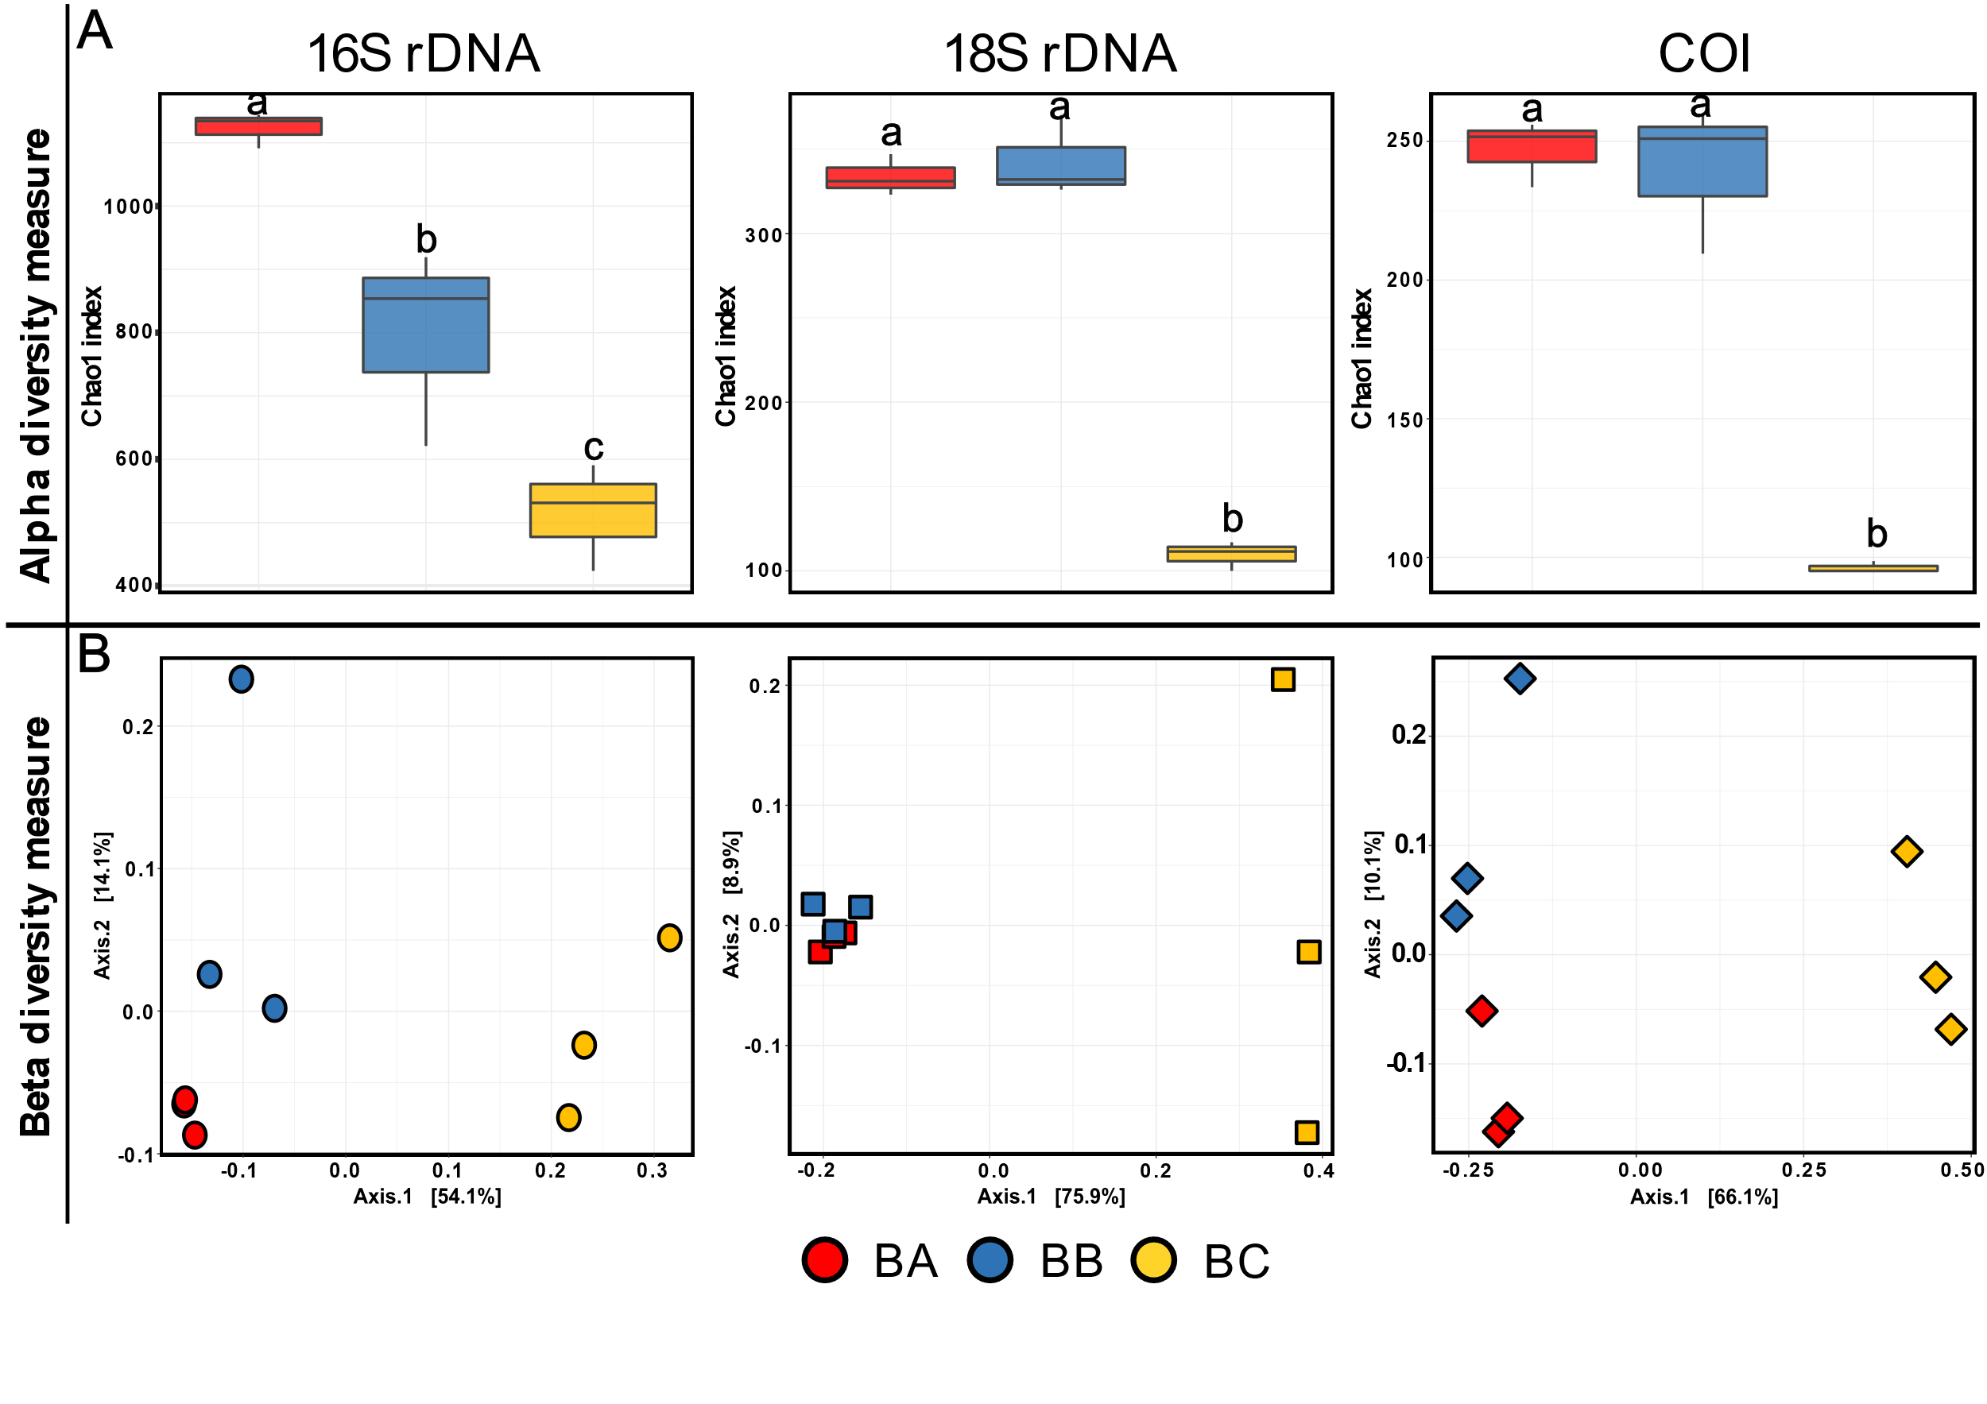
Figure 2: Distribution of alpha- and beta- diversity of the biofouling communities according to the 3 Étel sites (BA, BB and BC). (A) Boxplots of the Chao1 index at the ASV level at each site obtained from 16S rDNA, 18S rDNA and COI. The line in each box plot indicates the median, the box delimits the 25th and 75th percentile, and the whisker corresponds to the full range. Letters above boxplots represent pairwise comparisons between each site. (B) PCoA of biofouling composition across different primers (shapes) and at different sites (colors). Weighted Unifrac distances are used for 16S rDNA gene while unweighted Unifrac distances were used for both 18S rDNA and COIgene. Each point represents one sample.
A wide diversity of foulers has been identified across the sites (Figure 1B and 3). For Bacteria, the most abundant genera across BA and BB samples belonged to Alphaproteobacteria, Bacteroidia, Gammaproteobacteria, and Verrucomicrobiaea. In BC samples, the most prevalent group was an unknown genus (Gammaproteobacteria, order Pseudomonadales). Moreover, only one ASV of Archaea of Candidatus Nitrosopumilus genus were represented in the dataset, which contained only 0.04% of sequences reads. Despite these differences, 75% of the genera were shared between the three sites, accounting for over 98% of the total number of reads (Figure S4A). Conversely, only a small fraction (43.4% for 18S rDNA and 20.6% for COI) of genera were shared for eukaryotes between the three sites and this proportion averaged 88% and 95% of the total number of reads for 18S rDNA and COI respectively. Among 18 rDNA data, BA and BB samples shared about 40% of genera which contained only 8% of the total sequence reads (Figure S4B and S4C). Among 18S rDNA and COI datasets, the most dominant class for both BA and BB samples was Ectocarpus
(Phaeophyceae). Arthropods, and the genera Harpaticus and Jassa in particular, were more abundant in BA, while Bacillariophyta, especially Navicula and Shionodiscus were abundant in BB site. BC samples were composed of Arthropoda and Cnidaria, which are mainly represented by the genera Ectopleura and Jassa. Nevertheless, the rates of unassigned sequences were higher for COI than for 18S, with the highest proportion found in BB samples.
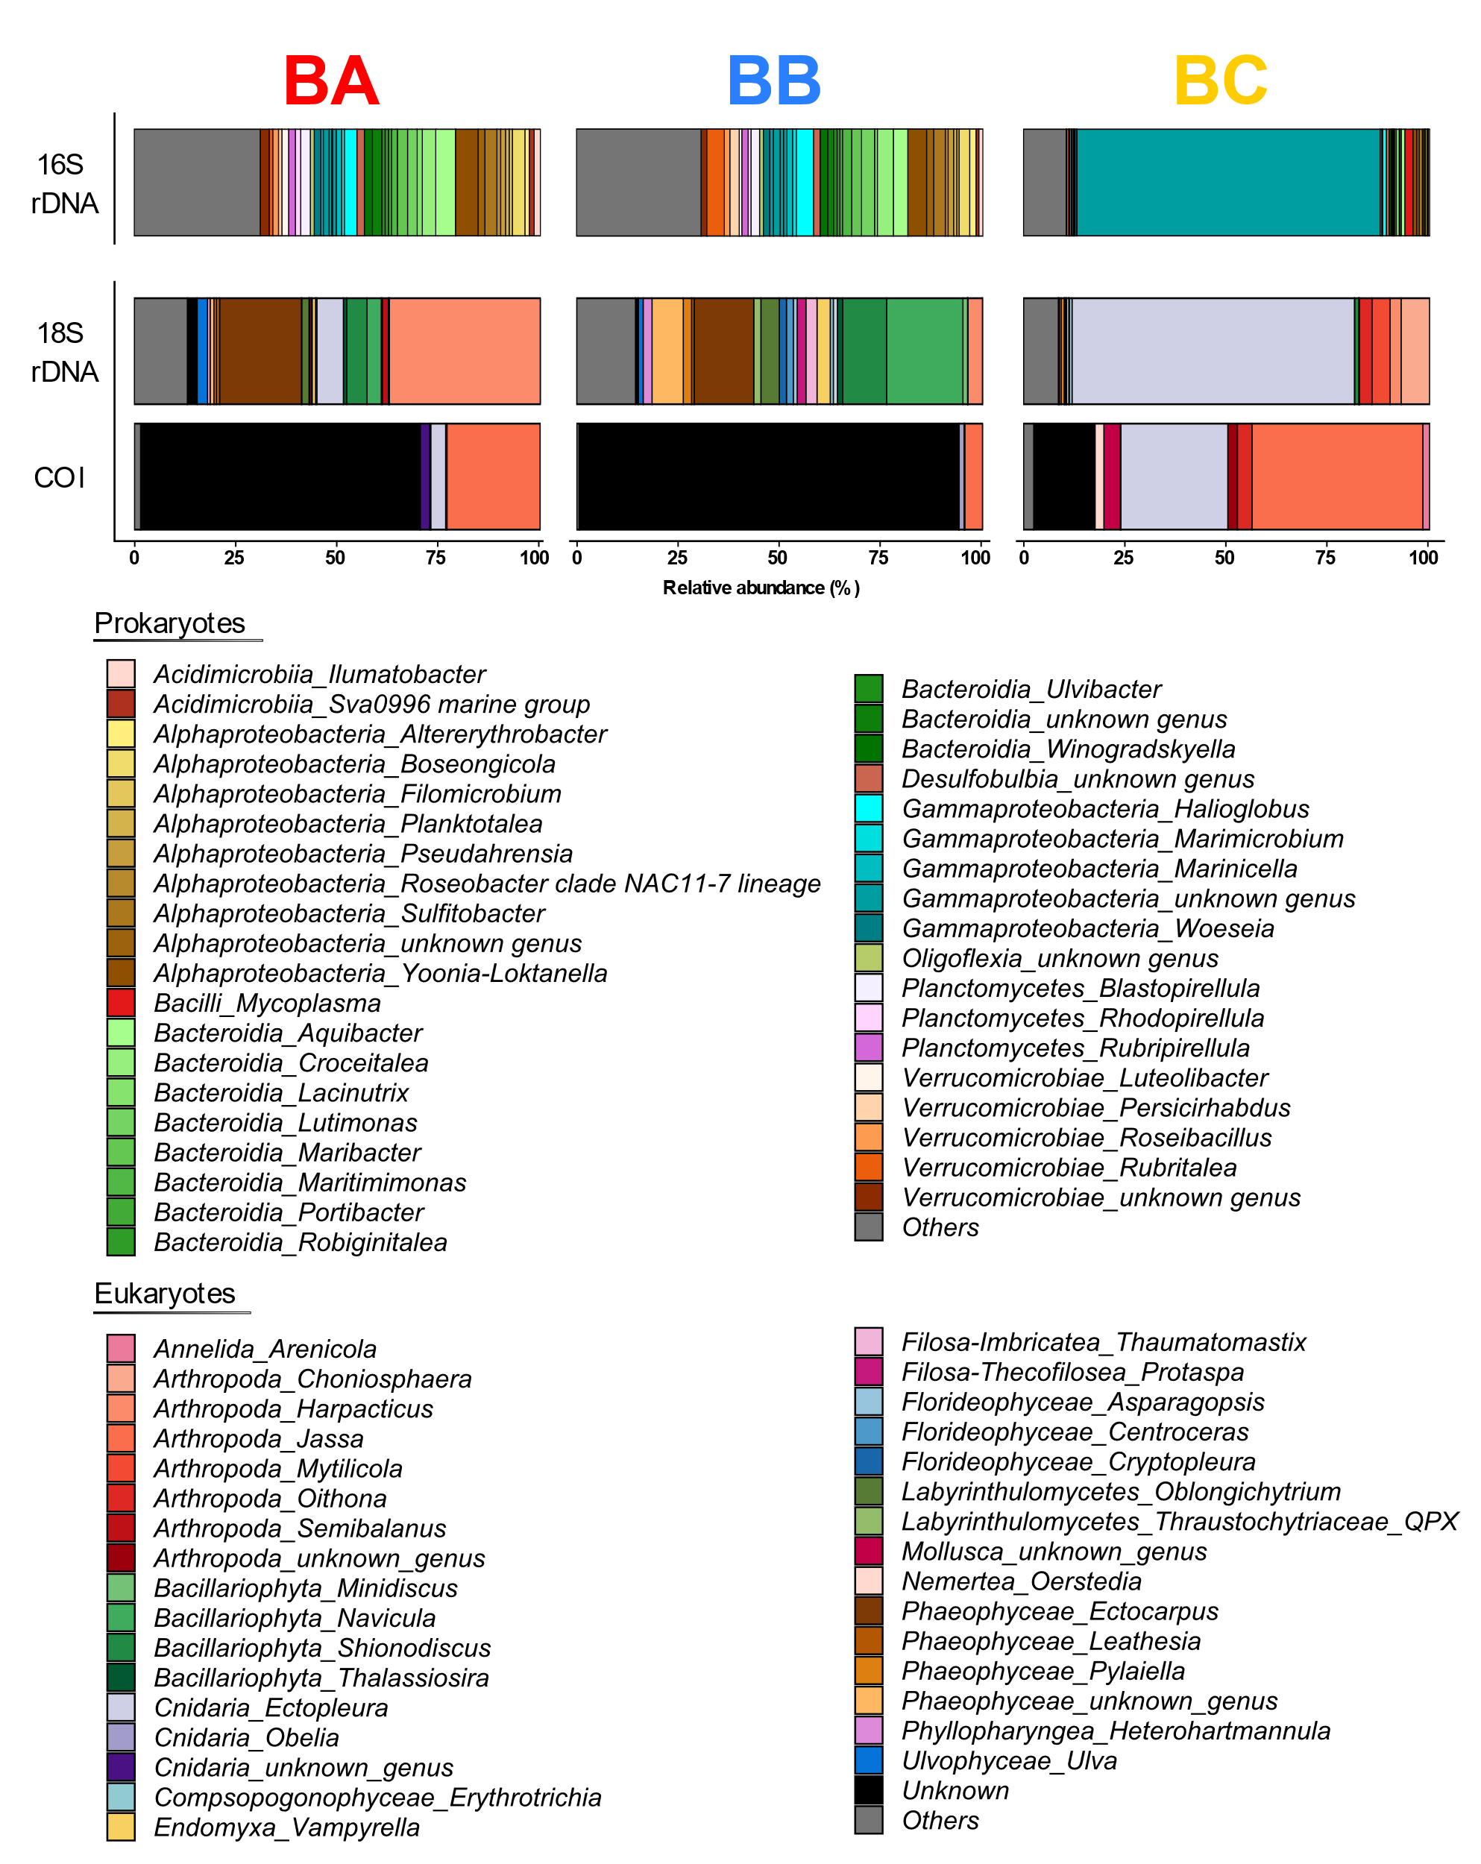

Figure 3: Composition of the marine fouling communities at the 3 Étel sites (BA, BB and BC). Taxonomic composition obtained from 16S rDNA, 18S rDNA and COI genes analyses at the genus level (relative abundance >0.05%).

Differential community analysis depending on hydrodynamic

Because of their taxonomic and hydrodynamic similarities, BA and BB samples were considered as being exposed to strong hydrodynamic conditions and BC to low ones. Accordingly, a differential analysis was performed to identify genera specifically associated to low and high hydrodynamic regimes. We showed the top 20 taxa which had significantly differential abundance (p < 0.001) and/or high LFC values between the two conditions (high current vs. low current) (Figure 4). The DESeq2 results showed that some members of the Alphaproteobacteria, such as Neorickettsia, Albimonas and the genera Mycoplasma, were more enriched in low current samples. Gammaproteobacteria were particularly notable, with 6 genera identified in the low current samples, including Marinomonas, Bordetella, Francisella and some genera of Pseudomonadales which contains Endozoicomonas genera (Figure 4A). The latter had a higher abundance in low current than in strong current and showed the most significant fold changes, greater than -12. However, this was not the case for all genera. For example, a notable increase in relative abundance was observed for genera classified as Aureispira, OM27 clade, Propionigenium or some genera of Alphaproteobacteria in samples exposed to high flow.
Among eukaryotic communities, the most significantly differentially abundant ASVs were identified in the high current condition. In the class Bacillariophyta, 3 genera including Tabularia, Navicula and Nitzschia were abundant, as well as a few genera in the classes Discosea-Flabellinia, Endomyxa, Filosa-Thecofiliseo, Labyrinthulomycetes, Phyllopharyngea, and Phaeophyceae, including the Heribaudiella genus. Conversely, discriminant genera in the low current condition were identified as members of the Arenicola (Annelida), Calliblepharis (Florideophyceae), Ectopleura (Cnidaria) but also all Arthropods genera such as Tachidius, and Oithona, (Figure 4B).

Figure 4: Differential analysis of genera obtained using DESeq2 between the most abundant and discriminant taxa in low and high flow regimes. Heatmap of differential abundance of genera (given as log2 normalized counts) and barplots of Log2FoldChange values obtained for (A) prokaryotes and (B) eukaryotes. Eukaryote communities includes COI and 18S taxa. A gradient from blue to red indicated genus abundance across sites. Barplots show Log2Foldchange values, positive values indicate an increased presence in low current and negative values indicate presence in high current. Only genera with a significance level lower than 0.001 (FDR-adjusted DESeq2 p-values), and Log2FoldChange higher than 5 are shown. Genera are grouped according to the class level.

Variations of metabolites in biofouling samples

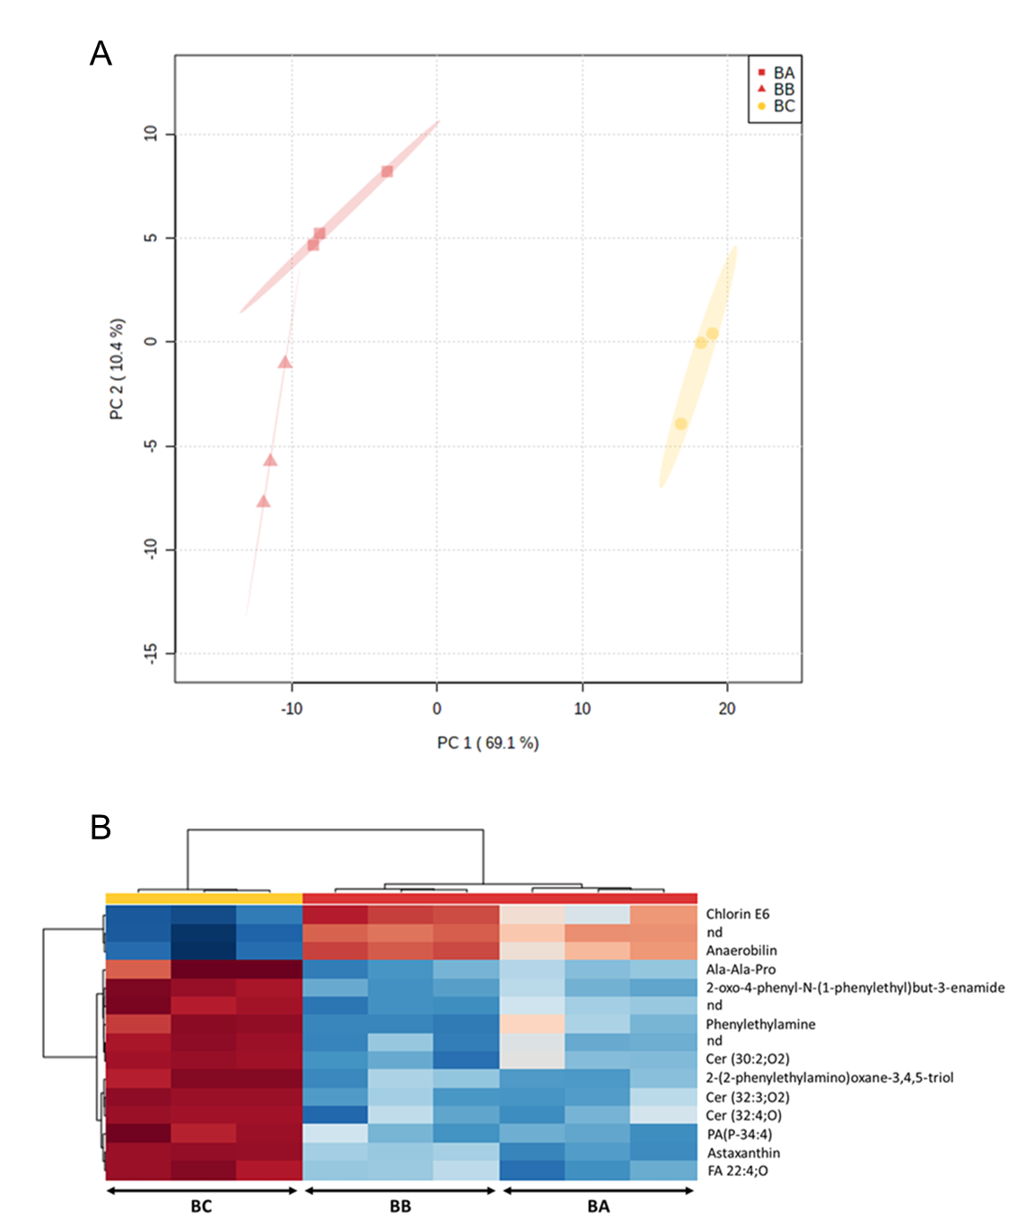
A UHPLC-(+)-ESI-MS untargeted metabolomics approach was applied and allowed, through the extraction of the raw LC-MS data to obtain a final dataset of 1414 m/z features. The resulting PCA score plot (Figure 5A) showed a clear distinction between the biofouling samples according to the hydrodynamic conditions. Thus, samples BA and BB were discriminated from samples BC along the first component (PC 1, 69.1% of the total variance) while BA samples were separated from BB samples along the second component (PC2, 10.4% of the total variance).
Figure 5: Untargeted LC-MS-based metabolomics discrimination of biofouling samples formed in high and low flow regimes. (A) Principal component analysis (PCA) score plots of marine biofouling extracts obtained from LC-MS data grouped with the three conditions: high (red square: BA and red triangle: BB) and low flow regimes (yellow: BC). (B) Hierarchical Clustering Heatmaps using the top 15 PLS-DA VIPs ("nd": not defined).

Then, a PLS-DA two-class model (high flow regime: BA/BB vs low flow regime: BC) was built to find chemomarkers differentially expressed depending on the hydrodynamic conditions. This PLS-DA model was used to determine the most discriminating m/z features. Metabolites with the highest VIP scores corresponded to those most differentially expressed between the two hydrodynamic conditions. The expression in each sample of the 15 most discriminating chemomarkers (VIP score>2) was presented in Figure 5B. The putative annotation of these chemomarkers was carried
out thanks to their MS/MS fragmentation pattern (interpretation and comparison with literature and specialized databases) and the use of the MN approach. All the elements relating to their annotation (database, molecular formula, observed ion, m/z, MS/MS fragmentation, MN cluster) were given in Table S2.

Molecular networking and chemomarkers annotation
The MN consisted of 323 nodes (i.e., m/z features), most grouped into 16 clusters of at least 3 nodes (labeled from A to P; Figure 6). Using such a tool, it was possible to: (i) have a whole overview of the metabolome expression of biofouling samples according to the hydrodynamic conditions and to locate specifically the main chemomarkers (VIPs), and (ii) better annotate these chemomarkers. Thus, this approach allowed the organisation and visualisation of MS/MS data in the form of a "spectral similarity map" (Nothias et al. 2015). The combination between the MN and the analysis of the MS/MS spectra conducted to the putative annotation of 65 metabolites of the present dataset, including 12 of the 15 first VIPs (See Table S2). More precisely, metabolites gathered in cluster A were hydrophobic compounds, such as fatty acids and derivatives, and most of them were specifically more expressed under one type of hydrodynamic conditions rather than another but without a general trend at the cluster level towards one of these two conditions. The unknown VIP n°2 (C₃₆H₅₈O₅) belonged to this cluster. Cluster B was composed by ceramides which were over-expressed in low hydrodynamic conditions (BC). More particularly, 3 ceramides were included among the15 first VIPs (VIPs n°9, 13 and 14; See Table S2). Unknown metabolites, more expressed in low hydrodynamic conditions (BC), were the main components of cluster C while several carotenoids, more expressed in strong hydrodynamic conditions (BA/BB), were part of cluster D. Several phenylethylamine derivatives, among which VIPs n°1, 6 and 12, constituted cluster E and were characteristic of BC samples. Within clusters G, K and L, no clear differences between the two hydrodynamic conditions were observed but in these clusters two chlorophyll a derivative, pheophorbide a (cluster F) and pheophytin a (cluster L), were mainly expressed in BC samples. Clusters H, I, J and M were composed by metabolites also over-expressed in BC samples among which can be mentioned: (i) the unidentified VIP n°8 in cluster H, (ii) 3 lyso-phosphatidylcholines in cluster I, (iii) a carnitine derivative in cluster J, and (iv) 2 monoacylglycerols and a fatty acid in cluster M. Clusters N, O, and P gathered metabolites mainly observed in BA/BB samples. More precisely, cluster N was composed by 3 peptides while 3 steroids were found in cluster O and the degradation product, anaerobilin (VIP n°15), was putatively annotated in cluster P. Finally, 6 of the main VIPs were detected in clusters composed by two nodes or as self-loops (single nodes). Among them, chlorin E6 (VIP n°10) was mainly expressed in BA/BB samples while the others (VIPs n°3, 4, 6, 7, and 11) were found predominantly in BC samples.

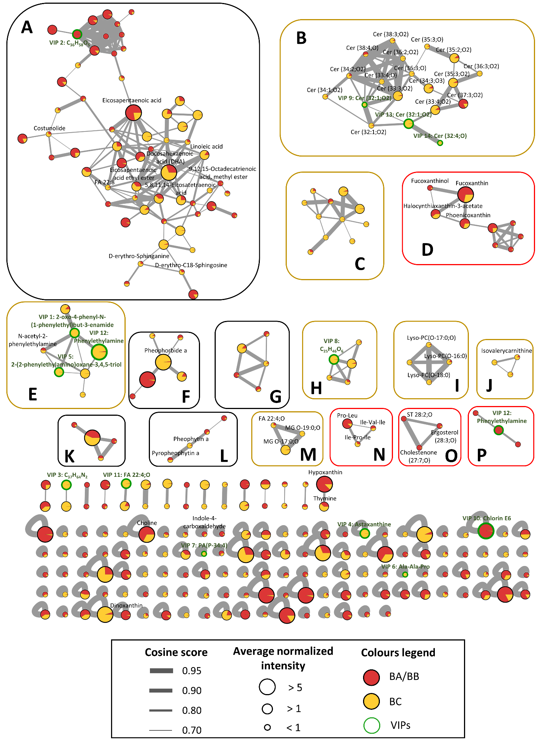
Figure 6: Molecular network built with LC-MS/MS data of extracts of marine biofouling.

Each node corresponds to a metabolite for which color ratio corresponds to its relative abundance in the two hydrodynamic conditions (High: BA/BB samples in red; Low: BC samples) and the size corresponds to the normalized intensity. Some putatively annotations are given and discriminant compounds (VIPs) between the two hydrodynamic conditions are circled in green. (FA: Fatty acid; PA: Phosphatidic acid; Cer: Ceramide; MG: Monoalkylglycerol; ST: Sterol ; PC: Phosphatidylcholine)

Biofilm quantity and chemical characterisation of the EPS matrix

As expected by the observation of the submerged panels (Figure 1B), the amount of biofilm harvested increased in low hydrodynamic conditions, with a significant difference between BA or BB and BC (p < 0.0001) (Figure S5). Conversely, the proportion of colloidal EPS was significantly higher in BA than in BB and BC (Figure 7). Variations in total amounts of carbohydrates, uronic acids and proteins were determined for the two EPS fractions, namely colloidal and bound, and for the biofilm residual fraction. Whatever the site, total carbohydrate content of the biofilms (all fractions taken together) was higher than protein content with a markedly decrease of the C/P ratios in low hydrodynamic conditions (C/P ratios of 6.5, 3.5 and 1.8 in biofilms from BA, BB and BC, respectively). Looking at the composition of the biofilm matrix (EPS extracted in colloidal and bound fractions), the same trend was noted with a significant decrease of C/P ratios when panels where exposed to a lower current (p < 0.006) (Figure 7). For BC, the C/P ratio was even lower than 1, indicating a predominant protein content of the matrix. Specifically, BC differed from the two other sites by higher proportions of protein (p < 0.01) in all fractions (colloidal, bound, and residual) (Figure S6). Focusing specifically on carbohydrate contents, no significant difference was noted between sites (p > 0.05) regardless of the fraction. The same observation was done for the uronic acid (UA) contents in colloidal and residual fractions; while for the bound fraction, BC samples presented a higher proportion of UA than BA and BB (p = 0.03) (Figure S6).
Furthermore, a PCA of the different biofilm fractions at the three sites based on the composition in proteins, carbohydrates and UA was achieved (Figure S7). Three clusters corresponding to the three sites were observed on the resulting score plot. BA and BC samples were discriminated along the first component, which accounted for 48.6% of the total variance. BC samples showed a more marked difference with the two other samples along the first component. The most discriminant parameters of BC were the total protein content, and to a lesser extent the content of UA in the EPS.

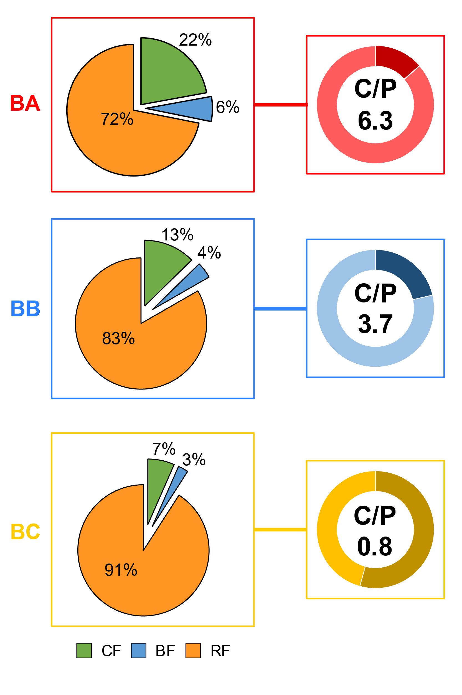
Figure 7: Distribution (proportions in mass percent) of the different fractions (Colloidal and Bound Fractions as EPS fractions, and Residual Fraction) and Carbohydrate/Protein ratios in the biofouling samples collected at the 3 Étel sites (BA, BB, and BC). The left pie chart shows the mean percentage of each fraction, colloidal (green), bound (blue) and residual (yellow), across the three buoys. The doughnut chart on the right shows the average proportion of protein (P) in dark color, and total carbohydrate (C), in light color into each site. The carbohydrate/protein ratio is shown within the doughnut chart. For more details see Table S4.

DISCUSSION
In this study, we intend to determine if and how flow dynamics and turbulence impact the biofouling process in the Étel estuary in Autumn. Hydrodynamic has been seldomly studied on biofouling to date. The use of an original approach using ADCP for flow characterisation and a multi-omics approach (metabarcoding and metabolomics) coupled with biochemical analysis, allowed us to unravel links between taxonomic and metabolic biofilm adaptations and specificities of the Étel estuary.

Hydrodynamic comportment of the Étel estuary
Turbulence measured at BA, BB and BC were in accordance with previous estimates derived from ADCP measurements collected in the center of the Sea Scheldt estuary, Belgium (Sentchev et al. 2020). The main difference in the hydrodynamic profile of BA, BB and BC was the flow velocity. In the center of the river (BA and BB), the mean and maximum flow speed were 0.7-0.8 m/s and 2.4 m/s, respectively, similar to that evaluated in the center of the Sea Scheldt estuary whereas the maximum velocity at Étel estuary is 70% higher. The maximum velocities at Étel estuary were observed during the ebbing stage of the tide. During this tidal stage, the flow converged due to the estuary shape which generated a flow acceleration and high velocities. During the flooding stage of the tide, the flow passed over several bathymetric features, including a prominent ridge, before reaching BA and BB. The complex bathymetry generated friction and macroturbulence near the bed, which then propagated upward in the water column causing a deceleration of the flow and lower velocities. In BC, low water depth and the proximity of the shoreline limited substantially the flow velocity during both ebb and flood tide thus justifying flow velocity approximately 3 times lower than that observed in BA and BB. Conditions at the Étel site allowed to conclude on mean velocity influence in providing distinct levels in the same global environment. Nevertheless, the turbulence was globally homogenous on the three points BA, BB and BC and, consequently, it was globally not possible to assess its specific influence on biofilm. Controlling turbulence (velocities fluctuations) is complex, in particular in natural environment, and dedicated experiments should be developed to study its influence separately for identical mean velocities. Therefore, physical constrains applied to biofilms were mostly shear stress on our studied sites.

Shear stress does not influence the composition of the core bacterial community but affects community structure
Previous studies have shown that hydrodynamic modifies the structure and diversity of bacterial river communities (Battin 2000; Besemer et al. 2009; Hödl et al. 2014). Our results revealed that richness and diversity tended to be higher with high flow currents, with a different community structure compared to the one observed in low current conditions. Previous studies have described similar trends in biofilm diversity but have not reliably linked the variations observed within bacterial communities with hydrodynamic (Lehtola et al. 2005; Douterelo et al. 2013; Li et al. 2015). Indeed, Li et al. (2015) only concluded, by modeling the effects of hydrodynamics on bacterial communities within fluvial biofilms, that diversity was higher in flowing waters than in calm waters. Conversely, Rickard et al. (2004) have demonstrated that a loss of diversity in a multispecies drinking water biofilm was linked to an increasing shear stress from 0.12 to 0.26 m/s. The main reasons for the distinct diversity and structure of biofilms can be the different transport rates of nutrients, dissolved oxygen variations, and cell adhesion, influencing biofilm formation and growth. A higher fluid velocity could promote nutrient and bacterial cell transport, which a positive effect on biofilm formation (Simões et al. 2007; Moreira et al. 2015), while stagnant or low flow conditions are a barrier to nutrient delivery and waste components removal from the colony (Stewart 2012), and do not allow a good water oxygenation either. With respect to bacterial cell adhesion, it has been shown in porous media or tubes that the hydrodynamic torque, imparted by local shear, traps, and accumulates motile bacteria in high-shear regions near surfaces, thereby promoting biofilm formation (Rusconi et al. 2014). However, very high shear stress conditions may prevent cell attachment or be responsible for cell detachment, which makes the biofilm senser and thinner (Angermann, 2010; Catão et al., 2019; Gomes & Mergulhão, 2021; Krsmanovic et al., 2021). A more integrated view of the effect of hydrodynamic on biofilms has been given by Van Loosdrecht et al. (1995) who considers that biofilm structure is governed by a balance between detachment and growth of biofilm communities. In other words, biofilm diversity could be promoted until a certain level of flow, which was the case of the Étel estuary during our experiments, but potentially limited beyond. This may in some way refer to the intermediate disturbance’s hypothesis (Connell 1978), suggesting that, in the context of patch dynamics (Wilson 1994) relevant for surface colonisation (Hutchinson et al. 2006; Molino et al. 2009), especially here when biofilms are submitted to fluids (Durham et al. 2012), the highest diversity will be reached with intermediate perturbation.
Thereafter, main differences between sites communities were clearly associated to the high abundance of an unknown genus among Pseudomonadales in BC, which was the dominant group. Pseudomonadales have been reported as an extremely diverse and flexible group, including the genus Endozoicomonas. They are reported to include numerous symbionts of many marine sessile marine invertebrates, including corals, sponges, and cnidarians (Neave et al. 2017). This observation is closely consistent with the presence of cnidarians, especially the genus Ectopleura, at BC. However, except this taxa, bacterial communities exhibited very similar core composition across the three sites, with 235 genera in common accounting for over 98 % of the total number of reads. The taxonomic composition, dominated by the phyla Bacteroidetes, Planctomycetes, Desulfobacterota, Verrucomicrobia, has been previously reported to dominated biofilm assemblages (e.g. Catao et al., 2021; Djaoudi et al., 2022; Oberbeckmann et al., 2021). Besemer et al (2007) have shown that bacterial communities under different river current intensities (from 0.065 m/s to 0.390 m/s) diverged from the initial community and converged to the same composition as the biofilm matured. Catão et al. (2019) observed changes in the taxonomic composition of marine prokaryotic biofilm communities when PVC panels were subjected in static vs. highly dynamic conditions (15 knots, i.e., 3 times the velocities at BA and BB). One hypothesis could be that flow velocities experienced in the three sites in the Étel estuary were already enough high to select adapted bacterial taxa. Our datasets showed an enrichment of genera among Flavobacteriaceae (for example Aquibacter, Lutimonas and Maribacter) and Rhodobacteriaceae (such as Boseongicola, Sulfitobacter and Yoonia-Loktanella) in samples exposed to high current, such genera being potentially better adapted to high hydrodynamic environments
Thus, our observations suggested that under variations in the intensity of hydrodynamic conditions (in-situ), there was a stable and resilient core community. One hypothesis would be that, given the Étel site is a very dynamic environment subjected to strong tidal current (Thiébaut et al. 2022), communities in the biofilm may adapt to their environment by physiological or genomic adaptation mechanisms.

Eukaryote selection under hydrodynamic conditions
Our results showed that hydrodynamic conditions influence the structure and distribution of eukaryotes in marine biofouling. We found a lower richness for samples less exposed to hydrodynamic (i.e., BC) with the greatest number of metazoans, 91% in total compared to 47% and 5% in BA and BB samples, respectively. Among this group, a high proportion of Cnidaria was observed in BC samples, and particularly the genera Ectopleura. Results showed that the only species identified in Étel was Ectopleura larynx. These colonial hydroids have generally been found in the Atlantic Ocean, particularly in sheltered sites where tidal flow is low (Want et al. 2021), which is consistent with our observations. Nevertheless, the spatial pattern of these cnidarians may also be related to the seasonal component, where Ectopleura larynx is known to dominate the assemblages during October-November (Blöcher 2013). Biofouling communities were identified on artificial surfaces in Lorient (Atlantic Ocean) (Briand et al. 2018). While Arthropods and Ulvophyceae include common genera (Harparticus and Ulva), the ciliates found in our data are in the minority with respect to the study of Briand et al. (2018).These differences could be explained by the fact that the environment of Étel is more dynamic than a harbor area, disadvantaging the installation of this group on surfaces. Furthermore, given that we do not use the same primer, problems related to the choice of genetic marker could explain the under-representation of taxa, as recently suggested for eukaryotic biofouling communities (Portas et al. 2022).
As reported in the literature, hydrodynamic plays a key role in dispersal and initial recruitment of larvae in marine environment (Abelson and Denny 1997; Koehl 2007; Wheeler et al. 2019). Larval and spore dispersal is primarily dependent on local hydrodynamic characteristics, which, depending on their intensity, can export larvae far from the original population. However, water movement also affects the encounter of the propagule with the substrate and the attachment processes (Wheeler et al. 2019). Unavoidably, adverse hydrodynamic may result in impeding larval settlement, which consequently results in reduced settlement (Sahu et al. 2013), as observed in this study. However, hydrodynamic can also indirectly affect the larval settlement through its effect on microbial communities. For example, barnacle larvae display significantly greater attachment on a biofilm developed at high shear stress than biofilm grown in low shear stress (Neal et al. 1996). This is consistent with the presence of barnacles of the genus Semibalanus found exclusively in the BA samples.
Furthermore, the results indicated that morphology is a determining factor for fouling colonisation under hydrodynamic conditions. Both sessile and motile eukaryotes were identified across the three sites. For sessile organisms, morphology has critical implications for their survival when experiencing intense hydrodynamic forces. The shape, size, and texture of a biofouling organism can influence its resistance under a shear stress (Gerard 1987; Johnson and Koehl 1994). This is especially true for diatoms, whose abundance was higher in high current samples, with Navicula, Nitzshia, and Cymbella being dominant. These genera have also been identified on ship coatings subjected to dynamic conditions up to 10 knots (Hunsucker et al., 2016; Hunsucker et al., 2014), highlighting their ability to withstand high current conditions. Together with bacteria, diatoms have been reported to secrete large quantities of EPS and their two raphes allow the cells to have a better adherence to the substrate (Christensen 1991; Zargiel et al. 2011). Recent investigations showed comparable results in comparing biofouling communities exposed to static and dynamic conditions (Zargiel and Swain 2014). The authors found that biofouling grown under dynamic conditions have a higher adhesion and diatom abundance compared to biofouling developed in static conditions. However, we observed that soft or mobile fouling organisms were more sensible to high shear stress, namely Ectopleura (Cnidaria) and many copepods such as the genera Oithona and Tachidius. Indeed, the strong hydrodynamic forces exerted by Étel's tidal episodes constitute a powerful selective force on biofouling organisms, some of which do not have the adapted morphology to fix themselves durably on the substrate.
Conversely, in high hydrodynamic conditions, some mobile organisms were found, including the copepod Harpacticus. Ciliates, characterized as a large and diverse unicellular group, were reported exclusively in BA and BB samples, and were dominated by several mobile taxa (Heterohartmannula and Trochilia of Cyrtophoria order) and one genus of sessile taxa (e.g., Ephelota). The same pattern was observed with the presence of some dinoflagellates, including the genera Prorocentrum and Biecheleria. According to Antoniadou et al. (2011), species diversity and abundance of mobile fauna increased with increasing habitat complexity offered by the presence of sessile species. Although the proportion of these groups was low (<1,6% of reads), an associative relationship can be established between the abundance of these mobile groups and the presence of Ulvophyceae, among which the genus Ulva was the most abundant in samples exposed to strong hydrodynamic. In this case, the green algae may represent a temporary refuge for these species. These results agreed with those of Briand et al. (2018) who observed a positive correlation between ciliates and dinoflagellates abundance and the presence of Ulvophyceae in Kernevel harbour (26 km from Étel).

Hydrodynamic strengths influence biofilm quantity and EPS composition
Shear stress also significantly affected both biofilm quantity and matrix composition, the latter known to be produced by both bacteria and diatoms. The presence of hydrodynamic strengths (BA/ BB vs. BC) resulted in an anticipated smoother biofilm, but less abundant and less rich in proteins too. In biofilms obtained under hydrodynamic stress, we noted that the proportion of matrix compounds (based on the quantity of secreted EPS recovered in colloidal and bound fractions) was greater. Firstly, among these EPS, polysaccharides dominated and more the hydrodynamic stress was strong, however without containing more UA. UA were quantified because of their carboxyl groups which provide binding sites to divalent cations, thus increasing the binding forces and structural stability of the biofilm matrix (Vu et al. 2009; Xu et al. 2018). Second, the proportion of EPS extracted in the colloidal fraction increased with increasing hydrodynamic forces. Since colloidal fractions contain the most soluble and loosely bound EPS of the matrix, high currents could eliminate them as more detachable EPS (Pierre et al. 2014). Here, under high shear stress, biofilm communities produce more colloidal EPS mainly in the form of exopolysaccharides; these consequently establishing sufficient interactions to form a mechanically stable protective structure. High shear or turbulent flow conditions induce greater secretion of polysaccharides, responsible for mechanical stability, more cohesive and resistant structure of the biofilm, in addition to promote initial cell adhesion on surfaces (Liu and Tay 2002; Douterelo et al. 2013; Lemos et al. 2015). Chang et al. (2020) observed similar result under high shear stress with Bacillius spp. since EPS production was increased to provide robust cell adhesion. Thus, biofilm may better resist to higher shear forces that tend to limit adhesion and to increase breakout forces by increasing the production of specific EPS, which are known to strengthen the cohesive forces within the biofilm (Paul et al. 2012; Lemos et al. 2015; Krsmanovic et al. 2021). As diatoms composition seems to be more affected than bacterial one by shear stress, one may suggest that same bacterial taxa modify their EPS expression and/or different diatom taxa expressed different EPS. A better characterisation of EPS would be required to deepen the relative role of the different microbes in EPS contribution.

Biofouling metabolome reflects the presence of specific eukaryote communities depending on the hydrodynamic conditions
Untargeted LC-MS-based metabolomics was used to assess if contrasted hydrodynamic induced a metabolome shift at the community level. PLS-DA and molecular networking highlighted some putatively annotated metabolites which were specifically more expressed in one of the two hydrodynamic conditions. Among molecules found predominantly in samples BA/BB, three were steroids, including ergosterol. Ergosterol is the main fungal membrane sterol regulating membrane fluidity (Yang et al. 2015). In a wide number of previous studies, this compound has been used to estimate the fungal biomass in environmental samples. Moreover, according to recent studies, this compound has been isolated from several marine fungi such as Rhodotorula sphaerocarpa (Salazar Alekseyeva et al. 2021), Talaromyces sp. (Lebeau et al. 2020) and Phoma sp. (Wu et al. 2018). The high expression of ergosterol in BA and BB samples was then in agreement with the results obtained by metabarcoding which showed a higher proportion of fungi in BA/BB samples than in BC ones. In cluster D, 4 metabolites annotated as carotenoids were more expressed in BA/BB samples. The most abundant of them was annotated as fucoxanthin, a carotenoid mainly found in macro-, microalgae and diatoms (Peng et al., 2011; Xia et al., 2013). Fucoxanthin is the main xanthophyll produced by Ochrophyta and members of this division represented more than 35% of the organisms detected in BA samples and 61% of BB ones while they only represented 3% in BC samples. More precisely, fucoxanthin has already been detected in most macroalgae of the genus Ectocarpus, which are found exclusively in BA and BB samples, at 20% and 15% abundance, respectively (Lourenço-Lopes et al. 2021). Fucoxanthin is also common in unicellular microalgae (i.e., diatoms, class Bacillariophyta) (Brunet et al., 1996; Peng et al., 2011) and such taxa were found predominantly in BA/BB samples. In the same way, dinoxanthin, one of the main xanthophyll of dinoflagellates, was observed as a self-loop in the MN and it was mainly expressed in BA/BB samples. Conversely, astaxanthin was specifically expressed in BC samples. Astaxanthin is a naturally occurring carotenoid pigment with strong antioxidant activity which is commonly found in both crustaceans and macroalgae (Galasso et al. 2017; Weaver et al. 2018). The presence of this carotenoid could be correlated with the presence of Ectopleura larynx representing 70% in low hydrodynamic conditions against, on average, 4% in high hydrodynamic conditions. This species exhibits a bright red-orange coloration of their gonophores which may be due to astaxanthin accumulation. Another hypothesis could come from the diet of hydroids which consists mainly of crustaceans (containing astaxanthin), especially copepods and cladocerans (Blöcher 2013). Nevertheless, astaxanthin accumulation may also reflect a seasonal variations linked to crustaceans and diatoms domination, during summer and winter respectively (Genzano 2005). Moreover, lipids were found more abundantly in BC samples. Several lipid classes followed these findings, namely lyso-phosphatidylcholines (cluster I), monoacylglycerols (cluster M) and ceramides (cluster B). In this last cluster, 19 neutral glycosphingolipids have been annotated. Most of them have been already described in microalgae, including dinoflagellates, diatoms or haptophytes, invertebrates, cnidaria or some bacterial species (Li et al. 2017; Panevska et al. 2019). Lipids form the structural basis of cell membranes. They are also used as an energy reserve by all marine invertebrates, and they are among the most important organic compounds found in all marine invertebrates. Among them, fatty acids, monoalkyldiacylglycerols, triacylglycerols, glycerophospholipids and sphingolipids (Imbs et al., 2021) have been already described for their implication in host-microbe interactions and for the role they play in mutualistic cnidarian-Symbiodinium symbiosis communications (Kitchen et al. 2017).

Conclusions
This original multidisciplinary approach allowed the multi-scale characterisation of biofouling by examining communities but also their metabolic production through the analysis of the metabolome and the biochemical components of the biofilm matrix. Our results pointed out that hydrodynamic forces, and specifically shear stress, in the Étel estuary in Autumn shape the structure of communities, and consequently the metabolites profiles, but also modify the matrix nature and quantity. Thus, strong currents, generated by the specific tidal regime of the Étel estuary, lead to an overall greater diversity, with eukaryotic communities specifically sensitive to hydrodynamic conditions. Symbionts in Pseudomonadales and their host Ectopleura notably dominate at the lowest shear stress. Consequently, to high currents, the exopolymeric matrix consisted of six times more polysaccharides than proteins, playing a key role in biofilm adhesion and cohesion.

Acknowledgments
Funding: this work benefited from France Energies Marines and State financing managed by the National Research Agency under the Investments for the Future program bearing the reference ANR-10-IED-0006-32 and from the European Union's Horizon 2020 research and innovation program under the grant agreement 815180. This work was carried out in the frame of the ELEMENT and ABIOP+ projects. The authors would like to than Chantier Bretagne Sud and Guinard Energies for their welcome and help in the field. We are grateful to the Roscoff Bioinformatics platform ABiMS (http://abims.sb-roscoff.fr), part of the Institut Français de Bioinformatique (ANR-11-INBS-0013) and BioGenouest network, for providing help and/or computing and/or storage resources. The authors thank Dr S. Greff (Aix-Marseille University, IMBE, France) for the LC-MS experiments which were conducted on the regional metabolomics platform MALLABAR [Funds: Institute of Ecology and Environment (INEE) of the French National Centre for Scientific Research (CNRS), Total Foundation and the French Sud-PACA regional council].

REFERENCES

Abelson, A., and M. Denny. 1997. Settlement of Marine Organisms in Flow. Annual Review of Ecology and Systematics 28: 317–339. doi:10.1146/annurev.ecolsys.28.1.317.
Angermann, L. 2010. Numerical Simulations: Examples and Applications in Computational Fluid Dynamics. BoD – Books on Demand.
Antoniadou, C., E. Voultsiadou, and C. Chintiroglou. 2011. Seasonal patterns of colonization and early succession on sublittoral rocky cliffs. Journal of Experimental Marine Biology and Ecology 403: 21–30. doi:10.1016/j.jembe.2011.04.001.
Antunes, J., P. Leão, and V. Vasconcelos. 2019. Marine biofilms: diversity of communities and of chemical cues. Environmental Microbiology Reports 11: 287–305. doi:10.1111/1758-2229.12694.
Araújo, P. A., J. Malheiro, I. Machado, F. Mergulhão, L. Melo, and M. Simões. 2016. Influence of Flow Velocity on the Characteristics of Pseudomonas fluorescens Biofilms. Journal of Environmental Engineering 142. American Society of Civil Engineers: 04016031. doi:10.1061/(ASCE)EE.1943-7870.0001068.
Battin, T. J. 2000. Hydrodynamics is a major determinant of streambed biofilm activity: From the sediment to the reach scale. Limnology and Oceanography 45: 1308–1319. doi:10.4319/lo.2000.45.6.1308.
Battin, T. J., L. A. Kaplan, J. D. Newbold, X. Cheng, and C. Hansen. 2003. Effects of Current Velocity on the Nascent Architecture of Stream Microbial Biofilms. Applied and Environmental Microbiology 69. American Society for Microbiology: 5443–5452. doi:10.1128/AEM.69.9.5443-5452.2003.
Besemer, K., G. Singer, R. Limberger, A.-K. Chlup, G. Hochedlinger, I. Hödl, C. Baranyi, and T. J. Battin. 2007. Biophysical Controls on Community Succession in Stream Biofilms. Applied and Environmental Microbiology 73. American Society for Microbiology: 4966–4974. doi:10.1128/AEM.00588-07.
Besemer, K., G. Singer, I. Hödl, and T. J. Battin. 2009. Bacterial Community Composition of Stream Biofilms in Spatially Variable-Flow Environments. Applied and Environmental Microbiology. American Society for Microbiology. World. doi:10.1128/AEM.01284-09.
Blöcher, N. 2013. Biofouling in the Norwegian Salmon Farming Industry. Norges teknisk-naturvitenskapelige universitet, Fakultet for naturvitenskap og teknologi, Institutt for biologi.
Blumenkrantz, N., and G. Asboe-Hansen. 1973. New method for quantitative determination of uronic acids. Analytical Biochemistry 54: 484–489. doi:10.1016/0003-2697(73)90377-1.
Bokulich, N. A., S. Subramanian, J. J. Faith, D. Gevers, J. I. Gordon, R. Knight, D. A. Mills, and J. G. Caporaso. 2013. Quality-filtering vastly improves diversity estimates from Illumina amplicon sequencing. Nature Methods 10: 57–59. doi:10.1038/nmeth.2276.
Bradford, M. M. 1976. A rapid and sensitive method for the quantitation of microgram quantities of protein utilizing the principle of protein-dye binding. Analytical Biochemistry 72: 248–254. doi:10.1016/0003-2697(76)90527-3.
Briand, J.-F., A. Barani, C. Garnier, K. Réhel, F. Urvois, C. LePoupon, A. Bouchez, D. Debroas, et al. 2017. Spatio-temporal variations of marine biofilm communities colonizing artificial substrata including antifouling coatings in contrasted french coastal environments. Microbial Ecology 74: 585–598. doi:10.1007/s00248-017-0966-2.
Briand, J.-F., X. Pochon, S. A. Wood, C. Bressy, C. Garnier, K. Réhel, F. Urvois, G. Culioli, et al. 2018. Metabarcoding and metabolomics offer complementarity in deciphering marine eukaryotic biofouling community shifts. Biofouling 34: 657–672. doi:f.
Brunet, C., D. Davoult, and R. Casotti. 1996. Physiological reactions to a change in light regime in cultured Skeletonema costatum (Bacillariophyta): implications for estimation of phytoplankton biomass. Hydrobiologia 333: 87–94. doi:10.1007/BF00017571.
Callahan, B. J., P. J. McMurdie, M. J. Rosen, A. W. Han, A. J. A. Johnson, and S. P. Holmes. 2016. DADA2: High-resolution sample inference from Illumina amplicon data. Nature Methods 13. Nature Publishing Group: 581–583. doi:10.1038/nmeth.3869.
Carriot, N., B. Paix, S. Greff, B. Viguier, J.-F. Briand, and G. Culioli. 2021. Integration of LC/MS-based molecular networking and classical phytochemical approach allows in-depth annotation of the metabolome of non-model organisms - The case study of the brown seaweed Taonia atomaria. Talanta 225: 121925. doi:10.1016/j.talanta.2020.121925.
Carriot, N., R. Barry-Martinet, J.-F. Briand, A. Ortalo-Magné, and G. Culioli. 2022. Impact of phosphate concentration on the metabolome of biofilms of the marine bacterium Pseudoalteromonas lipolytica. Metabolomics 18: 18. doi:10.1007/s11306-022-01875-x.
Catão, E. C. P., T. Pollet, B. Misson, C. Garnier, J.-F. Ghiglione, R. Barry-Martinet, M. Maintenay, C. Bressy, et al. 2019a. Shear Stress as a Major Driver of Marine Biofilm Communities in the NW Mediterranean Sea. Frontiers in Microbiology 0. Frontiers. doi:10.3389/fmicb.2019.01768.
Catão, E. C. P., T. Pollet, B. Misson, C. Garnier, J.-F. Ghiglione, R. Barry-Martinet, M. Maintenay, C. Bressy, et al. 2019b. Shear Stress as a Major Driver of Marine Biofilm Communities in the NW Mediterranean Sea. Frontiers in Microbiology 10. Frontiers. doi:10.3389/fmicb.2019.01768.
Catao, E. C. P., N. Gallois, F. Fay, B. Misson, and J.-F. Briand. 2021. Metal resistance genes enrichment in marine biofilm communities selected by biocide-containing surfaces in temperate and tropical coastal environments. Environmental Pollution 268: 115835. doi:10.1016/j.envpol.2020.115835.
Chang, J., X. He, X. Bai, and C. Yuan. 2020. The impact of hydrodynamic shear force on adhesion morphology and biofilm conformation of Bacillus sp. Ocean Engineering 197: 106860. doi:10.1016/j.oceaneng.2019.106860.
Chong, J., O. Soufan, C. Li, I. Caraus, S. Li, G. Bourque, D. S. Wishart, and J. Xia. 2018. MetaboAnalyst 4.0: towards more transparent and integrative metabolomics analysis. Nucleic Acids Research 46: W486–W494. doi:10.1093/nar/gky310.
Christensen, T. 1991. The Diatoms. Biology and Morphology of the Genera. Phycologia 30. Taylor & Francis: 233–235. doi:10.2216/i0031-8884-30-2-233.1.
Connell, J. H. 1978. Diversity in Tropical Rain Forests and Coral Reefs. Science 199. American Association for the Advancement of Science: 1302–1310. doi:10.1126/science.199.4335.1302.
Dang, H., and C. R. Lovell. 2016. Microbial Surface Colonization and Biofilm Development in Marine Environments. Microbiology and Molecular Biology Reviews 80: 91–138. doi:10.1128/MMBR.00037-15.
Degraer, S., D. Carey, J. Coolen, Z. Hutchison, F. Kerckhof, B. Rumes, and J. Vanaverbeke. 2020. Offshore Wind Farm Artificial Reefs Affect Ecosystem Structure and Functioning: A Synthesis. Oceanography 33: 48–57. doi:10.5670/oceanog.2020.405.
Djaoudi, K., J. Angel. T. Onrubia, A. Boukra, L. Guesnay, A. Portas, R. Barry-Martinet, B. Angeletti, S. Mounier, et al. 2022. Seawater copper content controls biofilm bioaccumulation and microbial community on microplastics. Science of The Total Environment 814: 152278. doi:10.1016/j.scitotenv.2021.152278.
Dobretsov, S., R. M. M. Abed, T. Muthukrishnan, P. Sathe, L. Al-Naamani, B. Y. Queste, and S. Piontkovski. 2018. Living on the edge: biofilms developing in oscillating environmental conditions. Biofouling 34: 1064–1077. doi:10.1080/08927014.2018.1539707.
Douterelo, I., R. L. Sharpe, and J. B. Boxall. 2013. Influence of hydraulic regimes on bacterial community structure and composition in an experimental drinking water distribution system. Water Research 47: 503–516. doi:10.1016/j.watres.2012.09.053.
Dubois, Michel., K. A. Gilles, J. K. Hamilton, P. A. Rebers, and Fred. Smith. 1956. Colorimetric method for determination of sugars and related substances. Analytical Chemistry 28: 350–356. doi:10.1021/ac60111a017.
Durham, W. M., O. Tranzer, A. Leombruni, and R. Stocker. 2012. Division by fluid incision: Biofilm patch development in porous media. Physics of Fluids 24. American Institute of Physics: 091107. doi:10.1063/1.4747154.
Escudié, F., L. Auer, M. Bernard, M. Mariadassou, L. Cauquil, K. Vidal, S. Maman, G. Hernandez-Raquet, et al. 2018. FROGS: Find, Rapidly, OTUs with Galaxy Solution. Bioinformatics 34: 1287–1294. doi:10.1093/bioinformatics/btx791.
Flemming, and J. Wingender. 2010. The biofilm matrix. Nature Reviews Microbiology 8. Nature Publishing Group: 623–633. doi:10.1038/nrmicro2415.
Galasso, C., C. Corinaldesi, and C. Sansone. 2017. Carotenoids from Marine Organisms: Biological Functions and Industrial Applications. Antioxidants 6. Multidisciplinary Digital Publishing Institute: 96. doi:10.3390/antiox6040096.
Gast, R. J., M. R. Dennett, and D. A. Caron. 2004. Characterisation of Protistan Assemblages in the Ross Sea, Antarctica, by Denaturing Gradient Gel Electrophoresis. Applied and Environmental Microbiology 70. American Society for Microbiology: 2028–2037. doi:10.1128/AEM.70.4.2028-2037.2004.
Genzano, G. N. 2005. Trophic ecology of a benthic intertidal hydroid, Tubularia crocea, at Mar del Plata, Argentina. Journal of the Marine Biological Association of the United Kingdom 85. Cambridge University Press: 307–312. doi:10.1017/S0025315405011197h.
Gerard, V. A. 1987. Hydrodynamic streamlining of Laminaria saccharina Lamour. in response to mechanical stress. Journal of Experimental Marine Biology and Ecology 107: 237–244. doi:10.1016/0022-0981(87)90040-2.
Gomes, L. C., and F. J. M. Mergulhão. 2021. A Selection of Platforms to Evaluate Surface Adhesion and Biofilm Formation in Controlled Hydrodynamic Conditions. Microorganisms 9. Multidisciplinary Digital Publishing Institute: 1993. doi:10.3390/microorganisms9091993.
Hödl, I., L. Mari, E. Bertuzzo, S. Suweis, K. Besemer, A. Rinaldo, and T. J. Battin. 2014. Biophysical controls on cluster dynamics and architectural differentiation of microbial biofilms in contrasting flow environments. Environmental Microbiology 16: 802–812. doi:10.1111/1462-2920.12205.
Hunsucker, J. T., K. Z. Hunsucker, H. Gardner, and G. Swain. 2016. Influence of hydrodynamic stress on the frictional drag of biofouling communities. Biofouling 32. Taylor & Francis: 1209–1221. doi:10.1080/08927014.2016.1242724.
Hunsucker, K. Z., A. Koka, G. Lund, and G. Swain. 2014. Diatom community structure on in-service cruise ship hulls. Biofouling 30. Taylor & Francis: 1133–1140. doi:10.1080/08927014.2014.974576.
Hunsucker, K. Z., H. Gardner, K. Lieberman, and G. Swain. 2019. Using hydrodynamic testing to assess the performance of fouling control coatings. Ocean Engineering 194: 106677. doi:10.1016/j.oceaneng.2019.106677.
Hutchinson, N., S. Nagarkar, J. C. Aitchison, and G. A. Williams. 2006. Microspatial variation in marine biofilm abundance on intertidal rock surfaces. Aquatic Microbial Ecology 42: 187–197. doi:10.3354/ame042187.
Isberg, R. R., and P. Barnes. 2002. Dancing with the Host: Flow-Dependent Bacterial Adhesion. Cell 110: 1–4. doi:10.1016/S0092-8674(02)00821-8.
Johnson, A., and M. Koehl. 1994. Maintenance of dynamic strain similarity and environmental stress factor in different flow habitats: thallus allometry and material properties of a giant kelp. Journal of Experimental Biology 195: 381–410. doi:10.1242/jeb.195.1.381.
Kitchen, S. A., A. Z. Poole, and V. M. Weis. 2017. Sphingolipid Metabolism of a Sea Anemone Is Altered by the Presence of Dinoflagellate Symbionts. The Biological Bulletin 233. The University of Chicago Press: 242–254. doi:10.1086/695846.
Koehl, M. R. A. 2007. Mini review: Hydrodynamics of larval settlement into fouling communities. Biofouling 23. Taylor & Francis: 357–368. doi:10.1080/08927010701492250.
Krsmanovic, M., D. Biswas, H. Ali, A. Kumar, R. Ghosh, and A. K. Dickerson. 2021. Hydrodynamics and surface properties influence biofilm proliferation. Advances in Colloid and Interface Science 288: 102336. doi:10.1016/j.cis.2020.102336.
Lawes, J. C., B. A. Neilan, M. V. Brown, G. F. Clark, and E. L. Johnston. 2016. Elevated nutrients change bacterial community composition and connectivity: high throughput sequencing of young marine biofilms. Biofouling 32. Taylor & Francis: 57–69. doi:10.1080/08927014.2015.1126581.
Lebeau, J., T. Petit, M. Fouillaud, L. Dufossé, and Y. Caro. 2020. Alternative Extraction and Characterisation of Nitrogen-Containing Azaphilone Red Pigments and Ergosterol Derivatives from the Marine-Derived Fungal Talaromyces sp. 30570 Strain with Industrial Relevance. Microorganisms 8: E1920. doi:10.3390/microorganisms8121920.
Lehtola, M. J., I. T. Miettinen, T. Lampola, A. Hirvonen, T. Vartiainen, and P. J. Martikainen. 2005. Pipeline materials modify the effectiveness of disinfectants in drinking water distribution systems. Water Research 39: 1962–1971. doi:10.1016/j.watres.2005.03.009.
Lemos, M., F. Mergulhão, L. Melo, and M. Simões. 2015. The effect of shear stress on the formation and removal of Bacillus cereus biofilms. Food and Bioproducts Processing 93: 242–248. doi:10.1016/j.fbp.2014.09.005.
Leray, M., J. Y. Yang, C. P. Meyer, S. C. Mills, N. Agudelo, V. Ranwez, J. T. Boehm, and R. J. Machida. 2013. A new versatile primer set targeting a short fragment of the mitochondrial COI region for metabarcoding metazoan diversity: application for characterizing coral reef fish gut contents. Frontiers in Zoology 10: 34. doi:10.1186/1742-9994-10-34.
Li, Y., C. Wang, W. Zhang, P. Wang, L. Niu, J. Hou, J. Wang, and L. Wang. 2015. Modeling the Effects of Hydrodynamic Regimes on Microbial Communities within Fluvial Biofilms: Combining Deterministic and Stochastic Processes. Research-article. ACS Publications. American Chemical Society. World. doi:10.1021/acs.est.5b03277. October 13.
Li, Y., Y. Lou, T. Mu, A. Ke, Z. Ran, J. Xu, J. Chen, C. Zhou, et al. 2017. Sphingolipids in marine microalgae: Development and application of a mass spectrometric method for global structural characterisation of ceramides and glycosphingolipids in three major phyla. Analytica Chimica Acta 986: 82–94. doi:10.1016/j.aca.2017.07.039.
Liu, Y., and J.-H. Tay. 2002. The essential role of hydrodynamic shear force in the formation of biofilm and granular sludge. Water Research 36: 1653–1665. doi:10.1016/S0043-1354(01)00379-7.
Lourenço-Lopes, C., M. Fraga-Corral, C. Jimenez-Lopez, M. Carpena, A. G. Pereira, P. Garcia-Oliveira, M. A. Prieto, and J. Simal-Gandara. 2021. Biological action mechanisms of fucoxanthin extracted from algae for application in food and cosmetic industries. Trends in Food Science & Technology 117. Plant-Based Bioactive Compounds: Healthy Promoters And Protective Agents: 163–181. doi:10.1016/j.tifs.2021.03.012.
Love, M. I., W. Huber, and S. Anders. 2014. Moderated estimation of fold change and dispersion for RNA-seq data with DESeq2. Genome Biology 15: 550. doi:10.1186/s13059-014-0550-8.
Martin, M. 2011. Cutadapt removes adapter sequences from high-throughput sequencing reads. EMBnet.journal 17: 10–12. doi:10.14806/ej.17.1.200.
Marty, A., F. Schoefs, G. Damblans, J.-V. Facq, B. Gaurier, and G. Germain. 2022. Experimental study of two kinds of hard marine growth effects on the hydrodynamic behavior of a cylinder submitted to wave and current loading. Ocean Engineering 263: 112194. doi:10.1016/j.oceaneng.2022.112194.
McMurdie, P. J., and S. Holmes. 2013. phyloseq: An R Package for Reproducible Interactive Analysis and Graphics of Microbiome Census Data. PLOS ONE 8. Public Library of Science: e61217. doi:10.1371/journal.pone.0061217.
Molino, P. J., E. Campbell, and R. Wetherbee. 2009. Development of the initial diatom microfouling layer on antifouling and fouling-release surfaces in temperate and tropical Australia. Biofouling 25. Taylor & Francis: 685–694. doi:10.1080/08927010903089912.
Moreira, J. M. R., M. Simões, L. F. Melo, and F. J. Mergulhão. 2015. The combined effects of shear stress and mass transfer on the balance between biofilm and suspended cell dynamics. Desalination and Water Treatment 53: 3348–3354. doi:10.1080/19443994.2014.933625.
Nadell, C. D., D. Ricaurte, J. Yan, K. Drescher, and B. L. Bassler. 2017. Flow environment and matrix structure interact to determine spatial competition in Pseudomonas aeruginosa biofilms. Edited by Sara Mitri. eLife 6. eLife Sciences Publications, Ltd: e21855. doi:10.7554/eLife.21855.
Neal, A. L., F. N. Simões, and A. B. Yule. 1996. Interactions between shear rates and biofilms affecting exploratory behaviour by cyprids ofElminius modestus (Cirripedia). Marine Biology 127: 241–246. doi:10.1007/BF00942109.
Neave, M. J., C. T. Michell, A. Apprill, and C. R. Voolstra. 2017. Endozoicomonas genomes reveal functional adaptation and plasticity in bacterial strains symbiotically associated with diverse marine hosts. Scientific Reports 7. Nature Publishing Group: 40579. doi:10.1038/srep40579.
Noël, L. M.-L. J., J. N. Griffin, P. S. Moschella, S. R. Jenkins, R. C. Thompson, and S. J. Hawkins. 2009. Changes in Diversity and Ecosystem Functioning During Succession. In Marine Hard Bottom Communities, ed. M. Wahl, 206:213–223. Ecological Studies. Berlin, Heidelberg: Springer Berlin Heidelberg. doi:10.1007/b76710_15.
Norton, T. A., and E. M. Burrows. 1969. Studies on marine algae of the British Isles. 7. Saccorhiza polyschides (Lightf.) Batt. British Phycological Journal 4: 19–53. doi:10.1080/00071616900650031.
Nothias, L.-F., M. Esposito, J. Costa, J. Paolini, D. Touboul, and M. Litaudon. 2015. Molecular networks, a bioinformatic tool for tandem mass spectrometry data interpretation. Spectra Analyse: 65–70.
Oberbeckmann, S., B. Kreikemeyer, and M. Labrenz. 2018. Environmental Factors Support the Formation of Specific Bacterial Assemblages on Microplastics. Frontiers in Microbiology 8: 2709. doi:10.3389/fmicb.2017.02709.
Oberbeckmann, S., D. Bartosik, S. Huang, J. Werner, C. Hirschfeld, D. Wibberg, S. E. Heiden, B. Bunk, et al. 2021. Genomic and proteomic profiles of biofilms on microplastics are decoupled from artificial surface properties. Environmental Microbiology 23: 3099–3115. doi:10.1111/1462-2920.15531.
Oksanen, J., R. Kindt, P. Legendre, B. Hara, G. Simpson, P. Solymos, M. Henry, H. Stevens, et al. 2009. The vegan Package.
Oursel, B., C. Garnier, G. Durrieu, S. Mounier, D. Omanović, and Y. Lucas. 2013. Dynamics and fates of trace metals chronically input in a Mediterranean coastal zone impacted by a large urban area. Marine Pollution Bulletin 69: 137–149. doi:10.1016/j.marpolbul.2013.01.023.
Panevska, A., M. Skočaj, I. Križaj, P. Maček, and K. Sepčić. 2019. Ceramide phosphoethanolamine, an enigmatic cellular membrane sphingolipid. Biochimica Et Biophysica Acta. Biomembranes 1861: 1284–1292. doi:10.1016/j.bbamem.2019.05.001.
Parada, A. E., D. M. Needham, and J. A. Fuhrman. 2016. Every base matters: assessing small subunit rRNA primers for marine microbiomes with mock communities, time series and global field samples. Environmental Microbiology 18: 1403–1414. doi:10.1111/1462-2920.13023.
Paul, E., J. C. Ochoa, Y. Pechaud, Y. Liu, and A. Liné. 2012. Effect of shear stress and growth conditions on detachment and physical properties of biofilms. Water Research 46: 5499–5508. doi:10.1016/j.watres.2012.07.029.
Peng, J., J.-P. Yuan, C.-F. Wu, and J.-H. Wang. 2011a. Fucoxanthin, a Marine Carotenoid Present in Brown Seaweeds and Diatoms: Metabolism and Bioactivities Relevant to Human Health. Marine Drugs 9. Molecular Diversity Preservation International: 1806–1828. doi:10.3390/md9101806.
Peng, J., J.-P. Yuan, C.-F. Wu, and J.-H. Wang. 2011b. Fucoxanthin, a marine carotenoid present in brown seaweeds and diatoms: metabolism and bioactivities relevant to human health. Marine Drugs 9: 1806–1828. doi:10.3390/md9101806.
Pierre, G., J.-M. Zhao, F. Orvain, C. Dupuy, G. L. Klein, M. Graber, and T. Maugard. 2014. Seasonal dynamics of extracellular polymeric substances (EPS) in surface sediments of a diatom-dominated intertidal mudflat (Marennes–Oléron, France). Journal of Sea Research 92. Trophic Significance of Microbial Biofilm in Tidal Flats: 26–35. doi:10.1016/j.seares.2013.07.018.
Pluskal, T., S. Castillo, A. Villar-Briones, and M. Orešič. 2010. MZmine 2: Modular framework for processing, visualizing, and analyzing mass spectrometry-based molecular profile data. BMC Bioinformatics 11: 395. doi:10.1186/1471-2105-11-395.
Portas, A., N. Quillien, G. Culioli, and J.-F. Briand. 2022. Eukaryotic diversity of marine biofouling from coastal to offshore areas. Frontiers in Marine Science 9.
Quillien, N., M. Lejart, and Damblans, Guillaume. 2018. Bibliographical atlas of biofouling along the French coasts in the context of offshore renewable energy. France Energies Marines Editions. Plouzané.
Railkin, A. I. 2003. Marine Biofouling: Colonization Processes and Defenses. Boca Raton: CRC Press. doi:10.1201/9780203503232.
REPHY – French Observation And Monitoring Program For Phytoplankton And Hydrology In Coastal Waters. 2021. REPHY dataset - French Observation and Monitoring program for Phytoplankton and Hydrology in coastal waters. Metropolitan data. SEANOE. doi:10.17882/47248.
Rickard, A. H., A. J. McBain, A. T. Stead, and P. Gilbert. 2004. Shear Rate Moderates Community Diversity in Freshwater Biofilms. Applied and Environmental Microbiology 70. American Society for Microbiology: 7426–7435. doi:10.1128/AEM.70.12.7426-7435.2004.
Rusconi, R., J. S. Guasto, and R. Stocker. 2014. Bacterial transport suppressed by fluid shear. Nature Physics 10. Nature Publishing Group: 212–217. doi:10.1038/nphys2883.
Sahu, G., K. K. Satpathy, A. K. Mohanty, S. Biswas, M. S. Achary, and S. K. Sarkar. 2013. Larval abundance and its relation to macrofouling settlement pattern in the coastal waters of Kalpakkam, southeastern part of India. Environmental Monitoring and Assessment 185: 1951–1967. doi:10.1007/s10661-012-2679-9.
Salazar Alekseyeva, K., B. Mähnert, F. Berthiller, E. Breyer, G. J. Herndl, and F. Baltar. 2021. Adapting an Ergosterol Extraction Method with Marine Yeasts for the Quantification of Oceanic Fungal Biomass. Journal of Fungi 7. Multidisciplinary Digital Publishing Institute: 690. doi:10.3390/jof7090690.
Salta, M., J. A. Wharton, Y. Blache, K. R. Stokes, and J.-F. Briand. 2013. Marine biofilms on artificial surfaces: structure and dynamics. Environmental Microbiology 15: 2879–2893. doi:10.1111/1462-2920.12186.
Schultz, M. P., J. A. Bendick, E. R. Holm, and W. M. Hertel. 2011. Economic impact of biofouling on a naval surface ship. Biofouling 27: 87–98. doi:10.1080/08927014.2010.542809.
Sentchev, A., M. Thiébaut, and F. G. Schmitt. 2020. Impact of turbulence on power production by a free-stream tidal turbine in real sea conditions. Renewable Energy 147: 1932–1940. doi:10.1016/j.renene.2019.09.136.
Simões, M., M. O. Pereira, S. Sillankorva, J. Azeredo, and M. J. Vieira. 2007. The effect of hydrodynamic conditions on the phenotype of Pseudomonas fluorescens biofilms. Biofouling 23. Taylor & Francis: 249–258. doi:10.1080/08927010701368476.
Singer, G., K. Besemer, P. Schmitt-Kopplin, I. Hödl, and T. J. Battin. 2010. Physical Heterogeneity Increases Biofilm Resource Use and Its Molecular Diversity in Stream Mesocosms. PLOS ONE 5. Public Library of Science: e9988. doi:10.1371/journal.pone.0009988.
Song, J., L. Beule, E. Jongmans-Hochschulz, A. Wichels, and G. Gerdts. 2022. The travelling particles: community dynamics of biofilms on microplastics transferred along a salinity gradient. ISME Communications 2. Nature Publishing Group: 1–12. doi:10.1038/s43705-022-00117-4.
Stewart, P. S. 2012. Mini-review: Convection around biofilms. Biofouling 28. Taylor & Francis: 187–198. doi:10.1080/08927014.2012.662641.
Taormina, B., A. Percheron, M. P. Marzloff, X. Caisey, N. Quillien, M. Lejart, N. Desroy, O. Dugornay, et al. 2020. Succession in epibenthic communities on artificial reefs associated with marine renewable energy facilities within a tide-swept environment. Edited by Steven Degraer. ICES Journal of Marine Science 77: 2656–2668. doi:10.1093/icesjms/fsaa129.
Thiébaut, M., N. Quillien, A. Maison, H. Gaborieau, N. Ruiz, S. MacKenzie, G. Connor, and J.-F. Filipot. 2022. Investigating the flow dynamics and turbulence at a tidal-stream energy site in a highly energetic estuary. Renewable Energy 195: 252–262. doi:10.1016/j.renene.2022.06.020.
Van de Peer, Y., P. De Rijk, J. Wuyts, T. Winkelmans, and R. De Wachter. 2000. The European Small Subunit Ribosomal RNA database. Nucleic Acids Research 28: 175–176. doi:10.1093/nar/28.1.175.
Van Loosdrecht, M. C. M., D. Eikelboom, A. Gjaltema, A. Mulder, L. Tijhuis, and J. J. Heijnen. 1995. Biofilm structures. Water Science and Technology 32. Biofilm Structure, Growth and Dynamics: 35–43. doi:10.1016/0273-1223(96)00005-4.
Vieira, M. J., L. F. Melo, and M. M. Pinheiro. 1993. Biofilm formation: Hydrodynamic effects on internal diffusion and structure. Biofouling 7: 67–80. doi:10.1080/08927019309386244.
Vu, B., M. Chen, R. J. Crawford, and E. P. Ivanova. 2009. Bacterial Extracellular Polysaccharides Involved in Biofilm Formation. Molecules 14: 2535–2554. doi:10.3390/molecules14072535.
Wahl, M. 1989. Marine epibiosis. I. Fouling and antifouling: some basic aspects. Marine Ecology Progress Series 58: 175–189.
Wang, M., J. J. Carver, V. V. Phelan, L. M. Sanchez, N. Garg, Y. Peng, D. D. Nguyen, J. Watrous, et al. 2016. Sharing and community curation of mass spectrometry data with Global Natural Products Social Molecular Networking. Nature Biotechnology 34. Nature Publishing Group: 828–837. doi:10.1038/nbt.3597.
Wang, Q., G. M. Garrity, J. M. Tiedje, and J. R. Cole. 2007. Naïve bayesian classifier for rapid assignment of rRNA sequences into the new bacterial taxonomy. Applied and Environmental Microbiology 73. American Society for Microbiology: 5261–5267. doi:10.1128/AEM.00062-07.
Want, A., M. C. Bell, R. E. Harris, M. Q. Hull, C. R. Long, and J. S. Porter. 2021. Sea-trial verification of a novel system for monitoring biofouling and testing anti-fouling coatings in highly energetic environments targeted by the marine renewable energy industry. Biofouling 37. Taylor & Francis: 433–451. doi:10.1080/08927014.2021.1928091.
Weaver, R. J., P. A. Cobine, and G. E. Hill. 2018. On the bioconversion of dietary carotenoids to astaxanthin in the marine copepod, Tigriopus californicus. Journal of Plankton Research 40: 142–150. doi:10.1093/plankt/fbx072.
Wheeler, J. D., E. Secchi, R. Rusconi, and R. Stocker. 2019. Not Just Going with the Flow: The Effects of Fluid Flow on Bacteria and Plankton. Annual Review of Cell and Developmental Biology 35: 213–237. doi:10.1146/annurev-cellbio-100818-125119.
Whomersley, P., and G. B. Picken. 2003. Long-term dynamics of fouling communities found on offshore installations in the North Sea. Journal of the Marine Biological Association of the United Kingdom 83: 897–901. doi:10.1017/S0025315403008014h.
Wilson, J. B. 1994. The “Intermediate Disturbance Hypothesis” of Species Coexistence Is Based on Patch Dynamics. New Zealand Journal of Ecology 18. New Zealand Ecological Society: 176–181.
Wu, H.-Y., F.-L. Yang, L.-H. Li, Y. K. Rao, T.-C. Ju, W.-T. Wong, C.-Y. Hsieh, M. V. Pivkin, et al. 2018. Ergosterol peroxide from marine fungus Phoma sp. induces ROS-dependent apoptosis and autophagy in human lung adenocarcinoma cells. Scientific Reports 8. Nature Publishing Group: 17956. doi:10.1038/s41598-018-36411-2.
Xia, S., K. Wang, L. Wan, A. Li, Q. Hu, and C. Zhang. 2013. Production, Characterisation, and Antioxidant Activity of Fucoxanthin from the Marine Diatom Odontella aurita. Marine Drugs 11. Multidisciplinary Digital Publishing Institute: 2667–2681. doi:10.3390/md11072667.
Xu, C., S. Zhang, M. Beaver, P. Lin, L. Sun, S. M. Doyle, J. B. Sylvan, A. Wozniak, et al. 2018. The role of microbially-mediated exopolymeric substances (EPS) in regulating Macondo oil transport in a mesocosm experiment. Marine Chemistry 206: 52–61. doi:10.1016/j.marchem.2018.09.005.
Yang, H., J. Tong, C. W. Lee, S. Ha, S. H. Eom, and Y. J. Im. 2015. Structural mechanism of ergosterol regulation by fungal sterol transcription factor Upc2. Nature Communications 6. Nature Publishing Group: 6129. doi:10.1038/ncomms7129.
Zargiel, K. A., and G. W. Swain. 2014. Static vs dynamic settlement and adhesion of diatoms to ship hull coatings. Biofouling 30. Taylor & Francis: 115–129. doi:10.1080/08927014.2013.847927.
Zargiel, K. A., J. S. Coogan, and G. W. Swain. 2011. Diatom community structure on commercially available ship hull coatings. Biofouling 27. Taylor & Francis: 955–965. doi:10.1080/08927014.2011.618268.

Supplement 2

JSON Outputs of the collision risk assessment for the Orkney example

"collision_risk": {
"__type__": "dtoesa:CRM:CRMList",
"name": "none",
"description": "collision risk results",
"CRM_results": [
{
"__type__": "dtoesa:CRM:CRM_results",
"name": "",
"description": "",
"latin_name": "harbour porpoise",
"period": 1,
"avoidance_rate": 0.98,
"collision_risk_with_avoidance": 0.03,
"collision_risk_without_avoidance": 1.717
},
{
"__type__": "dtoesa:CRM:CRM_results",
"name": "",
"description": "",
"latin_name": "harbour seal",
"period": 1,
"avoidance_rate": 0.98,
"collision_risk_with_avoidance": 0.05,
"collision_risk_without_avoidance": 2.593
},
{
"__type__": "dtoesa:CRM:CRM_results",
"name": "",
"description": "",
"latin_name": "Grey seal",
"period": 1,
"avoidance_rate": 0.98,
"collision_risk_with_avoidance": 0.09,
"collision_risk_without_avoidance": 4.596
},
{
"__type__": "dtoesa:CRM:CRM_results",
"name": "",
"description": "",
"latin_name": "Minke whale",
"period": 1,
"avoidance_rate": 0.98,
"collision_risk_with_avoidance": 0.03,
"collision_risk_without_avoidance": 1.409
},
{
"__type__": "dtoesa:CRM:CRM_results",
"name": "",
"description": "",
"latin_name": "Eider",
"period": 1,
"avoidance_rate": 0.98,
"collision_risk_with_avoidance": 0.45,
"collision_risk_without_avoidance": 22.473
},
{
"__type__": "dtoesa:CRM:CRM_results",
"name": "",
"description": "",
"latin_name": "red-throated diver",
"period": 1,
"avoidance_rate": 0.98,
"collision_risk_with_avoidance": 0.02,
"collision_risk_without_avoidance": 1.003
},
{
"__type__": "dtoesa:CRM:CRM_results",
"name": "",
"description": "",
"latin_name": "cormorant",
"period": 1,
"avoidance_rate": 0.98,
"collision_risk_with_avoidance": 0.12,
"collision_risk_without_avoidance": 5.834
},
{
"__type__": "dtoesa:CRM:CRM_results",
"name": "",
"description": "",
"latin_name": "black guillemot",
"period": 1,
"avoidance_rate": 0.98,
"collision_risk_with_avoidance": 0.25,
"collision_risk_without_avoidance": 12.562
}
]

Nova Innovation
45 Timber Bush
Edinburgh
EH6 6QH
T: +44 (0)131 241 2000
E: info@element-project.eu

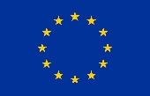

This project has received funding from the European Union’s Horizon 2020 research and innovation programme under grant agreement number 815180.

Aurélie Portas, Nathan Carriot, Annick Ortalo-Magné, Guillaume Damblans, Maxime Thiébaut, Gérald Culioli, Nolwenn Quillien, and Jean-François Briand (in press). Impact of hydrodynamics on biofilms community structure and metabolic expression in a highly energetic estuary.

